Open the TI-Nspire document The_Core.tns  A fossil is the remains or imprint of an organism from the past that has been preserved in Earth’s crust. The fossil record refers to all of the fossils that have been discovered, and it gives scientists insight into how organisms lived, died, and changed over many generations. The location of fossils within sedimentary rock can determine the relative age of the fossils. The lower the fossils are within the rock layer, the older they are. Similarly, the fossils near the surface are the youngest, and they are also typically more complex. Scientists can also use radioactive isotopes to obtain a more accurate measure of the age of the fossils. This process is called radioactive dating. |  |  | 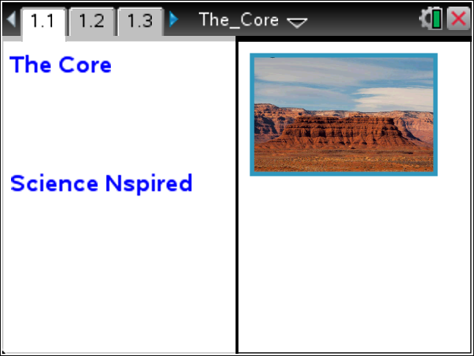
 | Move to page 1.2. Answer question 1 below and/or on your device.
Q1. Which of the following is a fossil?

A. part of an organism preserved in sedimentary rock
B. a footprint of an ancient animal
C. the imprint of a prehistoric leaf
D. all of the above

Move to page 1.3.
Read the directions for the simulation.

 | - Move the drill over the desert ground shown in the simulation. Select the drill to excavate a core sample. Repeat this process five times.  - Select and drag the samples to the grid at the bottom of the screen to arrange them from oldest to youngest. | 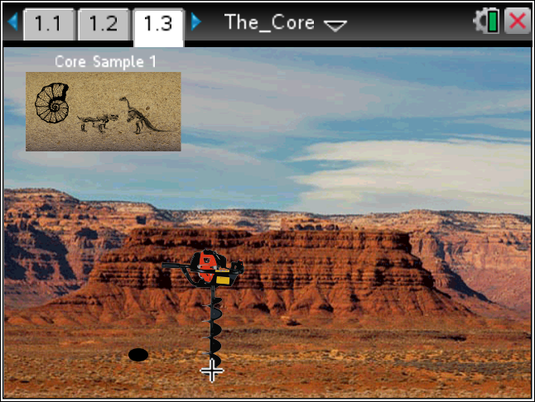
Tech Tip: To access the Directions again, select > Core Sample > Directions.
Tech Tip: To access the Directions again, select b or Document Tools () > Core Sample > Directions.

Move to pages 1.4 – 1.9.

After placing the core samples in the correct order on page 1.3, answer questions 2 – 7 below and/or in your .tns file.

Q2. What is the correct order of the fossil cores from oldest to youngest?
A. 5,2,1,4,3
B. 2,3,3,1,5
C. 3,4,1,2,5
D. 4,3,2,1,5

Q3. How did you determine the order of the fossils?

Q4. In which layer would you find the more complex fossils and why?
Q5. Fossils are usually formed in which type of rock?

A. igneous
B. sedimentary
C. metamorphic

Q6. What is the difference between relative dating and radioactive dating?

Q7. What can the fossil record tell us about the evolution of organisms?
A. Organisms have remained the same over time.
B. Organisms have become more complex over time.
C. Organisms have become less complex over time.

