Piecewise Functions TEACHER INSTRUCTIONS

Objective: Algebra/ e. Write, graph, and analyze linear and nonlinear functions (such as quadratic, greatest integer), and absolute value and inequalities in two variables given a table of values, slope, intercept, or rule.

Materials: PowerPoint, Student handout

Use the PowerPoint to guide students through the reasons for learning about step functions and the notation associated with the greatest integer and least integer functions. The phone & postage rate examples in the PowerPoint are slightly different from those in the student handout to provide additional examples for the students.

The second part of this activity, transforming the greatest integer function, is written with the assumption that students have already transformed absolute value & quadratic functions.

Piecewise Functions Name__________________________________

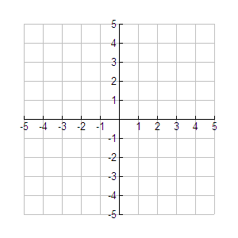
Ceiling Function: Floor Function (Greatest Integer Function):

1. 2.

3. 4.

5. 6.

7. 8.

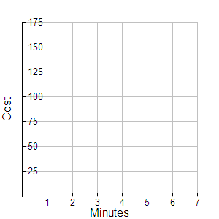
9. Phone companies determine the price of a call by rounding the length of the call to a certain time period (usually the nearest minute). For instance, a local weekday call on Long D’s Basic Residential plan will cost $0.20 each minute. Suppose that Long D also charges a $0.25 connection fee for each call.

Minutes | Cost
0<x<1
1<x<2
2<x<3
3<x<4
4<x<5
5<x<6

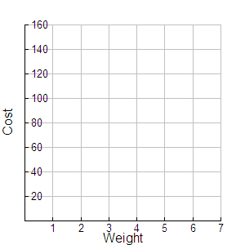

10. Postage Stamp Function: The table shows the cost of mailing a letter that weighs x ounces. Source: USPS.

Weight | Cost |  | Complete the table for packages with the following weights. | Weight | Cost
0<x<1 | 39¢ |  | Complete the table for packages with the following weights. | .98
1<x<2 | 63¢ |  | Complete the table for packages with the following weights. | 1.26
2<x<3 | 87¢ |  | Complete the table for packages with the following weights. | 2.55
3<x<4 | 111¢ |  | Complete the table for packages with the following weights. | 3.01
4<x<5 | 135¢ |  | Complete the table for packages with the following weights. | 4.29
5<x<6 | 159¢ |  | Complete the table for packages with the following weights. | 6

11. Apply It! Carrie Callalot has a phone bill determined by , where C is the cost of a monthly phone bill with calls totaling m minutes. A different company called her and offered her 7¢ per minute with a monthly fee of $4.95.
Write a function, N(m) to define the offer by the new company.
If she is looking for the best long distance service, which company should she use and why?
Transforming the Greatest Integer Function

Use your graphing calculator to transform .

1. Sketch the graph of 2. Sketch the graph of
What effect does have on a function if ?
What effect does have on a function if ?
Does it make sense for the graphs of and to look the same?

3. Sketch the graph of .
What happened to the original greatest integer function?
4. Create a greatest integer function that has twice as many steps as .

5. Create a greatest integer function that has steps twice as long as .
6. Create a greatest integer function that has steps half as long as .

