Introduction
By moving in a specific way in front of a CBR 2, you can attempt to make a motion plot that matches a given Distance-Time plot. You can change the shape of the plot by adjusting your starting position, speed, and the direction in which you move.
Objectives  In this activity you will:  - Make Distance-Time plots to match various plots.  - Make connections between types of movements and characteristics of Distance-Time graphs. |  | 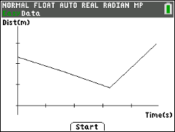
You'll Need

- TI 84 Plus CE, with Vernier EasyData™ App
- CBR 2™ motion sensor unit with mini-USB connecting cable
Using the CBR 2™ motion sensor and EasyData™ App
Connect the handheld with the CBR 2 using the USB cable. EasyData will immediately open, and the CBR 2 will begin collecting distance data every time it clicks. In the EasyData app, the tabs at the bottom indicate the menus that can be accessed by pressing the keys directly below. For example, to go to File to select New, press o. To change the Setup, press p. To Start, press q. To see the Graph, press r. To Quit the app, press s. |  | 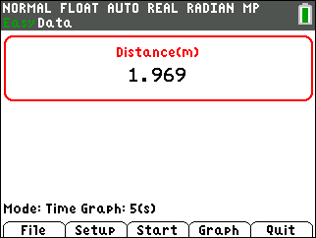
Collecting the Data  You will use a wall as a target for the CBR 2. Use a meter stick to measure 1-meter intervals from the wall. Mark each interval on the floor with a piece of masking tape for a total distance of 4 meters. |  | 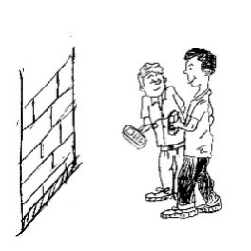
To get ready to do this activity, change the and select Distance Match. You will see a message to study a graph that is generated randomly and then to choose which means press q. Note: When you select Start, be sure to be ready because the CBR 2 will immediately start. |  | 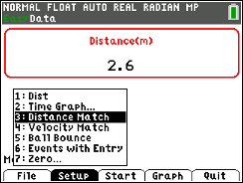
1. Think about how you need to move to match the graph generated by the calculator. Remember that the CBR 2 will measure the distance from you to the wall during the experiment. The tick marks on the vertical axis in the graph are measured at 1 meter intervals.
2. Hold the CBR 2 in one hand and the calculator in the other or have a partner hold the calculator. Aim the CBR 2 at the wall.
3. When you are ready, select by pressing q .
4. Sketch the given graph you were to match at the right. Then sketch your walk. Use two different colors (or solid and dotted lines) to distinguish the plots and label them as “Graph” and “Match.” To Retry the same graph, select . |  | 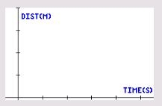
Looking at the Results
1. Describe the way you had to move in order to match each segment of the graph. Mention rate and direction.
2. How well did you match the given graph? Describe how you could improve each segment of your match plot. Be specific.
Trial 1:
3. Select by pressing p to get a different graph to match. Sketch two different graphs along with your walks on the axes below.
Trial 2 Trial 3
For each trial, describe how you walked to match the given graph. If your plot did not match well, tell how you could make it better.
Trial 2:

Trial 3:
4. Complete the statements to make some conclusions about the types of motion needed to make specific plots.

a. The steepness of the line segments is affected by the _____________of the walker.

b. The slant (upward or downward) of the line segments is affected by the

__________ of the walker.

c. A person standing still in front of the CBR 2 is represented by a

_____________________ line segment on the plot.

Going Further  1. Write a few sentences to tell a short story explaining the kind of motion the plot shown might represent. Be creative. |  |  | 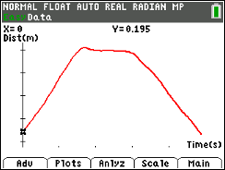
2. Draw a possible motion plot for the story described below.

Stacy walks at a constant rate from her house to the school bus stop. With about a quarter of the distance left, she sees the bus coming, so she runs at a constant rate to try to catch it. She gets to the bus stop, but misses the bus. After a short rest, Stacy turns around and walks back home at a constant rate.

