Binomial Probabilities
TI-Nspire™ CX Family

Activity Overview
Time required
60 minutes

In this activity, students begin with a hands-on experiment of rolling a die and keeping track of the numbers of successes and failures. They then simulate their experiment by using the randBin command on their handheld. Next, they use the binomPdf command to find the theoretical probabilities and compare their experimental probabilities to the theoretical probabilities. Students also use the binomCdf command to find cumulative probabilities. The activity concludes with deriving the formula for finding binomial probabilities.

Topic: Permutations, Combinations & Probability
- Calculate the probability of r successes in n Bernoulli trials for a particular experiment.
- Use the binomial probability density function to verify the probabilities calculated for n Bernoulli trials.

Teacher Preparation and Notes
- This activity is designed to be used in an Algebra 2 classroom. It can also be used in an introductory Statistics class.
- You will need standard dice for students to roll. If dice are not available, you can use spinners divided into six equal sections.
- This activity assumes basic knowledge of probability, including the difference between experimental and theoretical probabilities, as well as arrangements and combinations. Students should also know what is meant by the complement of an event.
- Notes for using the TI-Nspire™ Navigator™ System are included throughout the activity. The use of the Navigator System is not necessary for completion of this activity.

Associated Materials
- BinomialProb_Student.doc
- BinomialProb.tns
- BinomialProb_Soln.tns

Problem 1 – Experimental probability
Introduce or review the rules for a binomial experiment.
- There are n independent trials, or observations.
- There are two possible outcomes, or categories: a success or a failure.
- The probability of a success, p, remains constant throughout the experiment. The probability of a failure, q, is also constant; q = 1 – p.
Give each student a single die. Each student should perform the experiment of rolling the die five times and recording the result where a “6” is a success and any other number is a failure.
Success | Failure

Have students repeat this experiment nine more times, using Table 1 on their worksheets as a place to record and keep track of their results. A sample table is shown at right.
Next, students can complete Table 2 by recording the number of successes in each of the 10 experiments. In the first row, they should write the number of successes, and in the second row, they should record the percent of successes. The numbers should sum to 10, the percents should sum to 1.

A sample table is shown below. (It corresponds to the sample tally table above.) The last row shows experimental binomial probabilities. Ask various students what their experimental probability was for exactly two successes.

 | 0 | 1 | 2 | 3 | 4 | 5
Number of Successes | 5 | 3 | 2 | 0 | 0 | 0
Percent of Successes | 0.5 | 0.3 | 0.2 | 0 | 0 | 0

Explain that in this scenario, n = 5 because there were five trials per experiment. The experiment was performed 10 times. Ask students how they think performing the experiment 100 times would affect the probability distribution (the values in the last row of the table). They should predict that the results would become closer to the theoretical probability. Ask students if they would want to sit there and repeat the experiment 100 or more times.
Explain to students that their TI-Nspire handheld or computer software fortunately has a function that will simulate binomial experiments. They will learn to use it and see how the simulated results compare to their actual results.

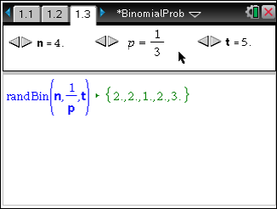
To simulate the same experiments performed earlier, instruct students to move to page 1.3. They can change the sliders to modify the number of trials per experiment, probability of success in each trial, and number of experiments.

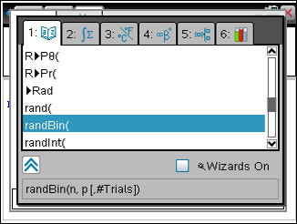
Students can also use the Scratchpad to view the same simulation. They can find the randBin command in the Catalog (by pressing k) or in the menu by selecting MENU > Probability > Random > Binomial.

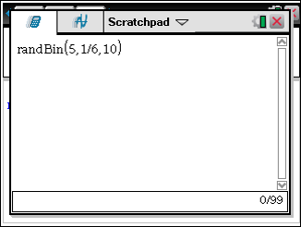
The syntax for the randBin command is: number of trials per experiment, probability of success in each trial, and number of experiments.
This first command therefore should read
randBin(5,1/6,10), as shown to the right.

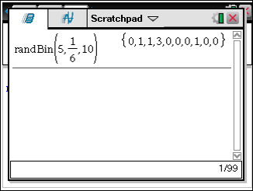
The command will reveal a list with the number of successes per experiment appears. Have students use this information to complete Table 3 on their worksheets and compare these simulate results to their Table 2 experimental results.

Problem 2 – Theoretical probability
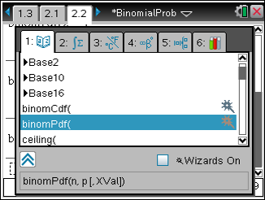
The probabilities in Tables 1 and 2 are experimental. To find the theoretical probabilities, have students advance to page 2.2 to use the binomPdf command. This command may also be found in the Catalog.
Or students can select MENU > Probability > Distributions > Binomial Pdf.

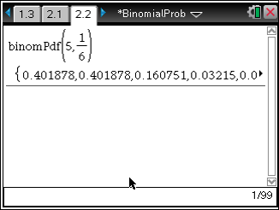
Have students enter the command binomPdf(5,1/6) and press ·. The list of theoretical probabilities appear, beginning with P(0) and ending with P(5). To view all the values, students can arrow up to the list and then arrow to the right.

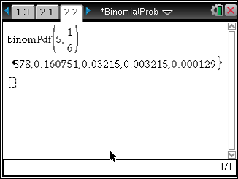
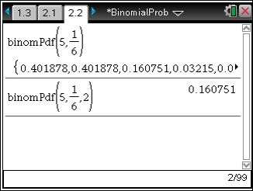
Have students enter the theoretical probabilities into Table 4 on their worksheets. Next, they should compare these theoretical probabilities to their experimental probabilities, both performed and simulated.

TI-Nspire Navigator Opportunity: Quick Poll
See Note 1 at the end of this lesson.
Explain to students that instead of seeing an entire probability distribution as they had just completed, they can choose to see the probability of any given number of successes by adding a third argument to the binomPdf command. Again on page 2.2, have students find binomPdf (5,1/6,2) to verify that the probability of exactly two successes (which can be found in the previous list) displays.

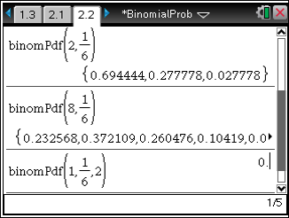
Instruct students to find binomPdf (2, 1 ) and
6
binomPdf (8, 1 ) . Ask how and why the distributions differ from binomPdf (5, 1 ) . Also ask which gives the
6
6
greater probability of exactly two successes and why. Then have them find binomPdf (1, 1 ,2). Encourage them to discuss why the probability is zero. (There cannot be two successes in only one trial!)
6
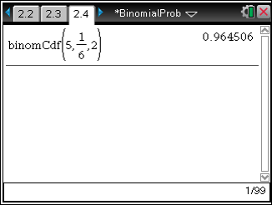
Next, students will use the binomCdf command, which gives cumulative probabilities. Tell students to move to page 2.4 and enter the command binomCdf(5,1/6,2) and verify that the resulting probability equals P(0) + P(1) + P(2).
To access the binomCdf command, students can use the Catalog or select MENU > Probabilities > Distributions > Binomial Cdf.
Allow students to check other cumulative probabilities as well.
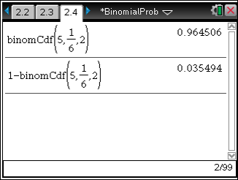
Ask students how they can use that result to find the probability of at least three successes
(P(3) + P(4) + P(5)).
This can easily be found by calculating the complement of binomCdf (5, 1 ,2) , as shown to the
6
right.

Problem 3 – Using the formula
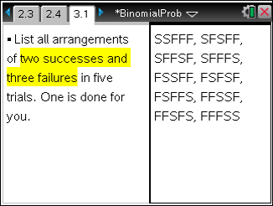
On page 3.1 or on the worksheet, students should list all arrangements of two successes and three failures.
Ask how many arrangements there are. (10—shown to the right) Then ask students how they might find the probability of any one of the arrangements. Since the trials are independent, they should determine that they need to multiply the probabilities of successes and failures. For example, for the arrangement SSFFF, the

probability is
1 ⋅ 1 ⋅ 5 ⋅ 5 ⋅ 5 .
6 6 6 6 6

Show that although the factors are in a different order, the probability of each arrangement is the same. Because there are 10 arrangements, the total probability of two successes in
6
( )

five trials when
p = 1
is 10 1 ⋅ 1 ⋅ 5 ⋅ 5 ⋅ 5 .
6 6 6 6 6

Introduce the formula for finding the binomial probability of r successes in n trials where p is the probability of success and q is the probability of failure: P(r ) = C ⋅ pr ⋅ qn −r .
n r
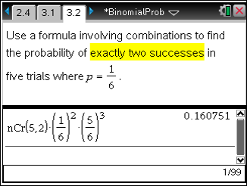
Have students advance to page 3.2 and use this formula to find the probability of exactly two
6

successes in five trials when
p = 1 . Students

will see that they get the same answer they did when using the binomPdf command.
To access the Combinations command, select MENU > Probability > Combinations, and type the values of n and r inside the parentheses.

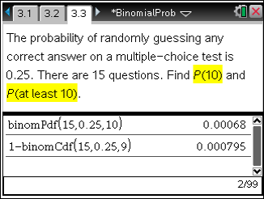
Allow students to work independently on the questions from page 3.3.
P(10) = 0.00068
P(at least 10) = 0.000795

TI-Nspire Navigator Opportunities

Note 1
Problem 1, Quick Poll
You may choose to use Quick Poll to assess student understanding. Ask questions about the probability distribution such as: Why do the probabilities get closer to zero towards the right side of the table?

