About the Lesson  A hot drink gradually cools off but how can the cooling process be described? In this activity, students will collect data as a heated temperature sensor cools for three minutes, graph the cooling curve, and determine a model to fit the temperature versus time data.  Students will:  - Collect temperature versus time data of a cooling object and graph a scatter plot.  - Model the temperature versus time data with an exponential equation in the form y = a(b)^{x} + c.  Vocabulary  - Horizontal Asymptote  - Vertical Translation  - Exponential function  Teacher Preparation and Notes  - This activity provides an opportunity for math-science connections.  - Students should be familiar with exponential functions and horizontal asymptotes.  - This activity is best performed with at least two students: one to hold the temperature sensor and one to run the calculator.  Note: After students have determined the values of a and c in their equation, you may wish to have them determine the value of parameter b using the Transfrm App. Ensure that students understand the effects of increasing and decreasing the value of b.  Activity Materials  - TI-84 Plus CE  - Vernier® EasyTemp Sensor for each group of students  - Cup of hot water (approximately 45 to 55 degrees Celsius) for each group of students  - Recommended: TI-SmartView™ CE Emulator Software for the TI 84 Plus Family | 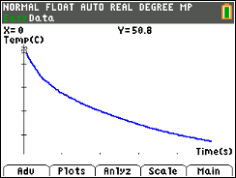  Tech Tips:  - This activity includes screen captures taken from the TI-84 Plus CE. It is also appropriate for use with the rest of the TI-84 Plus family. Slight variations to these directions may be required if using other calculator models.  - Access free tutorials at http://education.ti.com/calculators/pd/US/Online-Learning/Tutorials
Introduction
When you heat a liquid and then remove the liquid from the heat, the liquid cools at a certain rate.
In this activity, a temperature sensor will be heated in a cup of hot water for approximately 30 seconds and then removed from the water. Temperature versus time data will be collected for three minutes after the sensor is removed from the hot water. A mathematical model will be determined to describe the temperature of the sensor as a function of time.
Before collecting data, predict how the graph of temperature as a function of time would look after the heated sensor is removed from the hot water. Sketch your prediction to the right. Be sure to label the axes.  Write a sentence to explain why you think the graph will look like your prediction. |  | 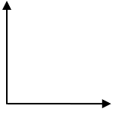
Setup
- This activity is best performed with at least two students: one to hold the temperature sensor and one to run the calculator.
- Connect the Vernier EasyTemp sensor to the TI-84 Plus CE. The Vernier EasyData® App launches automatically when you plug in the sensor.  Note: In the EasyData App, the tabs at the bottom of the screen indicate the menus that can be accessed by pressing the calculator keys directly below the tabs.  Note: The default unit of measurement in the EasyData App for the EasyTemp sensor is degrees Celsius. The ambient room temperature is displayed.  Note: The current Mode is Time Graph, and the default data collection duration is 180 seconds.  - Before collecting data, record the ambient temperature of the room.  Ambient temperature: _______________  Sample Answer: Answers will vary. For the sample data, the ambient temperature is 24.8 degrees Celsius. |  | 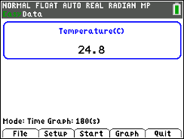
Data Collection
- Obtain a cup of hot water and place the EasyTemp sensor in the water. After it has heated for approximately 30 seconds, remove the sensor from the water and immediately press q to select Start.

Note: The EasyTemp sensor should be held still.

- After the data collection is complete, the temperature versus time graph is displayed. A graph of sample data is shown at the right.

Note: If it’s necessary to repeat the data collection, press s to select Main, and then press q to select Start. You will need to press s to overwrite the latest run.
- Sketch a graph of your data on the grid at the right.  Note: Label the axes. Be sure to include units.  How does the graph of your data compare to your prediction? |  | 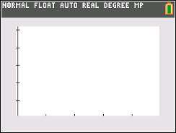
- Exit the EasyData App by pressing s to select Main. Press s again to select Quit.  - Time data are stored in L1, and temperature data are stored in L2.  - Press s to select OK. |  | 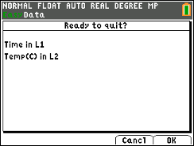
- Press y ,. Press · to select Plot 1. If Plot 1 is not turned on with the configuration shown at the right, turn Plot1 on and select L1 for the Xlist and L2 for the Ylist.  - Press q ® to select ZoomStat and your data will be displayed. |  | 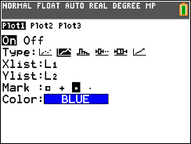
- Adjust the window to display a minimum temperature of 0 degrees Celsius.  - Press p, arrow to Ymin, and enter 0.  - Press s. |  | 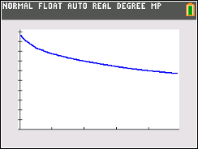
Data Analysis
- You will fit a model to your data.
- What type of function might be a good fit for your temperature versus time data?

Sample Answer: Answers will vary.

- As the time increases, the graph of your data should level off and approach (but not necessarily reach) a certain temperature value. What temperature should the sensor be approaching?

Sample Answer: The temperature should approach the ambient room temperature.

- A horizontal asymptote is a horizontal line that a graph approaches. Record the equation of the horizontal asymptote for your graph.

Sample Answer: Answers will vary, but the equation should be of the form y = k with a value of k that is the ambient room temperature. For the sample data, y = 24.8.

- Graph your horizontal asymptote.

Tech Tip: Press o and enter the equation of your asymptote. Press s.
Alternatively, from the Graph screen, press y <, and select Horizontal. Use the up or down arrow key to move the horizontal line. To delete the horizontal line, y <, and select ClrDraw.

- A model for this cooling curve is an exponential function of the form y = a(b)^{x} + c.

- How does the equation of the horizontal asymptote relate to the value of c?

Sample Answer: Answers will vary but the value of k in the equation of the horizontal asymptote should be close to the value of c.

- Based on the graph of your data, what is the value of c? ___________ (Be sure to include units.)

Sample Answer: Answers will vary. For the sample data, c is 24.8 degrees Celsius, the temperature of the room.

- What does the value of c represent in the exponential function?

Answer: The vertical translation of the function y = a(b)^{x}.

- Press r, and trace to the y-intercept of your temperature versus time graph.

- Use the coordinates of the y-intercept and the value of c to determine the value of a in the function y = a(b)^{x} + c.

Sample Answer: The y-intercept for the sample data is (0, 50.8). Using c = 24.8, the equation is 50.8 = a(b)⁰ + 24.8. a = 26

- What is the value of a? _____________ (Be sure to include units.)

Sample Answer: Answers will vary. For the sample data, a = 26 degrees Celsius.

- What does the value of a represent?

Answer: The difference between the temperature of the sensor when it was removed from the hot water (at time t = 0) and the value of c (the ambient room temperature).

- Based on the graph of your data, should the value of b in the function y = a(b)^{x} + c be between 0 and 1 or greater than 1? Justify your answer.

Sample Answer: Since the temperature values are decreasing as time goes by, the value of b should be between 0 and 1.

Note: This would be a good time to discuss exponential decay.

- Estimate a value for b. _____________________

Sample Answer: Answers will vary, but the value should be between 0 and 1.

- What does the value of b represent?

Sample Answer: The parameter b represents the percentage of the temperature the probe retains each second.
- Press o. Using the values you determined for a and c and your estimate for the value of b, enter the equation of your function in the form y = a(b)^{x} + c. Press s.

- If the graph of your function does not fit the data well, press o, adjust the value of b, and regraph. (If necessary, also adjust the values of a and c.)

- What is the equation of the function that best fits the data? _________________________

Answer: Answers will vary.

- If you collected data for more than three minutes, would the graph of the data eventually cross your horizontal asymptote? Justify your answer.

Answer: No. The graph of the data will approach but not cross the horizontal asymptote. The location of the horizontal asymptote is the room temperature, and the temperature of the sensor could not go below room temperature.

