Focus: Find patterns in perimeters.
Perimeter Patterns

Collecting and Organizing Data
Our first four or five similar shapes:

Our data is recorded here:
Shapes | Perimeter
1 (st)
2 (nd)
3 (rd)
4 (th)
5 (th)
6 (th)
•
•
•
Analyzing data and Drawing Conclusions
- A pattern we discovered in our table is:
- The 95th shape will have a perimeter of _____. We know this because:

Questions we thought of while we were doing this activity:

Perimeter Patterns
Pattern Blocks

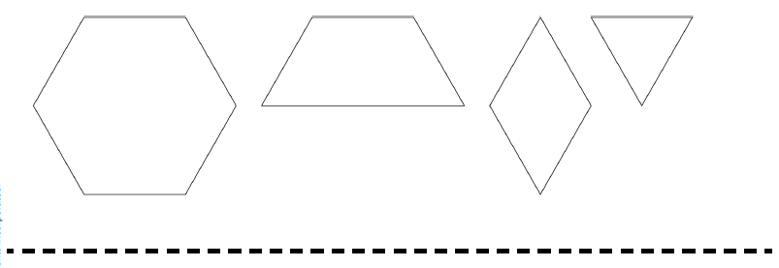
Other Geometric Shapes

