Problem 1 – Proof of the Pythagorean Theorem
We will begin this activity by looking at a right triangle and the square formed by each of the three sides of the right triangle. On page 1.3, you are given right triangle ABC. The spreadsheet on page 1.4 contains 3 columns: asquared, bsquared, csquared, and asquared + bsquared.
1. On page 1.3, grab and drag point B, and then press / + ^. Repeat this move three times. This process will collect data on page 1.4. Record the data you collected below.
Position | a² | b² | c² | a² + b²
1
2
3
4
2. What do the squares on each side of right triangle ABC represent?

3. How does the area of the two smaller squares compare to the larger square?

4. How are a² and the square on side a (side BC) related?

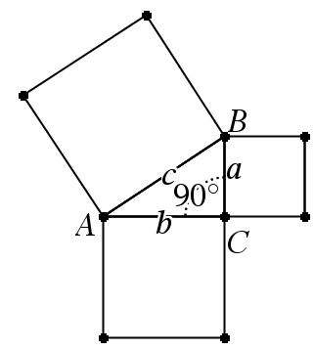
5. How are a² + b² and c² related?

Problem 2 – President Garfield’s Proof of the Pythagorean Theorem
On page 2.2, you are given right triangle ABC and a congruent triangle with a segment connecting them to form a trapezoid. You will use the area of a trapezoid and the area of the three triangles to prove the Pythagorean Theorem.
6. Using the formulas for area, set the area of the trapezoid equal to the sum of the area of all three triangles and simplify. Remember that the area of a triangle is .

7. State the Pythagorean Theorem.

Problem 3 – Proof by Dissection of the Pythagorean Theorem
On page 3.2, you are given right triangle ABC and three squares representing a², b², and c². Using page 3.2, answer the following questions.
8. What square represents c²?

9. What square represents b²?

10. What square represents a²?

11. What does this dissection tell you about the area of c² and the areas of a² and b²?

12. How does the dissection relate to the Pythagorean Theorem?

Problem 4 – Application of the Pythagorean Theorem
Find the length of the third side given two sides of the triangle.
13.  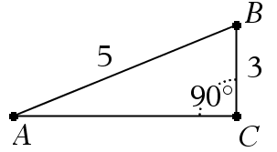 | 14.  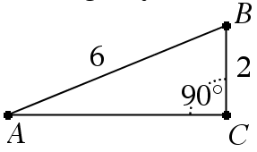
15.  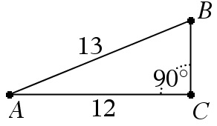 | 16.  