Math Objectives
- Determine domain and range in real-world situations.
- Writing and graphing equations to model problems.
- Recognize the meaning of domain and range in the real-world situations.

Vocabulary
- domain
- range

About the Lesson
- This lesson is a follow-up lesson to the activity Domain and Range 2.
- This lesson involves identifying the domain and range in a real- world problem and writing equations to model the situation.

Related Lessons
- Prior to this lesson: Domain and Range 2

Lesson Materials:
Student Activity AppDomainRange_Student.pdf AppDomainRange_Student.doc
TI-Nspire document
AppDomainRange.tns

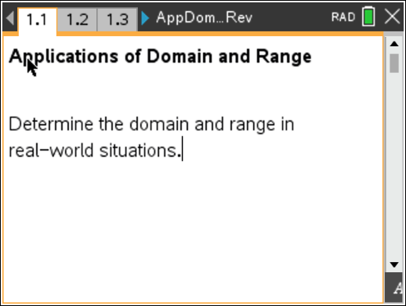

Discussion Points and Possible Answers
Teacher Tip: The template to enter piecewise defined functions can be found under the t menu.

Jessie is parking is parking in a garage for a concert. It costs $6 for the first 2 hours, an additional $3 for each additional hour or fraction of an hour, with a maximum charge of $24 for a day.

Move to page 1.2.

- In this situation, what represents the domain?

Answer: The time in the parking garage is the domain.

- What variable is associated with the range?

Answer: The cost to park is the range.

- What piecewise defined function represents the total cost?

⎧6, 0 ≤ x ≤ 2
Answer: y = ⎪6 + 3 , 2 < x ≤ 8
⎨ ⎡x − 2⎤
⎪24, 8 < x ≤ 24
⎩
Teacher Tip: Students may not relate the maximum value of y to the maximum
amount the parking bill could be. Help them find the maximum number of hours that would determine the maximum parking bill.

On page 1.7, graph the equations you determined above. You may need to try several approaches before finding the correct graph.

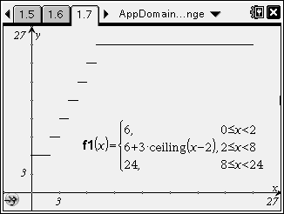
- Sketch your graph here.

Sample Answer: See graph at right.

- State the domain and range.

Answer: domain: 0 ≤ x ≤ 24 range: {6, 9, 12, 15, 18, 21, 24}

Move to page 2.1.

Peter needs to fill up his truck with gasoline to drive to and from school next week. If gas costs $2.79 per gallon, and his truck holds a maximum of 28 gallons, analyze the domain, range, and function values through the following questions.

- In words, what is the domain of the situation? On the graph, where can you find domain?

Answer: The domain is the number of gallons of gas purchased. On the graph, this is the possible
x-values.

- In words, what is the domain of the situation? On the graph, where can you find domain?

Answer: The range is the costs of the gasoline. On the graph, this is the possible y-values.

- If Peter purchases zero gallons, what is the cost?

Answer: $0

- If Peter purchases 10 gallons, what is the cost?

Answer: $27.90

- What is the maximum Peter can spend?

Answer: $78.12, assuming the gas tank is completely empty.

- Write an equation that models the total cost of the gas.

Answer: y = 2.79x, 0 ≤ x ≤ 28

On page 2.9, graph your equations and determine if they accurately represent the situation. If not, modify and graph again.

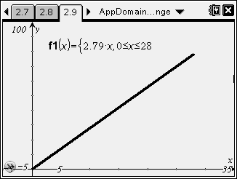
- Sketch your graph here.

Sample Answer: See graph at right.

- State the domain and range of this situation.

Answer: domain: 0 ≤ x ≤ 28; range: 0 ≤ x ≤ 78.12

- State the domain and range of this situation.

Answer: domain: 0 ≤ x ≤ 28; range: 0 ≤ x ≤ 78.12

- Summarize what you have found in this lesson. Explain how and why the domain and range are different between the two examples in this activity.

Sample Answer: In the first example, the domain is continuous from 0 to 24 and the range is discrete from 0 to 24. In the second example, the domain is continuous from 0 to 28 and the range is continuous from 0 to 78.12. The ranges are different because in the first example, the range is only certain values, since the charge is the same amount for a fraction of an hour as for an hour. The range in the second example is continuous because Peter can purchase a fraction of a gallon of gas.

Wrap Up:
Upon completion of the discussion, the teacher should ensure that students are able to:
  - determine the domain and range of a real-world situation
  - relate the domain and range to the variables in the problem
  - determine if the graph correctly shows the expected domain and range

