Activity Overview
In this activity, students will explore how the constant of variation, k, affects the graph of direct and inverse variations. Students will apply what they have learned to real world problems. As an extension or homework, students determine the type of variation of the given graph and then calculate the constant of variation.
Time Required: 45 minutes

Topic: Sequences, Series & Functions
- Direct Variation
- Indirect Variation
- Hyperbolas
- Constant of Variation

Associated Materials
- Variation_Student.doc
- Variation.tns
- Variation_Soln.tns

Problem 1 – Effect of k on direct variation
On page 1.2, students are introduced to the definition of direct variation. You may want to give further explanation of the constant of variation, k.  Students are to drag the slider to change the value of k, which then changes the graph, y = kx. They should observe the graph for positive and negative values of k.  Then students are to answer the questions on pages 1.4 to 1.8. Overall, students should notice that k affects the slope of the line and that the x- and y-values increase or decrease together.  Discussion Questions:  - How does direct variation relate to linear functions?  - Why must k be a non-zero number? | 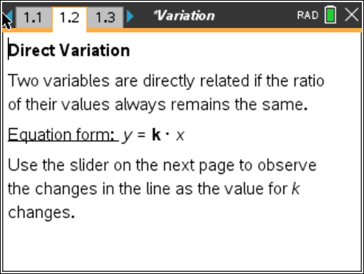  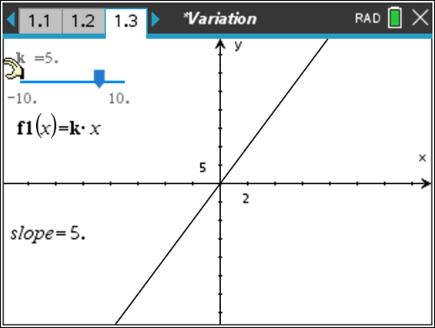
Problem 2 – Application of direct variation
On page 2.1, students are given an example of direct variation, an hourly employee. They are to determine which part of the equation represents the constant of variation (wage).  First, students are to rewrite the direct variation equation for different values of wages. Then students will use a graph of the function and a point on the graph to determine the amount of money the employee will make for a certain number of hours. To change k, students can drag the slider or click once on the number and change it.  Ask students if they can think of an example of an employee whose paycheck is NOT represented by a direct variation (i.e., a salaried employee). | 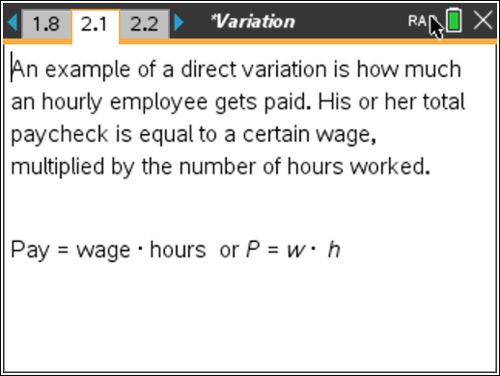  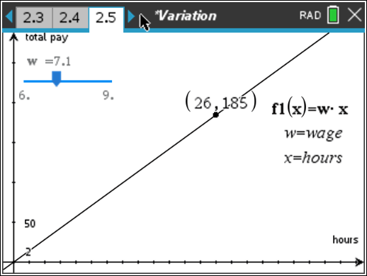

Problem 3 – Effect of k on inverse variation
On page 3.1, students are introduced to inverse variation. They should see that now k is divided by x, instead of multiplied by x.  Once again, students are to investigate the effect of k on the graph of an inverse variation by dragging the slider. Also shown on the screen are a point, which can be moved, and the product of the x- and y-coordinates of this point.  Then students are to answer the questions on pages 3.3 to 3.6. Overall, students should notice that k affects how close the graph comes to the origin and that the x- and y-values increase or decrease opposite of each other.  Discussion Questions:  - How are the graphs different from direct variation? Why are they different?  - Why must k be a nonozero number?  - Do we need both branches of the graph?  - How does the product of the coordinates of a point on the graph relate to the constant of variation? | 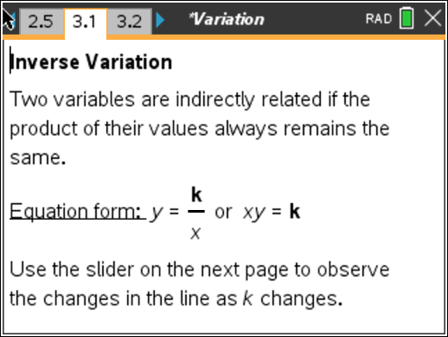  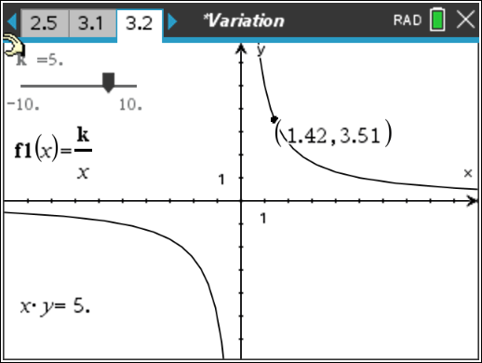
Problem 4 – Application of inverse variation
On pages 4.1 and 4.2, students are given a example of inverse variation, an salaried employee. They are to determine which part of the equation represents the constant of variation (salary).  First, students are to rewrite the inverse variation equation for different weekly salaries. Then students will use a graph of the function and a point on the graph to determine the amount per hour an employee will make for a certain number of hours worked.  To change k, students can drag the slider or click once on the number and change it. To change the point, students can either drag it or click twice on  the x-coordinate to change it. | 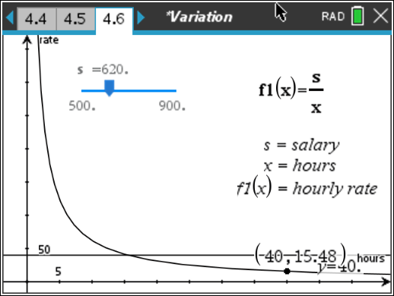

Problem 5 – Extension/Homework Problems
Students will examine a graph of a variation equation with a point labeled. They should find the value of the constant of variation and then write the equation on their worksheet.  For direct variation, students calculate k by dividing y by x and for inverse variation, they calculate k by multiplying x and y.  If students want to check their work on the TI-Nspire document, have them use the Text tool to write their equation on the screen. Then drag the equation to the axes. If they only see one graph, then their answer is correct. If they see two graphs, then they should revised their equation and try again.  Students can also check the calculation of k using the Text and Calculate tools from the Actions menu.  Discussion Questions:  - How do you know which variation equation to use?  - How can you use the point to find k?  - Can there be more than one equation for the graph? | 