Math Objectives  - Students will explore arithmetic sequences and series.  - Students will consider the effect of the value for the common difference and first term using Lists and sum commands.  - Students will graphically analyze the arithmetic sequences using graphs.  - Students will try to make a connection with how to understand these topics in IB Mathematics courses and on their final assessments.  Vocabulary  - Arithmetic Sequence • Common Difference  - Arithmetic Series • Explicit Formula  About the Lesson  - This lesson is aligning with the curriculum of IB Mathematics Applications and Interpretations SL/HL and IB Mathematics Approaches and Analysis SL/HL  - This falls under the IB Mathematics Core Content Topic 1 Algebra:  1.2a Arithmetic sequences and series  1.2b Use of the formula for the n^{th} term and the sum of the first n terms of the sequence  1.2d Applications  - As a result, students will:  Apply this information to real world situations  Teacher Preparation and Notes  - This activity is done with the use of the TI-84 family as an aid to the problems, specifically using Lists to input and generate sequences and the sum command to find a series.  - This activity serves as a nice introduction to arithmetic series.  Activity Materials  - Compatible TI Technologies:  TI-84 Plus*, TI-84 Plus Silver Edition*, TI-84 Plus C Silver Edition, TI-84 Plus CE  * with the latest operating system (2.55MP) featuring MathPrintTM _{functionality.} | 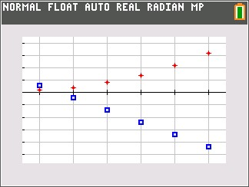  Tech Tips:  - This activity includes screen captures taken from the TI-84 Plus CE. It is also appropriate for use with the rest of the TI-84 Plus family. Slight variations to these directions may be required if using other calculator models.  - Watch for additional Tech Tips throughout the activity for the specific technology you are using.  - Access free tutorials at http://education.ti.com/calculators/pd/US/Online-Learning/Tutorials  Lesson Files:  Student Activity  Arithmetic_Sequences_and_Series_Student-84.pdf  Arithmetic_Sequences_and_Series_Student-84.doc
Teacher Tip: It would be beneficial for students to clear all lists and functions. Press y Ã and select ClearAllLists. Press o, move to any equation that is defined and press ‘.

Students should begin this activity knowing that a sequence is an ordered list of numbers that follows a pattern and that a series is an indicated sum of a sequence. For example,
1, 2, 3, 4 is a sequence and 1 + 2 + 3 + 4 is a series.

Part 1 – Sequences and Scatter Plots  Students are to create a new data table by pressing … and choosing Option 1: Edit under the EDIT menu. Instruct them to copy the data shown into L₁ and L₂.  Find the differences between consecutive terms of the sequence in L₂, and record them in L₃. They can either use the list/row numbers, L2(2)– L2(1), or the actual numbers, such as 8.75–7.5.  Students will then enter the terms of a sequence into L4, find the consecutive differences for the L4 sequence, and record them in L5.  For each sequence, graph the ordered pairs formed by the domain (the natural numbers listed in L1) and the terms of the sequence.  Students will plot L2 in Plot1 and L4 in Plot2. The Xlist for both plots should be L1. Have them press q and select 9:ZoomStat to view the plots. If they have trouble viewing both plots together, have them turn off one plot and then the other |  |  | 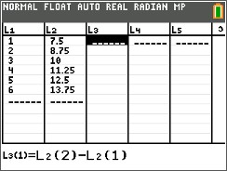  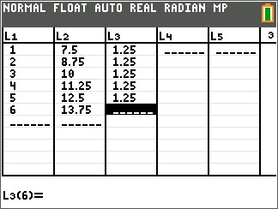  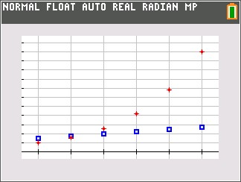
1. For each sequence, write the differences between the consecutive terms and give a description of the scatter plot.
- Sequence L2
Answer: 1.25, 1.25, 1.25, 1.25, 1.25. Possible answer: The points of the scatter plot form a straight line that slants up to the right.
- Sequence L4
Answer: 3, 5, 8, 13, 21. Possible answer: The points of the scatter plot form a curve.

- Study the graphs and the differences you found in L3 and L5. Make a conjecture.
Answer: Students should make conjectures about the scatter plot of a sequence and the differences between the consecutive terms. They should conjecture that for sequences with a common difference, the points form a straight line.

Now students are to clear the data from L2, L3, L4, and L5 but leave the numbers in L1. To do this, they can arrow up to the top of each list and press ‘ Í.  After entering the sequences shown at the right into L2 and L4, they will find the differences between consecutive terms, recording them in L3 and L5.  Students can press q and select 9:ZoomStat to view the plots of the sequences. |  |  | 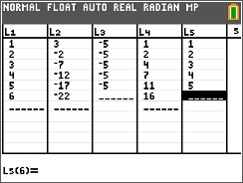
2. For each sequence, write the differences between the consecutive terms and give a description of the scatter plot.
- Sequence L2
Answer: –5, –5, –5, –5, –5. Possible answer: The points of the scatter plot form a straight line that slants down to the right.
- Sequence L4
Answer: 1, 2, 3, 4, 5. Possible answer: The points of the scatter plot form a curve.

- With a classmate, discuss how your observations affect your conjecture about the scatter plot of a sequence and the differences between the consecutive terms. Share your discussion with the class.
Answer: Students should find that the new data reinforces their conjecture that for sequences with a common difference, the points form a straight line.

Part 2 – Explicit Formulas and Sums  Students are shown the general explicit formula for an arithmetic  sequence.  $$u_{n}= u_{1}+ \left(n-1\right)∙d$$  They are to generate a sequence in L2 to display the first 30 terms of $u_{n}=7.5+ \left(n-1\right)∙1.25$. They will use the sequence  command by pressing y … [list], arrow over to the OPS menu and select seq(.  For the Expr, enter 7.5 + (N–1)*1.25. This is the explicit formula for this sequence (u₁ is 7.5 and d is 1.25). N is the variable, 1 is the first term (start), 30 is the number of terms (end), and the step is 1.  Note: N is selected by using the ƒ key.  Now students are to simplify the formula $u_{n}=7.5+ \left(n-1\right)∙1.25$  by distributing and combining like terms to get: u_{n} = 1.25n+ 6.25.  They need to use this formula and the sequence command to generate 30 terms of this sequence in L3.  Note: It is not necessary that students number L1 all the way to 30. |  | 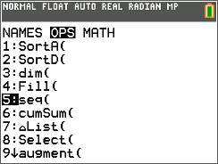  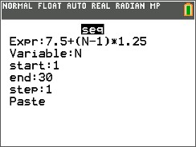  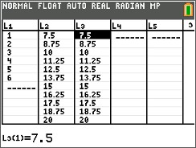
3. Simplify the formula $u_{n}=7.5+ \left(n-1\right)∙1.25$ by distributing and combining like terms. Use this formula in the sequence command to generate 30 terms of this sequence in L3.
Explain what you notice about the terms in L2 and L3.

Answer: The terms that appear in L₂ and L₃ should be the same.

Part 3 – Practice Finding the Sum of a Series  Now students are to find the sum of the first 30 terms of the  sequence from problem 2. The expression consisting of summing  the terms in a sequence is called a series.  On the Home screen students are to enter sum(L2). The sum command can be entered by pressing y … [list], arrow over to the MATH menu and select sum(. |  | 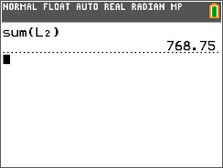
- Find the sum of the first 30 terms of this sequence in L₂ algebraically. Check your result using the sum command.  Answer: 768.75  Now they are to find the sum of the first 80 terms of the sequence below, using the Lists feature and the sum() command.  62, 67, 72, 77, 82…  Students will need to clear their L2 and L3 lists and use the same procedure as before. |  | 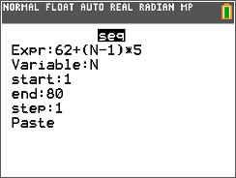
- Now, let’s look at another sequence. Find the sum of the first 80 terms of the sequence below, using the Lists feature and the sum() command.  62, 67, 72, 77, 82…  - Find the explicit formula for this sequence in simplified form.  Answer: $u_{n}=5n+57$  - What is the sum of the first 80 terms?  Answer: 20,760 |  | 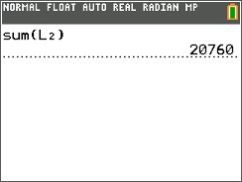

Further IB Extension
The Clemson Tigers football team play in the multilevel Memorial stadium. The closer you are to the field, the higher the ticket prices. The ticket prices for the first 4 rows of a Tigers football game are as follows:
Row 1: $120 per ticket; Row 2: $117 per ticket; Row 3: $114 per ticket
These ticket prices continue in an arithmetic pattern.

(a) Find the common difference between each consecutive row price. [1 mark]
Answer: $d=114-117=117-120= -3$ A1
The ticket prices go down by $3 each row.

(b) Calculate the price of a ticket in row 20. [2 marks]
Answer: $u_{20}=120+ \left(20-1\right)\left(-3\right)$ (M1)
$= 120+ \left(19\right)\left(-3\right)$
$=120-57$
$=63$ A1

(c) Find the total cost of buying 2 tickets in each of the first 20 rows. [3 marks]
Answer: $S_{20}= \frac{20}{2}\left(2\left(120\right)+\left(20-1\right)∙\left(-3\right)\right) or S_{20}= \frac{20}{2}\left(120+63\right)$ (M1)
$=10\left(240-57\right) =10\left(183\right)$
$=10\left(183\right) =1830$
$=1830$ A1
Multiplying their sum by 2 (tickets)
$2(1830)$
$=\$3660$ A1

**Note: This activity has been developed independently by Texas Instruments and aligned with the IB Mathematics curriculum, but is not endorsed by IB™. IB is a registered trademark owned by the International Baccalaureate Organization.

