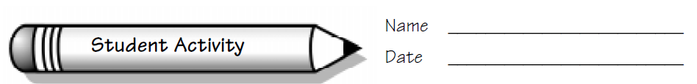

**Dividing Notes: First Things First**

**Focus: Using division in music**

**The Problem**

What do fractions have to do with music?

Look at the music called *Waltz in C*. What fraction do you see at the beginning? This fraction is called the *time signature*.

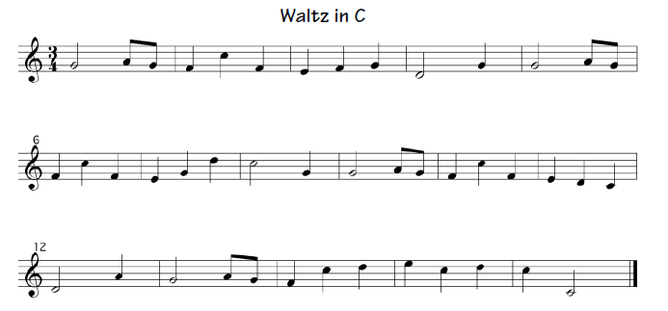

In this music, and .

**Working the Problem**

1. A conjecture is mathematical hypothesis. Make a conjecture about how these fractions relate to the time signature.
2. Using the fraction values for each note, add up all of the notes. What is the total?
3. Divide the total by the time signature. What number do you get?

4. Count the number of vertical lines in the music. These are called bar lines. They separate the music into measures. How many measures are there in the music?

What is the fractional value of each measure?

5. Write a statement about the relationship of the time signature and the total note values.

6. Look at the conjecture you wrote. Does the information you have now support your conjecture?

If your conjecture is not supported, write a new conjecture about the relationship between the time signature and the note fractions.

7. Look at the music *March*. What is the time signature for *March*?

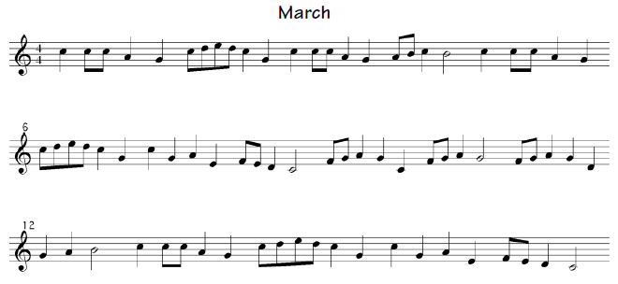

8. Using the fraction values for each note, add up all of the notes. What is the total?

9. Divide the total by the time signature. How many measures should there be?

What is the fractional value of each measure?

10. Based on the fractional value of each measure, draw the bar lines.

11. How did the fraction of the time signature help you draw the bar lines?

**Dividing Notes**

**The Problem:** How can division with fractions help solve a music problem?

Oscar Semiquaver, the forgetful composer, has written a new melody. Unfortunately, he left off all of the note stems and the bar lines. In fact, he made all of the notes look like whole notes, but he only wanted one whole note in the melody. Your team has been asked to fill in the note heads of the notes that should be filled in, add the stems to the notes that need them, and add the bar lines to his melody.

**The Facts**

* The time signature is a fraction. This fraction indicates the total value of notes in each measure.
* The value of each note is a fraction. This chart shows the fractional value of each note.

|  |  |  |
| --- | --- | --- |
| Name | Symbol | Value |
| Whole note |  |  |
| Half note |  |  |
| Quarter note |  |  |
| Eighth note |  |  |
| Eight notes  (written as two eighth notes) |  |  |

* Bar lines are used to divide the notes into measures.
* Complete measures have exactly the same fractional value as the time signature. If the value of each note in a measure is added, it equals the fraction of the time signature.
* Incomplete measure are allowed as the first and last measures of the music. These two incomplete measures must add up to the value of a complete measure.
* Adding values to the notes heads is adding the rhythm to the music. The note heads indicate the pitches only.
* Only one whole note can be used in the melody. Whole notes are often used as the last note, but they can be anywhere in the melody.
* Half notes, quarter notes, and eighth notes can be used in many different combinations to make up a measure of music.

**The Task**

1. Your team will create a chart or display.

* The display will show the new melody with stems added to the note heads and bar lines added to the music. Each measure must contain the same value as the time signature. Every measure in your melody must be a complete measure. Make sure the fractional values in each measure add up to the value of the time signature.
* The display will also include a title and the fractional value of each note. If you have someone from your group who can play the melody, have them play it for the class. If not, an adult will perform your melody.

2. Each person on the team will write an explanation of the team’s solution. This explanation will answer the following questions:

* How did your team decide to add the stems to the notes? How did your team decide what value each note would have?
* How did your team check to make sure each measure is complete? How did you use the TI- in this process?
* Name two different ways you can change the rhythm of the melody and still have complete measures. How do you know these two ways will work?
* What would happen to the melody if you changed the time signature to 5/4? What would you need to do to each measure and to the bar lines? Would there still be the same number of measures? How do you know?



**C:\Users\Karen\AppData\Local\Temp\Temp1_Texas Instruments - Icon rendering.zip\Texas Instruments - Icon rendering\JPEG\Calculator icon.jpg**

**Dividing Notes: Using the TI-15**

