Problem 1 – Explore and discover
The graph at the right is the curve y = x².  Your challenge is to think of at least two ways to estimate the area bounded by the curve y = x² and the x-axis on the interval [0, 1] using rectangles. Use the following guidelines:  - all rectangles must have the same width  - you must build all your rectangles using the same methods  - the base of each rectangle must lie on the x-axis | 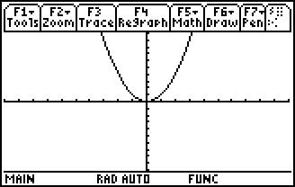
Graph y = x² and set your window to [–0.1, 1] for x and [–0.2, 1.3] for y. Draw your first and second method on the graphs below. For each method calculate the following:
- Number of rectangles
- Height and width of each one
- Area of each
- Sum of the area
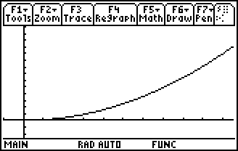
- Which method did a better job?

- How could you improve on it?

In the following problem, you will examine three common techniques that use rectangles to find the approximate area under a curve. Perhaps you discovered some of these techniques during your exploration in the above problem. The first problem uses rectangles whose right-endpoints lie on the curve y = x².

Problem 2 – Using five right-endpoint rectangles
Divide the interval [0, 1] into five equal pieces. Enter the information for each interval or rectangle in the table below. Remember that the right endpoint is the x-value and the height is the y-value of the right endpoint on the curve.
Interval | Right Endpoint | Height | Area

The formula that can be used to express the total area is:
R₅ = 0.2 ∙ f1(0.2) +0.2 ∙ f1(0.4) + 0.2∙f1(0.6) + 0.2∙f1(0.8) + 0.2 ∙ f1(1.0)
or
R₅ = 0.2[f1(0.2) +f1(0.4) +f1(0.6) + f1(0.8) + f1(1.0)]
- Calculate this sum.

- Now add up the numbers in the Area column.

- Are these two numbers the same or different?

Another way to find the area of the rectangles is using sigma notation.
- Write the notation in the form. Adjust what is being summed.

To sum it on the calculator, use Home > F3:Calc > 4:Σ( sum for the command with the format:
- Does this agree with the answer for the area you found previously?

Problem 3 – Using five left-endpoint rectangles
This problem uses rectangles whose left-endpoints lie on the curve y = x².
Divide the interval [0, 1] into five equal pieces. Enter the information for each interval in the table below. Remember that the left endpoint is the x-value and the height is the y-value of the left endpoint on the curve.
Interval | Left Endpoint | Height | Area

The formula that can be used to express this area is:
L₅ = 0.2 ∙ f1(0) +0.2 ∙ f1(0.2) + 0.2∙f1(0.4) + 0.2∙f1(0.6) + 0.2 ∙ f1(0.8) or
L₅ = 0.2[f1(0) +f1(0.2) +f1(0.4) + f1(0.6) + f1(0.8)]
- Calculate this sum.

- Now add up the numbers in the Area column.

- Are these two numbers the same or different?

- What is the sigma notation for the area of the rectangles?

- Use the calculator to find the sum. Does this result agree with the answer above?

Problem 4 – Using five midpoint rectangles
We will now investigate a midpoint approximation. How would you draw five rectangles, with equal width, such that their midpoints lie on the curve y = x²?
Divide the interval [0, 1] into five equal pieces. Enter the information for each interval or rectangle in the table below. Remember that the midpoint is the x-value and the height is the y-value of the midpoint on the curve.
Interval | Midpoint | Height | Area

The formula that can be used to express this area is:
M₅ = 0.2 ∙ f1(0.1) +0.2 ∙ f1(0.3) + 0.2∙f1(0.5) + 0.2∙f1(0.7) + 0.2 ∙ f1(0.9) or
M₅ = 0.2[f1(0.1) +f1(0.3) +f1(0.5) + f1(0.7) + f1(0.9)]
- Calculate this sum.

- Now add up the numbers in the Area column.

- Are these two numbers the same or different?

- What is the sigma notation for the area of the rectangles?

- Use the calculator to find the sum. Does this result agree with the answer above?

Problem 5- Summarize your findings
In this activity, you explored three different methods for approximating the area under a curve. The exact area under the curve y = x² on the interval [0, 1] is or 0.333.
- Which approximation produced the best estimate for the actual area under the curve?

- Describe which factors contribute to left, right, and midpoint rectangles giving overestimates versus underestimates.

- What can you do to ensure that all three of these techniques produce an answer that is very close to ? Test your conjecture by using evaluating a sum that produces a much more accurate answer.

