Open the TI-Nspire document Wondering About Waves.tns.  Have you ever seen a crowd do “the wave” in a stadium? A section of people stand up and sit down, and then the section next to those people stand up and sit down, and this process repeats all around the stadium. In this process, a wave is transmitted by a crowd of people. Waves on a spring are transmitted in a similar way. In this activity, you will explore some of the different properties of waves on a spring. | 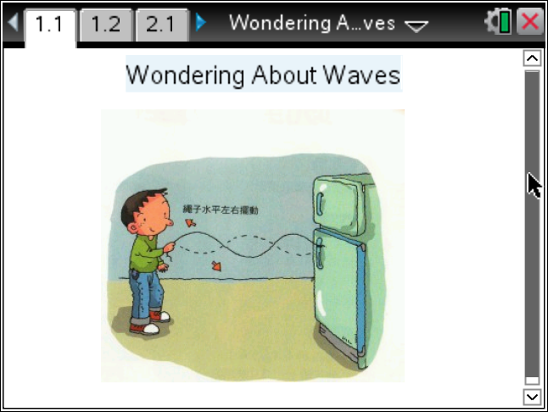

Move to pages 1.2 - 1.3 and read the background information for this activity.
A wave is a disturbance that transmits energy through space. For example, consider a spring that is pulled tightly and fixed to a wall at one end. If you hold the free end and move it up and down, a pulse, or disturbance, will move along the spring. The disturbance that moves along the spring transmits the energy that you initially put into the spring when you moved it up and down. When the disturbance on the spring reaches the fixed end, it will reflect backwards along the spring towards you. If you shake the spring up and down at a specific rate, the pulse moving down the spring will interfere with the reflected pulse to create a standing wave pattern. You will explore some of these patterns in this activity.

Waves have different properties. The height of a wave is called the amplitude. The rate at which a wave vibrates is called frequency. If you shake a spring up and down, the rate at which you shake your hand will determine the frequency of the wave on the spring. The distance over which a wave completes one full cycle is called the wavelength. For waves on a spring, there are some frequencies at which the wave will vibrate with a very large amplitude. This phenomenon is called resonance. The frequencies at which resonance occurs are called resonant frequencies. There are many different resonant frequencies for a spring, and each one will produce a different standing wave pattern. Different standing wave patterns are called harmonics.

Move to page 1.4 and answer the question below.
Q1. A spring is fixed to the wall at one end. You are shaking the free end of a spring at different frequencies. How will you know when you are shaking the spring at a resonant frequency?
Move to page 1.5.  Read the directions for the simulation.  - Begin by observing the fundamental frequency of the spring. To do this, select Menu > Wondering About Waves > Fundamental. Then, select the play button to begin the simulation. Record the observed resonant frequency and energy of the spring in the table. |  | 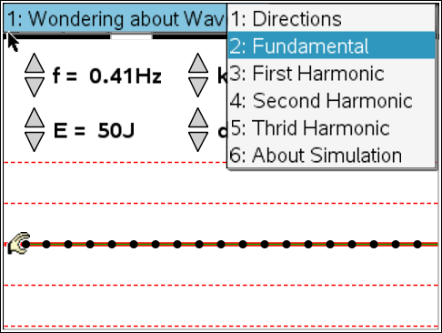
Harmonic Mode | Observed Resonant Frequency (Hz) | Energy (J) | Actual Resonant Frequency (Hz)
Fundamental |  |  | f₁ =
Second |  |  | f₂ =
Third |  |  | f₃ =
Fourth |  |  | f₄ =
2. Use the up and down arrows (¤ and £) to set the energy to 20 J. Observe what happens to the wave form. Then, use the up and down arrows to increase the frequency of the wave pulse. Do this until you observe the second harmonic mode. Record the observed resonant frequency and energy in the table.  3. Increase the energy to 100 J. Increase the frequency until you observe the third harmonic mode. Record the observed resonant frequency and energy in the table.  4. Increase the energy to 200 J. Increase the frequency until you observe the fourth harmonic mode. Record the observed resonant frequency and energy in the table.  5. Check your observed resonant frequencies with the actual resonant frequencies for each mode. To do this, select Menu > Wondering About Waves and then select the second, third, and fourth harmonic modes. Observe the actual resonant frequencies and wave forms for each mode. Record these frequencies in the table. |  | 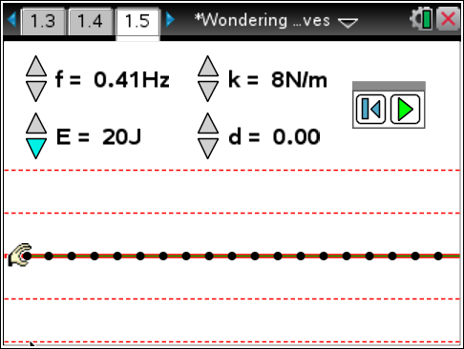
Tech Tip: To access the Directions again, select > Wondering About Waves > Directions.

Tech Tip: To access the Directions again, select b or Document Tools () > Wondering About Waves > Directions.
Move to pages 1.6 -1.10.
Answer questions 2 – 6 below and/or in the .tns file.

Q2. What happens when you increase the energy of the wave pulse in the simulation?

A. The frequency of the wave increases.
B. The wavelength of the wave increases.
C. The amplitude of the wave increases.
D. The speed of the wave increases.

Q3. In which harmonic mode does the wavelength of the standing wave equal the length of the spring?

A. fundamental harmonic
B. second harmonic
C. third harmonic
D. fourth harmonic

Q4. Observe the value of the actual fundamental resonant frequency, f₁. Compare this value to the other resonant frequencies by performing the following calculations:

f₂/ f₁ =
f₃/ f₁ =
f₄/ f₁ =

Q5. Is there a pattern between higher harmonic frequencies and the fundamental frequency? Explain.

Q6. When you pluck a guitar string, you hear one note. This corresponds to the fundamental resonant frequency of the string. However, as you saw in this simulation, a string will resonant at many different frequencies. Why is it that you only hear one main frequency when you pluck a guitar string? (Hint: Return to the simulation and set the energy to 20 J. Then, observe the wave form at each of the different resonant frequencies. What do you notice about the amplitude of the higher harmonics?)

Move to pages 2.1 – 2.2.
6. Move to the page in your document with the animation of a light wave. Select and drag the slider to adjust the wavelength of the light. Observe how the waveform changes. |  | 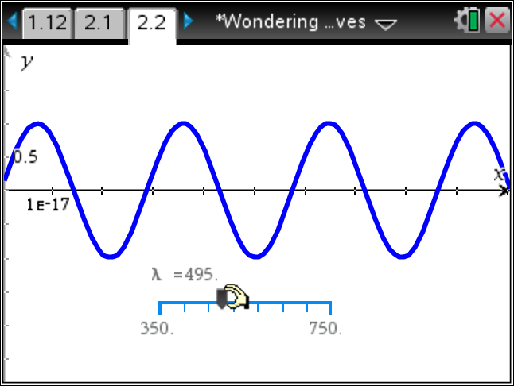
Move to page 2.3.
Answer question 7 below and/or in the .tns file.

Q7. List two ways that the electromagnetic wave is different than the standing wave on the spring.

