Selecting and dragging an object with Cabri Jr.
  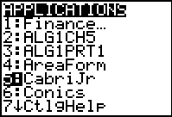   | 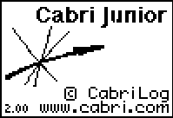
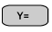 | We have created a new work space
 | Move the cursor to any location  Press 

What you see is your pointer displayed as a “hollow” arrow. This indicates a selected object.

You will also see that the point is “active”.

Move the cursor off the point until it is a solid arrow and then move it back to select the object again.
Once an object is selected you can move it by pressing  | As you can see the cursor is now a closed hand. Move the cursor and you will see how to drag a point.  After this press
Now we can label the point.  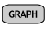 | Note the cursor is again in a new form. Press to open a text box.

Now Press  (A) | The point is now labeled A and the label is attached to the Point.
Move the cursor and select the point. Press
and watch the point and the label move on your screen.

Selecting and moving any object is done in the same manner.

Draw a line, a segment, a triangle and then select and drag each object.

