Shuffleboard Slide with Proportions
In this project, you will create a disk gliding game (shuffleboard). The game lets us the user “aim” at a triangle scoreboard. Once the user presses “clear”, the disk will slide a random distance forward toward the scoreboard. The score will be determined based on the final resting location of the disk. You are tasked with writing the code to create the scoreboard and determine a score for each disk. The rest of the code will be provided by your teacher.  *Note: Your calculator needs the additional ti_draw.8xv AppVar which is available in the OS and Apps bundle version 5.7 for the handheld. | Objectives:
Programming Objectives:
- Use the draw_poly() function to draw triangles
- Use the set_color() function to set pen colors
- Use the randint() function to generate random integers.
- Use if statements to make conditional decisions
Math Objectives:
- Draw polygons on the coordinate plane
- Use ratios and proportions to transform units
- Decide whether two quantities are proportional
- Use proportions to create scaled polygons
- Draw geometric shapes using coordinates and technology
Math Course Connections: Middle School Mathematics
In this project, you will create a disk gliding game, “shuffleboard”. The game lets the user “aim” at a triangle scoreboard. Once the user presses “clear”, the disk will slide a random distance forward toward the scoreboard. The score will be determined based on the final resting location of the disk. You are tasked with writing the code to create the scoreboard and determine a score for each disk. The rest of the code will be provided by your teacher. Note: Your calculator needs the additional ti_draw.8xv AppVar which is available in the OS and Apps bundle version 5.7 for the handheld.
Sample Game:
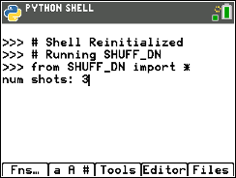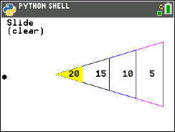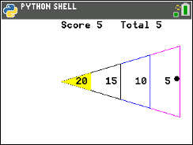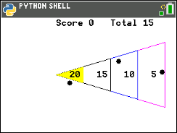
User selects 3 disks Disk slides vertically until After “clear” key is pressed, Final score displayed after
the user presses “clear” key the disk slides random distance all disks are played
- Obtain a copy of the “slideTMP.8vx” from your teacher. This contains the initial code for the project.

- Let’s examine the code.  Use the functions to aim, slide and score for each disk  Get the number of disks, initialize some variables  Libraries needed for the projects  Animation code for “clear” slide key  Animation code to slide the disk towards board  *You will add the 12 lines to draw the points board  *You will add the 11 lines to score the location of the disk after the slide. |  | 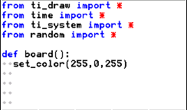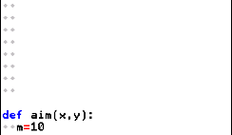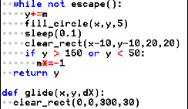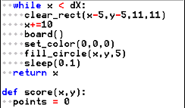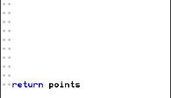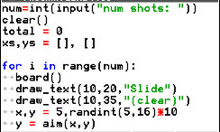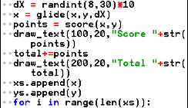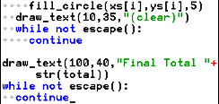  Display the final score after clearing old values
- Let’s first execute the initial code [trace], to see where we are.  Enter 3 for the number of shots.  Observe the disk sliding back and forth before the  “clear” key is selected.  After pressing clear” three times, the game is over.  The final score displays.  Your disks will be in different locations. The location  depends on when you press the “clear” key as well as  the random distance the disk travels.  Doesn’t look too much like a shuffleboard right now, but it will, after we add some additional code! |  | 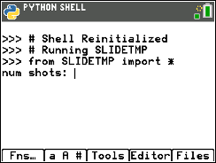  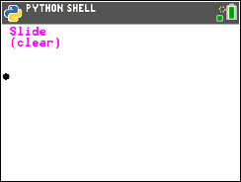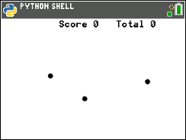
- Before programming the score board, we need to investigate its composition. Once you understand the board’s proportional relationships, you can code it using the drawing tools.

- Below is a scaled and deconstructed version of the scoring board.

Use a ruler to measure the height and base length for each triangle in centimeters.
Then calculate $\frac{height}{base}$.
Triangle | Side 1 (cm) | Side 2 (cm) | Height (cm) | Base (cm) | $$\frac{height}{base}$$
a

b

c

d

- What do you notice about $\frac{height}{base}$ for all 4 triangles?

- There are a few more observations to be made.
 | Fraction | Decimal | Percent
$$\frac{triangle a height}{triange d height}$$
$$\frac{triangle b height}{triange d height}$$
$$\frac{triangle c height}{triange d height}$$
$$\frac{triangle a height}{triange c height}$$

- You know how the four triangles are related. Now to scale these values to match the calculator screen. The largest triangle is 200 pixels by 120 pixels. Use your relationships from the steps above to find the height and base for the three smallest triangles. | Triangle Height (pixels) Base (pixels)  a  b  c  d 200 120

- Show work or explain how you found the height and base length for triangle a.
- Show work or explain how you found the height and base length for triangle b.
- Show work or explain how you found the height and base length for triangle c.

- The largest triangle will have a vertex at (100,105). The height is 200 pixels while the base is 120 pixels. Where are the other two vertices?
- Look at the two vertices you calculated.
i. Because the highest vertex is directly above the lowest vertex, your x-coordinates should be the same.
ii. Subtract your smallest y-coordinate from the largest coordinate.
Is the distance 120 pixels?
iii. The y-value 105 should be the middle y-coordinate for the 120-pixel base.
Find the average of your two y-coordinates. Is the average 105?

- To draw the triangle, start at (100,105). Draw a segment to (300,145). Then draw a segment to (300,165). Finally draw a segment back to (100,105).  The command draw_poly, requires the list of x-values in order of travel as well as the y-values in order of travel. The x values are [100, 300, 300, 100]. The y-values are [105,45,165,105].  Add the following code to line 8 just below the set_color in the board function:  draw_poly([100,300,300,100],[105,45,165,105])  [y=] Modul ti_draw draw_poly  Make sure the draw_poly line is indented two spaces.  That means there should be two diamonds in front of this line. | 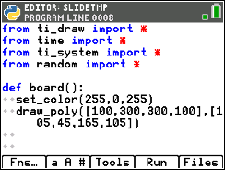
- Execute your code [trace]. Enter “1” for the number of shots. You need at least one shot for the board to appear.  If everything is typed correctly, you shouldn’t have any errors in your code. If you have an error, fix the error before you continue. Mostly likely, your error is on the draw_poly line of code. Make sure all the parenthesis (), square brackets [] and commas, are correct. | 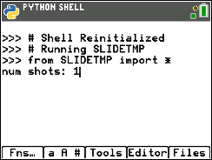  Example Run: 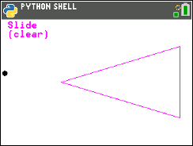
- The line set_color(255, 0, 255) sets the pen color to magenta before the darw_poly line is executed. Magenta is made with 255-red, 0-green, 255- blue.

This set_color function needs three colors, red, green, and blue.
set_color(255,0,0) is red. 255 red, 0 green, 0 blue
set_color(0,255,0) is green. 0 red, 255 green, 0 blue
set_color(0,0,255) is blue. 0 red, 0 green, 255 blue
set_color(255,255,0) is yellow. 255 red, 255 green, 0 blue
You can pick any integer values from 0 to 255 for each red, blue, green.
You may choose to change this color or keep it magenta. If you choose to change the color, execute your code to ensure you’ve entered valid integers.

- In step 7, you found the height and base for the 2nd largest triangle.  Use these values to find the other two vertices (a,b) and (c,d). | (a,b) = ( , )  (c,d) = ( , )
- Starting at the point (100,105), trace around the smaller triangle.
Record the x-values for the vertices in order [100, ____ , ____, 100]
Record the y-values for the vertices in order [105, ____, ____, 105]
- Change the color in the board function to blue, or any other color.  Draw the new triangle.  set_color(0,0,255)  draw_poly([100, _ _ _, _ _ _, 100],[105, _ _, _ _ _, 105])  *set_color [y=] Modul ti_draw control set_color  *to copy and paste a line of code, put the cursor on the line to copy,  [zoom] 6 Copy Line  [zoom] 7 Paste Line Below | (You shouldn’t have _ _ _ in your code. You should have the correct values you found in step 15).
- Execute your code [trace]. Enter “1” for the number of shots.  Does it give you the picture to the right?  (Your disk could be in a different location)  If you have an error, fix it. If the new triangle isn’t correct, re-evaluate the numbers in your last draw_poly. | 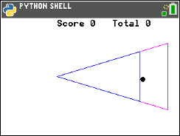
- Repeat the same process for the 2nd smallest triangle.  Look back at step 5 to find the dimensions for the triangle.  Find the values for the two vertices | (x,y) = ( , )  (m,n) = ( , )
- Change your pen color to black or a color of your choosing.  Plot your new triangle.  set_color(0,0,0)  draw_poly([100, _ _ _, _ _ _, 100],[105, _ _, _ _ _, 105])  Execute your code. Verify the new triangle is in the correct location. | (You shouldn’t have _ _ _ in your code. You should have the correct values you found in step 18).  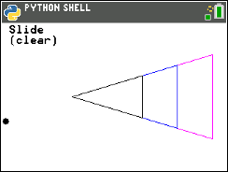
- Repeat the same process for the smallest triangle.
Look back at step 5 to find the dimensions for the triangle.
Find the values for the two vertices
- Instead of draw_poly, you will use fill_poly to fill in the triangle.  If r = 255 and g = 255, set_color(255,255,0) will produce yellow.  You may choose a different color if you like.  set_color(255,255,0)  fill_poly([100, _ _ _, _ _ _, 100],[105, _ _, _ _ _, 105])  Verify your code works. | (You shouldn’t have _ _ _ in your code. You should have the correct values you found in step 20).  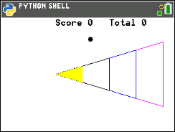
- Now to label the point values.  Points a, b, c and d will be halfway between the left and right boundary of the scoring zones. Where should each point lable be placed? | a. ( , )  b. ( , )  c. ( , )  d. ( , )
- Change the pen color back to black.  set_color(0,0,0) | 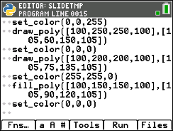
- The command draw_text(x,y,string) will draw on the screen.  To draw the first value type  draw_text(125,115,”20”)  [y=] Modul ti_draw draw_text | 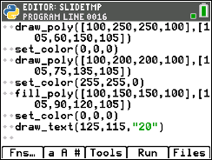  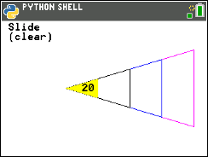
- Use the values you found in step 22 to draw the remaining values.  draw_text(_ _ _,115,"15")  draw_text(_ _ _,115,"10")  draw_text(_ _ _,115,"5")  Execute your code. Make sure the labels appear in the correct location. | (You shouldn’t have _ _ _ in your code. You should have the correct values you found in step 22).  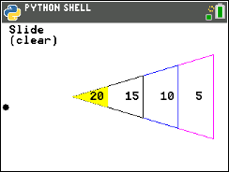
- Your game is almost complete. All you need to do is code the scoring mechanism. How do you score points?
How do you know if the disc is inside a scoring region or outside a scoring region?
Let’s look for a scoring pattern.
Caculate the rate of change between the distance the disc travels past the closest vertex on the x-axis and the distance from the line of symmetry.
$$\frac{60}{200}=0.3$$ | $$\frac{ }{ }≈$$ | $$\frac{ }{ }≈$$ | $$\frac{ }{ }≈$$

$$\frac{60}{200}=0.3$$ | $$\frac{ }{ }≈$$ | $$\frac{ }{ }≈$$ | $$\frac{ }{ }≈$$

Look at all the shots in step 26 that would earn points. How do they compare to the gameboard rate of 0.3?
Look at all the shots that would not earn points. How do they compare to the gameboard rate of 0.3?
Complete the following statement.
In order to earn points,
the disc x value must be greater than or equal to 100, less than or equal to _________
and $\frac{y distatance past 105}{x distance from 100}$ must be ____________

- Now to translate your word statement above, called psuedo code into Python.
if x >= 100 and x <= 300 and abs((y – 105)/(x – 100)) <= 0.3:
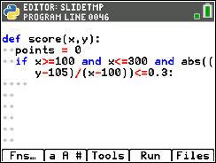
Add this line of code to the score function.
Make sure you include a colon, : , at the
end of the line.
if
[y=] ctl if
>=, <=, and
[2nd] [ math ]

abs
You need the absolute value function to measure the distance from the line of symmetry.
If a disc is within the boundaries to score points, how many points should the user get?
To earn 20 points, the x value should be between _______ and _____.
To earn 15 points, the x value should be between _______ and _____.
To earn 10 points, the x value should be between _______ and _____.
To earn 5 points, the x value should be between _______ and _____.
Explain or show how you found the boundaries above.
- Use your answers from step 27 to fill in the Python template:  if x >= ___ and x < ___:  points = 20  elif x >= ___ and x < ___:  points = 15  elif x >= ___ and x < ___:  points = 10  elif x >= ___ and x < ___:  points = 5  **elif [y=] ctl elif  Notice the indenting in the picture on the right. The new if, elif, else statements need indented two spaces from the original if. The points = lines are indented two additional spaces from the if, elif, else statements. | (You shouldn’t have _ _ _ in your code, you should have the correct values you found in step 27).
- Execute your code.  Play your game three times.  Each time enter 3 shots.  Verify your boundaries create the correct score.  If they are not correct, re-evaluate your work in step 27.  Two example runs are shown on the right. | 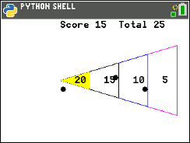  (We will discuss this case in the next step, why might this score be an issue?)
- The code was written using the CENTER of the disk and the assumption it would land inside the triangle. The picture to the right has two discs with centers outisde the triangle, however, parts of the circles overlap the triange. These two discs are not counted in the score.The same issue happens if the center goes past the large triangle. How might we adjust the code to fix this?
- The disc radius is 5 pixels.
That means, instead of using the ratio $\frac{60}{200}=0.3$, we should use $\frac{65}{200}=0.325$.
Modify the first if statement in the score function to accommodate this adjustment.
- Instead of making 300 the maximum x value, what should it be?  Change the maximum x value from 300 to the new x value.  Instead of making 100 the minimum x value, what should it be?  Change the minimum x value from 100 to the new x value. | (You should have the new value where the _ _ _ is in the highlighted line)
- Play your game several times. Make sure the modifications we made to the code work correctly.

