Math Objectives  - Students will use sinusoidal regression to determine equations to model various sets and use the equations to make inferences.  - Students will have discussions about their results and apply them to real world situations.  - Students will try to make a connection with how to understand these topics in IB Mathematics courses and on their final assessments.  Vocabulary  - Sinusoidal • Regression • Radian Measure  About the Lesson  - This lesson is aligning with the curriculum of IB Mathematics Approaches and Analysis SL/HL  - This falls under the IB Mathematics Content Topic 3 Geometry and Trigonometry 3.7:  (a) The circular functions sin x, cos x, and tan x ; amplitude, their periodic nature, and their graphs  (b) Composite functions of the form $f\left(x\right)=a\sin\left(b\left(x+c\right)\right)+d$  (c) Transformations  (d) Real-life contexts  As a result, students will:  - Apply this information to real world situations.  TI-Nspire™ Navigator™  - Transfer a File.  - Use Class Capture to examine patterns that emerge.  - Use Live Presenter to demonstrate.  - Use Teacher Edition computer software to review student documents.  - Use Quick Poll to assess students’ understanding  .  Activity Materials  Compatible TI Technologies: TI-Nspire™ CX Handhelds,  TI-Nspire™ Apps for iPad®, TI-Nspire™ Software | 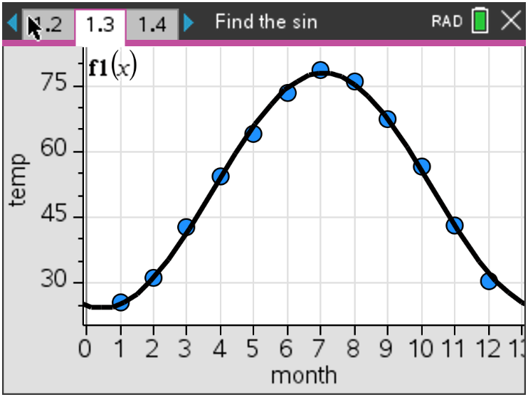  Tech Tips:  - This activity includes screen captures taken from the TI-Nspire CX II handheld. It is also appropriate for use with the TI-Nspire family of products including TI-Nspire software and TI-Nspire App. Slight variations to these directions may be required if using other technologies besides the handheld.  - Watch for additional Tech Tips throughout the activity for the specific technology you are using.  - Access free tutorials at http://education.ti.com/calculators/pd/US/Online-Learning/Tutorials  Lesson Files:  Student Activity  Find That Sine_Student-Nspire.pdf  Find That Sine_Student-Nspire.doc  FindThatSine.tns
In this activity, you will use the data in the file FindThatSine.tns, which contains the temperatures and hours of sunlight in Kansas City, and the heights of tides in the Bay of Fundy. You will find the equations of Sine curves that model the given data and answer several questions about what you have found.

**Note: Make sure that your handheld is in Radian mode.
Teacher Tip: To see the data for this activity, the FindThatSine.tns file either must be downloaded to your student’s handhelds or you must give them the data for each problem and have them answer the questions accordingly. The file is there to make visuals and analyzing easier to understand.

Problem 1 – Temperature

In this problem, you will graph data and find a sinusoidal function.

The temperature in Kansas City fluctuates from cold in the winter to hot in the summer. The average, monthly temperature (°F) has been entered into the list and spreadsheet on page 1.3. After your teacher has transferred the file to your handheld, open the file and read through pages 1.1 and 1.2.
Find the equation that models the data. Place the cursor on cell c1 and select Sinusoidal Regression from the Stat Calculations menu.

On page 1.4, create a scatter plot for this data (Menu, 3 Graph Entry/Edit, 6 Scatter Plot)

(a) Write the sine equation that models the data in the form $y=a ∙\sin\left[bx+c\right]+d$.

Solution: $f\left(x\right)=26.75\sin\left(0.47x-1.80\right)+51.1$

On page 1.4, press tab, the up arrow and then enter to see the sine regression stored in f1(x)
from the temp data. Move to page 1.5.
(b) Discuss with a classmate how well the sine curve of regression models the data. Share your
thoughts with the class.
Possible Discussion: The equation is a good fit for the data. The set of data is periodic. It
repeats the same cycle every 12 months.
(c) Move to page 1.6. Find the approximate temperature in Kansas City on March 15. Explain if this
is a reliable temperature you found.

Solution: Approximately, between 47 and 48 degrees (47.6°). Since this value is for
March, within the given data set (interpolation), it is reliable.

(d) Using your sine curve of regression, estimate when your temperature will reach 85° in Kansas
City and give an explanation of your results.

Solution: Since the average temperatures have a maximum of approximately 77.8°, the
temperature will never reach 85° given this data set to be modeled.

Teacher Tip: This may be a good time to discuss the reliability of making predictions within the given data set and outside the given data set. Also, teachers may want to demonstrate how to find these estimates using the regression curve by placing a point on the curve to find the March 15th temperature and using the Graphs Trace function to find the maximum.

Problem 2 – Hours of Sunlight

Move to page 2.1, then 2.2. The amount of light a location on the Earth receives from the Sun changes each day depending upon the time of year and latitude of that location. The amount of daily sunshine Kansas City experiences has been recorded in the lists on page 2.3 where the calendar day is in day, and the hours of sunlight is light.
Move to page 2.4 and create the scatter plot and sine equation that models the data as outlined in Problem 1. To create the scatter plot, make sure to change the X List to day and the Y List to light.
In early cultures, certain days of the year had significant importance because of the planting cycle. These days were the winter and summer solstices, and the spring and fall equinoxes. The equinoxes are the days with equal amounts of light and dark. The summer solstice has the greatest amount of sunlight, while the winter solstice has the fewest amount of sunlight.

(a) Rounding to the nearest hundredth, write down the sine equation.

Solution: $f\left(x\right)=2.80\sin\left(0.02x-1.38\right)+12.00$

(b) Discuss with a classmate how well the sine curve of regression models the data. Share your
thoughts with the class.
Possible Discussion: The equation is a good fit for the data. The set of data is periodic. It
repeats the same cycle every 365 days.

(c) Move to 2.5. Find the equinox dates using your sine curve of regression.

Fall Equinox ____________________ Spring Equinox ___________________

Solution: The vernal (spring) equinox is on 81.64 calendar days or March 22. The
autumnal (fall) equinox is on 266.97 calendar days or September 22.

(d) Move to 2.6. Find the date of the summer solstice (day with the greatest amount of sunlight).

Summer Solstice ____________________

Solution: The summer solstice is on 173.3 calendar days or June 22.

(e) Move to 2.7. Find the date of the winter solstice (day with the fewest amount sunlight).

Winter Solstice ____________________

Solution: The winter solstice is on 357.76 calendar days or December 22.

Problem 3 – Tides

Move to page 3.1. The Bay of Fundy has the highest tides in the world. If a tape measure were attached at the water line of a peer, and the water level height were recorded over a period of eighteen hours, data like that in the list and spreadsheet on page 3.2 would be generated.
Create the scatter plot and sine equation that models the data as outlined in Problems 1 and 2. To create the scatter plot, make sure to change the X List to time and the Y List to height.

(a) Rounding to the nearest hundredth, write down the sine equation.

Solution: $f\left(x\right)=4.44\sin\left(0.52x-3.11\right)+6.22$

(b) Discuss with a classmate how well the sine curve of regression models the data. Share your
thoughts with the class.

Possible Discussion: The equation is a good fit for the data. The set of data is periodic.
It repeats the same cycle every 12 hours.

(c) Using the sine curve of regression for the data, predict the water level when the time is 49 hours
after the readings were started. Share one or more ways you can attain this answer by using
your TI-Nspire CX II handheld.

Solution: At 49 hours, the water will be at approximately 4.52 feet.

Teacher Tip: It will be useful at some point to check your student’s handheld knowledge when it comes to making these predictions using the regression curve. As mentioned before, going to the geometry and using the point on tool is useful, as is the graph trace function. You may also want to remind them that drawing horizontal lines and finding points of intersection can be helpful.

Further IB Applications

The height of the tides off the coast of Fripp Island, SC is modelled by the function
$H\left(t\right)=a sin\left(b\left(t-c\right)\right)+d$, where t is the number of hours after midnight, and a, b, c, and d are constants, where a > 0, b > 0, and c > 0. The following graph shows the water for 15 hours, starting at midnight.

The first high tide occurs at 7:10 am and the next occurs 12 hours later. Throughout the day, the height of the water fluctuates between 6.9 ft. and 0.4 ft. All heights are given correct to one decimal place.

(a) Show that $b= \frac{π}{6}$.

Solution: $\frac{2π}{b}=12$ $12b=2π$ $b= \frac{2π}{12} or \frac{π}{6}$
(b) Find the value of a.

Solution: $\frac{max-min}{2}= \frac{6.9-0.4}{2}= \frac{6.5}{2}=3.25$

(c) Find the value of d.

Solution: $\frac{max+min}{2}= \frac{6.9+0.4}{2}= \frac{7.3}{2}=3.65$

(d) Find the smallest possible value for c.

Solution: Substituting t = 7:10 am (7.167) and H = 6.9 ft into their equation for H
$6.9=3.25\sin\left(\frac{π}{6}\left(7.167-c\right)\right)+3.65$
$c≈4.167$

(e) Find the height of the tide at 12:00 pm.

Solution: Using the full equation found from parts (a) – (d), plug in t = 12 or t = 0
$H=0.98808…$

(f) Determine the number of hours, over a 24 hour period, that the tide is over 4 ft.

Solution: Solve the equation $4=3.25\sin\left(\frac{π}{6}\left(x-4.167\right)\right)+3.65$
$t=4.37, 9.96$ and $t=16.37, 21.96$
Between each of those pairs of solutions, the tide is over 4 ft.
9.96 – 4.37 = 5.59 and 21.96 – 16.37 = 5.59
5.59 + 5.59 = 11.18 hours the tide is over 4 ft in a 24 hour period

TI-Nspire Navigator Opportunity: Quick Poll (Open Response)
Any part to any Problem in the activity would be a great way to quickly assess your student’s understanding of Transformations.

Teacher Tip: Please know that in this activity there is a lot of time dedicated to students talking with one another and sharing their thoughts with the class. The goal here is to not only review sinusoidal regression and interpretation, but also to generate discussion.

**Note: This activity has been developed independently by Texas Instruments and aligned with the IB Mathematics curriculum, but is not endorsed by IB™. IB is a registered trademark owned by the International Baccalaureate Organization.

