Math 20P Quadratic Functions Tech Sheet

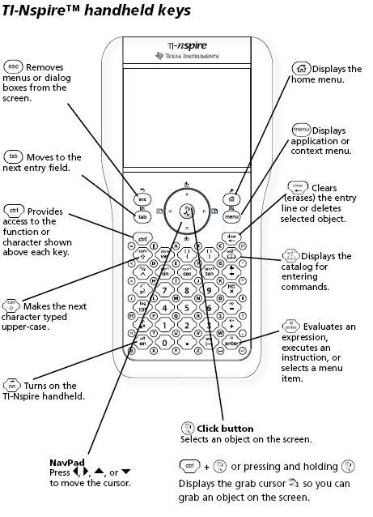

Pressing the home key c,
accesses the main home screen.

Begin a new document. Do not save
any existing documents.

Selecting New Document brings up the dialogue of adding an application page screen.

Enter equations in the function entry line.
Using escape d and tab e will move
the curser from the graph to the function entry
line and vise versa.

To create a graph enter the equation in the function entry line and press enter or the click key x.

