Orbit of Jupiter  TI-Nspire™ CX Family | Time required  45 minutes

Activity Overview
This activity explores models for the elliptical orbit of Jupiter. Problem 1 reviews the geometric definition of an ellipse as students calculate for a and b from the perihelion and aphelion of

Jupiter. Students then graph an ellipse using the Cartesian equation
x + y²
a2 b2
2
= 1 and discuss

the shortcomings of this method. Problem 2 develops the concept of a parametric curve by using a data capture to discover the coordinate equations of an ellipse. Problem 3 applies these equations to model of the orbit of Jupiter.

Topic: Conics & Polar Coordinates
- Graph the equation of any conic expressed in parametric form and identify its properties.

Teacher Preparation and Notes
- This activity is appropriate for an Algebra 2 or Precalculus classroom. This activity is intended to be teacher-led with students in small groups. You should seat your students in pairs so they can work cooperatively on their handhelds. You may use the following pages to present the material to the class and encourage discussion. Students will follow along using their handhelds.
- Students should have experience graphing ellipses and basic trigonometric functions.
- Notes for using the TI-Nspire™ Navigator™ System are included throughout the activity. The use of the Navigator System is not necessary for completion of this activity.

Associated Materials
- OrbitOfJupiter_Students.doc
- OrbitOfJupiter.tns
- OrbitOfJupiter_Soln.tns

Problem 1 – Graphing an Ellipse
The orbit of Jupiter is an ellipse with the sun at one focus. In this activity, students will develop and evaluate models, or equations, for Jupiter’s orbit.  Page 1.2 shows an animated model of Jupiter’s orbit. Discuss the orbit. What shape is it? In what direction does Jupiter move?  The orbit is elliptical, with the sun at one focus of the ellipse. Define perihelion and aphelion. |  |  | 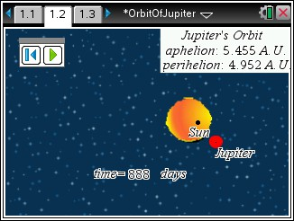
Jupiter’s perihelion, is 4.952 A.U. (astronomical units). This means that when Jupiter is closest to the sun in its orbit, it is 4.952 A.U. away.
Jupiter’s aphelion, is 5.455 A.U. (astronomical units). This means that when Jupiter is furthest from the sun in its orbit, it is 5.455 A.U. away.
We know the general equation of an ellipse centered at  x2 y2  (0, 0): + = 1. We can use this equation to model the  a2 b2  orbit, but first we have to find the values of a and b.  Direct students to the portion of their worksheet titled Building the Cartesian Model. There they will find detailed instructions on how to find a and b. |  |  | 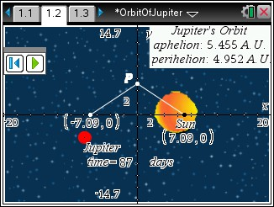
When students display the axes, they are in effect defining the center of the ellipse as the origin. Note: Students should not use the Coordinates and Equations tool to answer these questions, as the figure is not drawn to scale.
TI-NspireTM NavigatorTM Opportunity: Live Presenter, Quick Poll, and Class Capture
See Note 1 at the end of this lesson.
Solutions – Building the Cartesian Model
- (0, 0) | - (0.2515, 0) | - (–0.2515, 0) |  | - 5.2035 A.U.
- The sum of the distances from any point on the ellipse to the two foci is always equal. The point (5.2035, 0) is on the ellipse. (It is the rightmost point.) The distance from this point to the “sun” focus is the perihelion, 4.952 A.U. The distance from this point to the other focus is the aphelion, 5.455 A.U. Therefore the sum of the two distances, which will remain constant for every point on the ellipse, is 10.407, or 2a. The distance from point P to the “sun” focus is equal to the distance from point P to the other focus. Because the sum of these two distances must be 2a and the distances are equal, each
segment (hypotenuse) has length a.

- leg12 + leg22 = hyp2 ⇒ 0.25152 + b2 = 5.20352 ⇒ b = 5.20352 − 0.25152 ≈ 5.1974
Demonstrate how to store the values of a and b as variables on page 1.4. (Students can also use this calculator pane to calculate the values of a and b.) They should then enter the equation for the ellipse on page 1.5 using the Ellipse template (MENU > Graph Entry/Edit > Equation > Ellipse). | 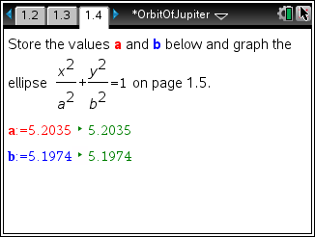
Discuss the model shown on page 1.5. Trace along the curves. How can we tell what direction Jupiter is traveling from this model? (We cannot.) If we move from the least x-value to the greatest, what sort of orbit does that describe? What about if we move from the least y-value to the greatest y-value? (Neither describes an orbit. Both would require two points to travel the two curves simultaneously.) | 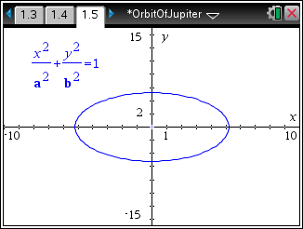
Direct students to answer the questions from the Evaluating the Cartesian Model section of their worksheet.

Solutions – Evaluating the Cartesian Model
- No. As x-increases, a point would move from left to right, then have to jump back to the left and start over again on the other function.
- It does not take time into account. Jupiter is at a certain place relative to the sun at a certain time, but time does not figure into these equations. It requires two functions instead of one. It relies on the square root function, which has a limited domain.
Problem 2 – A Parametric Model
This ellipse is one of many curves that cannot be expressed as a single equation in terms of only x and y. One better way to represent this type of curve is to use parametric equations. Instead of defining y in terms of x ( y = f(x) ) or x in terms of y ( x = g (y) ) we define both x and y in terms of a third variable called a parameter as follows.
x = f(t) y = g(t)
These equations are called parametric or coordinate equations. The third variable is usually denoted by t and often represents time. This makes parametric equations an especially good choice for the orbit of Jupiter.

Imagine taking snapshots of the position of Jupiter at different times as it orbited the sun. Then on each snapshot, measure the horizontal and vertical distance of Jupiter from the center of its orbit.
You could write a function that describes how the horizontal distance changes over time: x = f(t). You could also a function that describes how the vertical distance changes over time: y = g(t).
Each value of t defines a point (f(t), g(t)) that we can plot. The collection of points that we get by letting t be all possible values is the graph of the coordinate equations and is called the parametric curve.
But what are the coordinate equations? Let’s take another look at the ellipse. Have students complete the exploration in the Exploring Coordinate Equations section of their worksheet.  Solutions – Exploring Coordinate Equations  - Jupiter starts at its perihelion, at the rightmost point on the ellipse, and then moves counterclockwise around its orbit.  - Increases to 0; increases further to a | 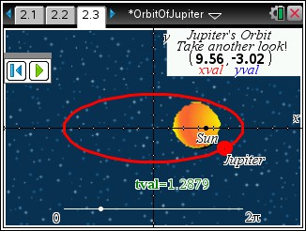
- The distance begins at 0, increases to b, decreases back to 0, decreases further to –b, and increases back to 0. Then the pattern repeats as Jupiter orbits again.
As the animation of Jupiter is playing, students are to press / ^ to capture the horizontal and vertical distances from the point on the ellipse to its center at time  t. They should work independently to gather 20 or more points. The data is recorded in the list on page 2.4. You may wish to use this data to confirm students’ responses to the questions in the Exploring Coordinate Equations section of their worksheet. | 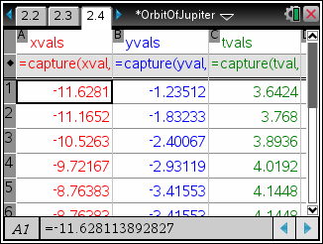
Students graph the xvals vs. the tvals on page 2.5 and the yvals vs. the tvals on page 2.6 and complete the relevant sections of their worksheet.  Solutions – Plot of x-values vs. t-values  - a cosine curve  - 12 and –12. These are the values of a and –a for the ellipse.  - x(t) = a cos(t) | 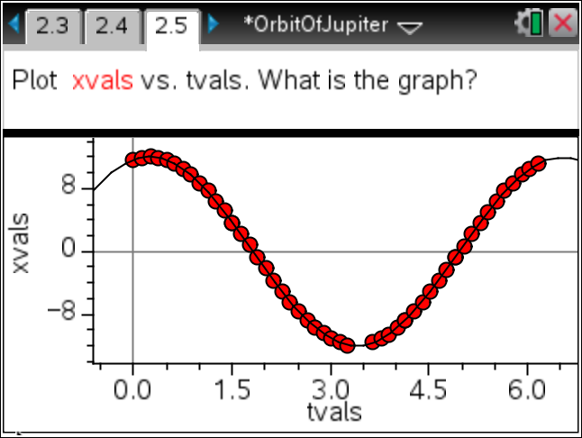

Solutions – Plot of y-values vs. t-values  - a sine curve  - 5 and –5. These are the values of b and –b for the ellipse.  - y(t) = b sin(t)  These are the coordinate equations of the ellipse! | 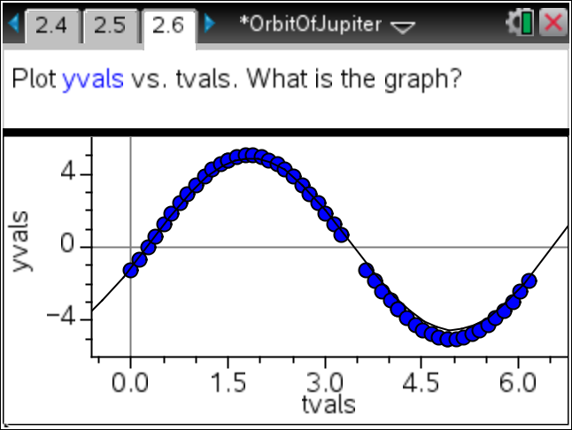
TI-NspireTM NavigatorTM Opportunity: Class Capture and Quick Poll
See Note 2 at the end of this lesson.
Problem 3 – Parametric Model of Jupiter’s Orbit
These two functions are the coordinate equations of the ellipse. They are usually written:
x(t) = a cos(t) y(t) = b sin(t) Students should check the equations on their worksheets.

Solutions – Checking the coordinate equations
x 2 + y 2 = ⇒ (a cos t )2 + (b sin t )2 = ⇒ a 2 cos2 t + b 2 sin2 t = ⇒
- a 2 b 2 1 a 2 b 2 1 a 2 b 2 1
cos2 t + sin2 t = 1 ⇒ 1 = 1
- x(t) = 5.2035 cos t; y(t) = 5.1974 sin t
Now that they have found the coordinate equations for Jupiter’s orbit, students graph the parametric curve. They must first change the graph type on page 3.2 to parametric (MENU > Graph Entry/Edit> Parametric) and then enter the appropriate equations in x1 and y1. They should use the numerical values of a and b, not the variables.  To animate the model, first draw a point on the curve. Then move the cursor over the point and press / b. Choose Attributes, then arrow down to the second attribute. Enter a value of 1 or 2 to set the animation  speed. | 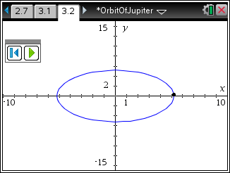

TI-NspireTM NavigatorTM Opportunities

Note 1
Question 1, Live Presenter, Quick Poll, and Class Capture
Use Live Presenter to display the orbit of Jupiter when the planet's orbit is animated. Use the display to solicit responses regarding the path of the orbit. Send a quick poll to obtain student responses for their calculated value of b. Use Class Capture to monitor student progress as students store the values of a and b on page 1.4 and graph the ellipse on page 1.5, offering help where needed.

Note 2
Question 2, Class Capture and Quick Poll
Use Class Capture to monitor student progress as they collect their data and plot the two scatter plots. Send students a Quick Poll asking them for the equation that models the x-values and a separate quick poll asking for the equation that models the y-values. When displaying student results, have them shown in graph format to help make more connections between the equation and the graph.

