Lesson 10: Why is M’Kenna losing so much weight?

Previous Lesson | We revisited the Driving Question Board (DQB) to see our progress. We reorganized our DQB cluster questions by body system and revisited M’Kenna’s Doctor's Note to look at her symptoms in other body systems. We added two big questions to the DQB: “How can a problem in one body system cause problems in other systems?” and “How are these different systems connected?”
This Lesson  Investigation  2 days | 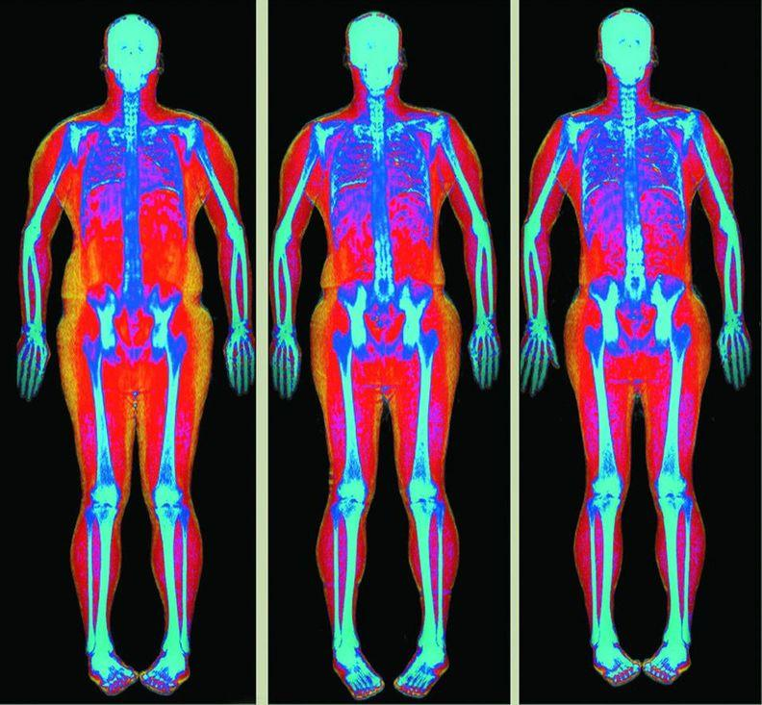Copyright UC Regents / UC Davis Health Sports Medicine Program | We analyze trends in M’Kenna’s weight and height and look at images of weight loss over time. It looks as though the fat is disappearing, which makes us wonder, where is the fat going? We read an article that says, when kids lose weight, the fat is being “burned.” We wonder if this is the same “burning” as when we light something on fire. We do an experiment and light different types of fats on fire, weigh them, and compare their properties before and after they burn. We see that they seem to disappear too! This makes us wonder, what is happening to fat when it burns?
Next Lesson | We will conduct two investigations to trap the gases produced by burning food. We will use the results of these investigations to figure out that food needs to undergo a chemical reaction with oxygen to release energy and that carbon dioxide gas and water vapor are products of that process.

BUILDING TOWARD NGSS  MS-LS1-3, MS-LS1-5, MS-LS1-7, MS-PS1-1 (applied in a new context), MS-PS1-2 (applied in a new context) | What students will do  Analyze and interpret data using graphical displays and statistics to identify temporal relationships to provide evidence for how M’Kenna’s pattern of body growth and weight have changed over time compared with typical children her age.  Obtain, evaluate, and communicate information to determine the central ideas in an article to help determine where fat (matter) goes when people lose weight.  Plan and carry out an investigation to produce data to serve as the basis for evidence to answer the question, Where does matter go when people lose weight?  What students will figure out  - When a person/animal loses weight, fat seems to go away. Some say that, when you lose weight, you “burn” fat.  - When different types of fat are ignited with a flame and allowed to burn, their masses decrease.  - We also notice that the properties of the fats are different after they have been burned.  - Because of these pieces of evidence and our prior knowledge about chemical reactions, this makes us think that a chemical reaction is happening when fat is burned.

Lesson 10 • Learning Plan Snapshot
Part | Duration | Summary | Slide | Materials
1 | 7 min | NAVIGATION  Facilitate an Initial Ideas Discussion to orient students to the lesson question. | A-B
2 | 10 min | IDENTIFY PATTERNS IN M’KENNA’S WEIGHT  Analyze M’Kenna’s growth chart, which shows evidence of her recent weight loss. Identify from where M’Kenna is likely losing weight—most of which is from her fat. | C | Patterns in M’Kenna’s Weight
3 | 10 min | BUILDING UNDERSTANDINGS  Facilitate a discussion for students to share their analysis from their “What I see” and “What it means” statements. | D-E2
4 | 15 min | WHERE DOES FAT GO WHEN LOST?  Students read an article that says that kids burn fat when they lose weight. We wonder about how this “burning” applies to our bodies. | F-H | Children Need More Fat in Their Diets Compared to Adults

End of day 1
5 | 5 min | INTRODUCE FAT BURNING INVESTIGATION | I-J | What Happens to Fat When It Burns?
6 | 8 min | ANALYZE NUTRITION LABELS  Students analyze nutrition labels of duck fat and vegetable oil to see what substances they contain. | K
7 | 7 min | PREPARE FOR INVESTIGATION AND DEMONSTRATE WICK BURN | L
8 | 20 min | 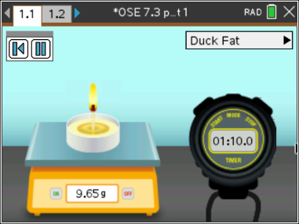  TI-Nspire Alternative to THE FAT BURNING INVESTIGATION  Have students run the TI-Nspire simulation to collect data on what happens during the burning of two different types of fat. The TI-Nspire simulation is a virtual version of the hands-on lab. Students can repeat the virtual simulation as many times as they’d like. They can change the content from Duck Fat to Vegetable Oil or run it with only the wick. | M | TI-Nspire file, “OSE 7.3 part 1”  Note – To learn how to obtain and use TI-Nspire CX Premium Teacher software go to www.ScienceNspired.com and click, “Let’s get started”, then click, “Get to know your software”
9 | 5 min | PROGRESS TRACKERS AND HOME LEARNING  Have students work on the “Making Sense” questions, if time permits, and assign the rest of them for home learning to share out at the start of the next period. | N-O | Progress Tracker

End of day 2

Lesson 10 • Materials List
 | per student | per group | per class
Fat Burning Investigation materials | - safety goggles  For the TI-Nspire alternative investigation you will only need:  - TI-Nspire CX or CX II Handheld or Computer software  - TI-Nspire .tns file “OSE 7.3 Part 1” | - ½ cup vegetable oil in a cup  - 1 pipette  - 2 prepared wicks  - 6oz of duck fat in a cup  - 1 plastic knife  - 1 long-reach lighter  - 2 small foil tins | - digital scale
Lesson materials | - Patterns in M’Kenna’s Weight  - Children Need More Fat in Their Diets Compared to Adults  - science notebook  - What Happens to Fat When It Burns?  - Fat Burning Lab Protocol  - Progress Tracker

Materials preparation (60 minutes)

Review teacher guide, slides, and teacher references or keys (if applicable).

Make copies of handouts and ensure sufficient copies of student references, readings, and procedures are available.

If your classroom has a no-flame policy, you can have students use the TI-Nspire CX or CX II graphing calculators with the file titled, “OSE 7.3 Part 1” which has simulations of the fat burning investigation, or show students these videos, and they can make their observations and make sense from the data they collect while watching what happens when fat is burned:
- https://youtu.be/V2anFe_ROug
- https://youtu.be/zJmj2-LpSv8
- https://youtu.be/lyIzp9OSllE

Day 2: Burning Fat Investigation
- Group size: Four students per group.
- Setup: Gather materials for lab. Prepare materials as suggested in the https://youtu.be/Inx_kNKaFAs and the instruction steps below.
- Alternatively, if your students will use TI-Nspire CX or CX II graphing calculators with simulations in the file, “OSE 7.3 Part 1”, the materials below will not be required. Students will interact with virtual materials to conduct the same investigation using both virtual duck fat, virtual vegetable oil, and wick. Follow the procedures for operating the simulation within the TI-Nspire file. For help downloading the TI-Nspire teacher premium software and/or loading the file onto the calculators, visit www.ScienceNspired.com and follow the prompts for “Let’s get started” and “Get to know your software”. All OSE materials are located under the “OpenSciEd” link

1. Prepare vegetable oil: Pour ½ cup of 100% vegetable oil into an 8 oz cup. Label the cup “vegetable oil.” Make 1 cup per group. Make these ahead of time for all groups. The leftover oil can be reused in between classes because each group only needs about 1 tablespoon of oil. | 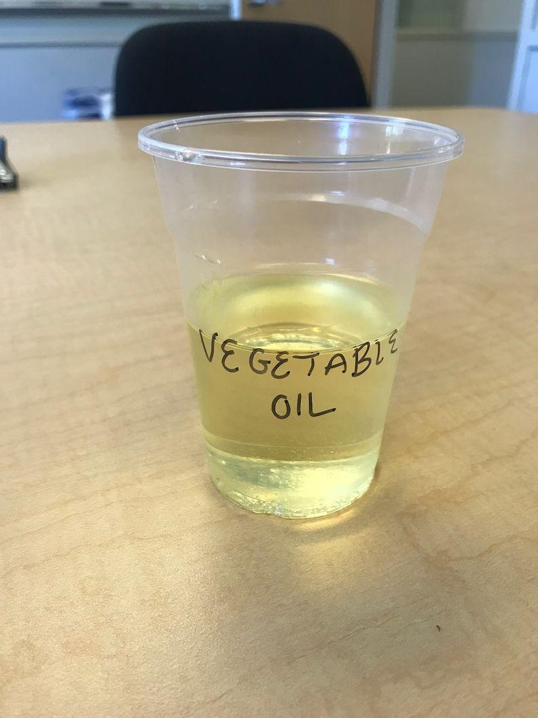
2. Prepare duck fat: Scoop 6 tablespoons of duck fat into an 8 oz cup. Leave a plastic knife in the cup. Label the cup “duck fat.” Make one cup per group. This should last for six class periods. | 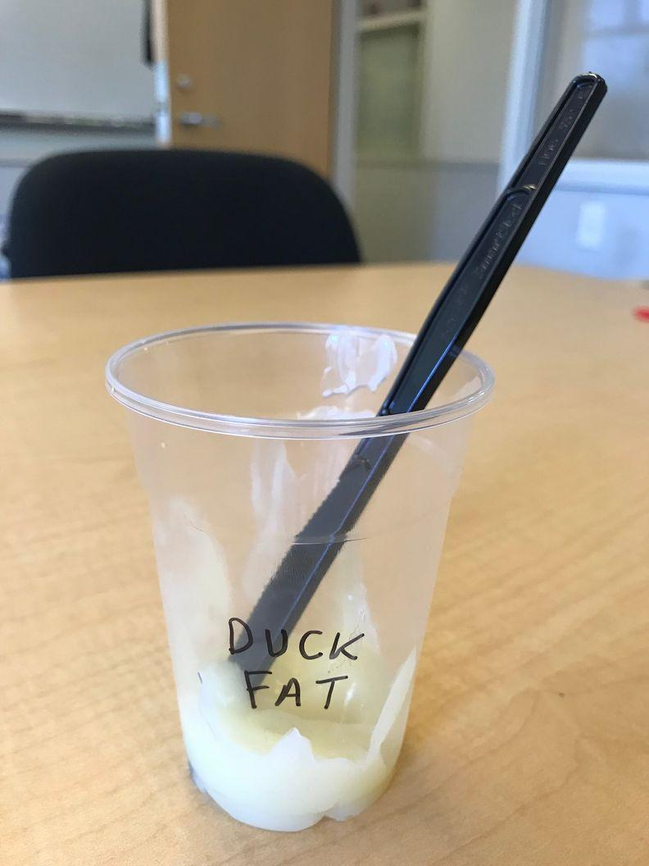
3. Prepare wicks for students to test the duck fat and oil samples: Cut wicks down so that the top of the wicks stands 0.5-in. tall. Prepare two wicks per group, plus a few extra for the class demonstration. | 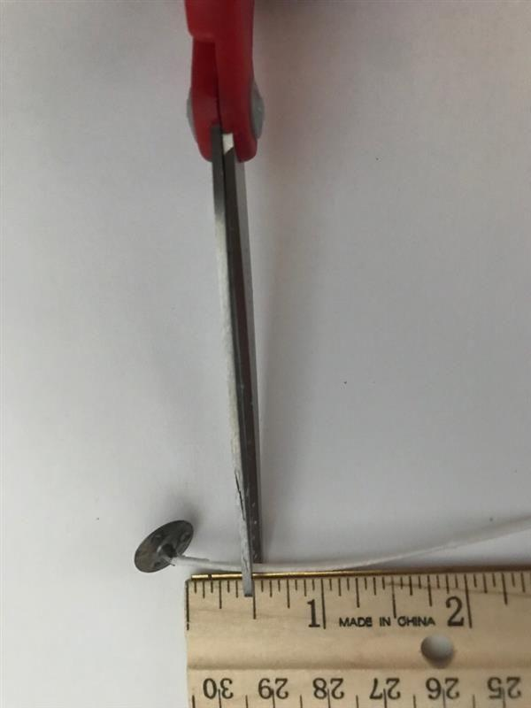

- Notes for during the lab: Preparing the duck fat samples can get messy. You may want students to wear gloves when preparing these samples. Knives work better than spoons for preparing the duck fat samples. Also, sometimes the wax from the wick can drip into the vegetable oil when it is burning. If students note that the oil is hardening, double check that it’s not actually the wax.

- Safety: Make sure you have an area in which you and the students can safely conduct the burn tests in parts 1 and 2. If you and the students do these burn tests in lab, make sure they are on non-flammable lab tables. The amount of smoke and ash that will go into the air is minimal, but you should let your front office know that you are burning things in lab today and make sure that you have temperature-based, rather than smoke-based, fire detectors in lab. If you are concerned about any of these, you can relocate this lab to be done along a concrete surface outside. Again, let your front office know of this before you take students outside. Be sure to have a fire extinguisher available.

- Disposal: Allow the fats to cool completely after burning. Then, put them into a non-flammable container (e.g., a coffee canister) and place in the garbage. You can also put the oil and duck fat into a freezer to cool before disposing. The small foil trays can be saved and reused.

- Storage: All non-perishable items can be stored for later use at room temperature. Opened oil can be stored on a shelf for one year. Duck fat can be stored in the refrigerator or on a shelf for six months, and leftover amounts should be disposed of in the garbage.

Lesson 10 • Where We Are Going and NOT Going

Where We Are Going

Though students may still have lingering ideas that matter can disappear when it is burned, this lesson will provide additional evidence that maybe something else is happening to it namely, that it is transformed through a chemical reaction, and the products are going into the air. At this point, it is not important that students identify the products that go into the air, just that their masses decrease. Because we know from previous background that matter can’t be destroyed, the matter must be going somewhere.

In prior units, students learned that substances have properties that do not change, such as color, odor, and state of matter. They learned that, in chemical reactions, the atoms that make up the molecules of the old substance break apart and rearrange to form new molecules made of the same atoms but in different arrangements; these new substances have new properties, such as color, odor, and state of matter. They also learned that chemical reactions can release or absorb energy from the surroundings. These ideas are revisited in this lesson and in Lessons 11 and 12.

Where We Are NOT Going

When these molecules break apart and the atoms in them rearrange to form new substances (different molecules), energy is released into the surroundings. Students do not need to know about bonds breaking and forming in this process.

LEARNING PLAN for LESSON 10
1 · NAVIGATION | 7 min
MATERIALS: None
Look back and review M’Kenna’s unexplained symptom of weight loss. Present slide A. Have students turn and talk to the person next to them about what the class has figured out.

Suggested prompts | Sample student responses | Follow-up questions
What did we figure out last class? | We went back to our DQB to take stock of what we’ve figured out so far. When we did that, we realized that we didn’t have a good explanation of most of her non-digestive symptoms. We thought we could figure out why she was losing so much weight. | What do we still have to figure out?
Which symptom might be the easiest to figure out next? | Why she was losing so much weight. | Why do you think that?

Sharing the Initial Ideas Discussion about weight loss. Present slide B. Look at M’Kenna’s Doctor’s Note and remind students that, in the previous session, we decided we still couldn’t explain M’Kenna’s weight loss. Have students talk to a partner about their initial ideas of why she might be losing so much weight. Have students go public with a couple of initial ideas.

KEY IDEAS | Purpose of this discussion: Elicit students’ initial ideas about what could be causing M’Kenna’s weight loss to see if students are able to connect to what was figured out in Lesson Set 1 with her not getting enough matter inside her body because her villi in her small intestine are damaged. If students do not make this connection, that’s OK; they will have the opportunity to do so later on.  Listen for these ideas:  Accept all answers. Potential ones listed below.  - M’Kenna isn’t getting enough nutrients from food.  - She’s throwing up a lot because the food is making her sick.  - Her body is using her fat because when you don’t eat a lot, your body loses fat, and you lose weight.

Say, We have some ideas about what’s causing her weight loss, but we need to investigate it more. I have access to M’Kenna’s actual weight and height growth charts. Let’s take a look at them together.

ADDITIONAL GUIDANCE | Weight can be a tricky topic to address in middle school. Some students may be sensitive to learning about weight gain and weight loss, so be mindful of your students’ feelings throughout the course of this lesson. Figuring out weight gain and weight loss using unusual examples (e.g., M’Kenna’s condition, ultra-athletes, stranded on an island) or nonhuman examples can lessen the anxiety this topic may bring for your students.

2 · IDENTIFY PATTERNS IN M’KENNA’S WEIGHT | 10 min
MATERIALS: Patterns in M’Kenna’s Weight
Orient students to M’Kenna’s height and weight charts. Say, All we know up to this point is that M’Kenna is losing a lot of weight, but we don’t know exactly how much weight or how quickly she’s losing it. Some of you mentioned wanting to know more about how much weight she has lost. Doctors also record your weight and height when you visit them. Let’s check out M’Kenna’s growth and weight chart from her doctor.  Hand out Patterns in M’Kenna’s Weight to each student. Ask students if they’ve ever seen their own height and weight chart from their annual well checks or physicals. Have students explain what they already know about why doctors take these measurements, and how they can help determine a person’s overall health from the numbers.  Listen for student ideas such as these:  - If you stop growing, you might be sick.  - They can tell when you have a growth spurt.  - If your weight changes a lot, they might think you’re sick.  Focus students on the weight chart and set aside the height chart for now. Show students how to read percentiles and make note to students that the weight scale is in kilograms (kg) and not pounds (lbs).✱ See Key: Patterns in M’Kenna’s Weight Key for more guidance on student responses.  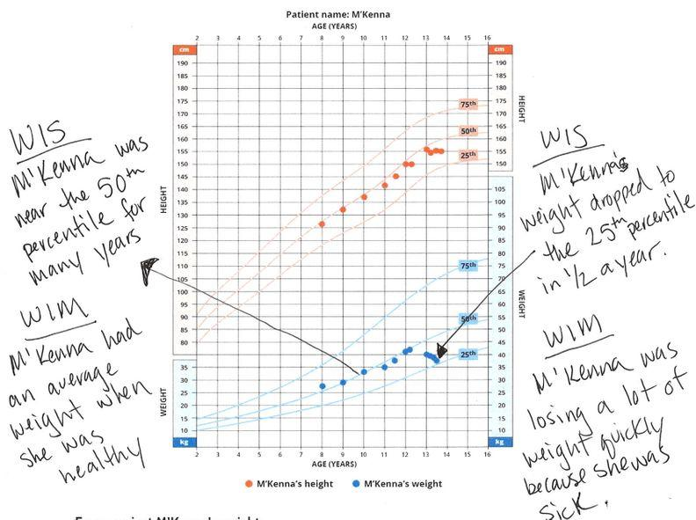  Give students time to analyze and interpret the weight graph individually. Prompt students to write “What I see” (WIS) statements first. Remind students to write directly on the graphs, drawing arrows to their observations. After a few minutes, encourage students to transition from WIS statements to “What it means” (WIM) statements. If students are not sure about their WIM statements, they can bring those questions to their groups to figure out.  Arrange students into groups to share their analysis. Ask students to compare their WIS and WIM statements with one another. If students want to add to their graphs as they hear their group members share, encourage them to do that. If students could not write WIM statements to explain their observations, ask groups to work to construct WIM statements together. Prompt groups to first discuss the questions at the bottom of the handout. When they are ready, they can write a response. Encourage students to bring any questions or confusions to the whole-group discussion that follows. | ✱ SUPPORTING STUDENTS IN ENGAGING IN ANALYZING AND INTERPRETING DATA  Introduce the idea of statistics to students when analyzing this graph. Give students a brief explanation of percentiles to help them in their data analysis of the growth charts. Explain to students that the 50th percentile means that 50% of kids weigh less than M’Kenna, and 50% weigh more. If she is on the 50th percentile line, she is right in the middle, or median, in terms of weight for her age. Median means that, if M’Kenna is one of 100 kids, 50 of them would weigh more than M’Kenna, and 50 would weigh less. Do the same for 75th percentile and 25th percentile. Add the term “median” to your word wall if students are not familiar with it already.

3 · BUILDING UNDERSTANDINGS | 10 min
MATERIALS: None
Make sense of the patterns in the data as a whole group. Bring students back together in a whole group. Present slide D and facilitate a Building Understandings Discussion. Probe a bit deeper as students share their explanations (WIM) to help them articulate their thinking.

KEY IDEAS | Purpose of this discussion: Prompt students to share at least one WIS and WIM pairing from their analysis to draw out patterns in M’Kenna’s weight before she got sick and how it has changed. Ask students to think about what part of M’Kenna’s body is losing the weight after looking at slide E1 and/or E2. This problematizes the next piece of this lesson because it looks like the fat is just going away from the pictures, which begs the question, So where does fat go when someone loses weight?  Listen for these ideas:  - M’Kenna’s weight has been going down in the last year.  - Her weight loss has been occurring rapidly.  - The man/dog has more fat before.  - The fat spots got smaller and smaller.  - The muscle stayed the same or increased.
Continue to project slide D and use the suggested prompts below.

Suggested prompt | Sample student response
What was the pattern in M’Kenna’s weight before she got sick (ages 8-12)? | She was around the 50th percentile every year.
How did M’Kenna’s weight pattern change? If M’Kenna’s weight continues on the new pattern, where do you expect her weight to be at age 14? | She dropped to the 25th percentile in a year (or less). At age 14, she might weigh 35 kg when she should weigh 55 kg if she was in the 50th percentile.
If M’Kenna was your patient and you saw this change in her weight pattern, would you be alarmed? Why or why not? | Yes, because her weight changed so much so fast.
Even though we didn’t focus on her height, did you notice any patterns in her height that you would be alarmed about as well? | Yes, she is not growing taller anymore either!

Brainstorm where M’Kenna’s weight is going. Ask students to think about what part(s) of M’Kenna’s body is losing the weight. Elicit a few initial ideas from students (e.g., students might mention fat or muscle). Present slide E1 and/or slide E2. Tell students that this imaging shows a man’s body (or a dog’s body) over time as the man/dog has lost weight.

Ask students to take a moment to identify how the body tissue has changed when the man/dog lost weight. Where did the stuff that was lost come from? Where did the stuff go? Ask students to share their ideas.

ADDITIONAL GUIDANCE | The imagery used on these slides is an enhanced form of x-ray traditionally used for bone density scans. It’s called dual-energy x-ray absorptiometry (DEXA). In recent years, DEXA has been used to identify fat tissue for weight loss purposes. We have provided a human example (slide E1) and an animal alternative (slide E2). Select which slide you prefer most; you only need to present one of them to your students.

Say, OK, so we think M’Kenna could be losing weight, and it’s coming from fat on her body. Why is she losing this fat? How does the fat get out of her body? It can’t just disappear, even though that’s what it looks like in the pictures. Where does the weight go?

4 · WHERE DOES FAT GO WHEN LOST? | 15 min
MATERIALS: Children Need More Fat in Their Diets Compared to Adults
Motivate students to want more information about where fat goes when lost. Present slide F. Have students discuss the question on the slide with a partner.

Suggested prompt | Sample student response
Where do you think the fat goes when someone loses weight? | Maybe it come out in your poop.  Maybe you sweat it out.  We don’t really know!

Say, Those are interesting ideas! I have an article that talks about fat in our bodies and maybe it will give us some clues as to where fat goes when it’s lost.

Introduce the article. Hand out copies of Children Need More Fat in Their Diets Compared to Adults.

Tell students, We were just looking at one source of fat in the slides, but in this article there are two sources of “fat” discussed. The two types of fat are: (1) “body fat” or fat on our bodies and (2) “dietary fat” or fat molecules that come from the foods we eat. Not all of our body fat comes from eating fat molecules. This article talks about both types of fat on our bodies as well as the fat that kids and adults need to eat.

Present slide G. Have students read the article twice. The first time you should: (1) have students read silently and circle words that they don’t know and try to get the main idea or gist of the article, while you circulate among students to assist any struggling readers and (2) on the second readthrough, tell students that the goal is to answer these three questions on the slide with a partner.

KEY IDEAS | The purpose of reading this article is to plant the idea that one way people use fat is to “burn” it. It’s likely that students have heard of burning fat or burning calories when you exercise, but what does that really mean? Is it actually like burning when you light something on fire? That’s what we want students to be thinking after reading it.

Present slide H. After students have finished their second reading of the article, have students share their responses with a partner while writing the answers to the prompts.

Suggested prompt | Sample student response
According to the article, how do adults and children use fat differently? According to the article, which age group needs the most fat? | Kids use fat for “normal growth processes” like bone development and making proteins. They need extra calories for growth and development. Adults aren’t growing like kids are, so they don’t need as much fat.
How did that affect their recommendations for the amount of fat in a person's diet? | Babies and toddlers need the most fat. Then older kids need a little more and adults need the least amount of fat in their diets.
What did the researchers find with children who were 8 years old on average? | The kids burned more body fat than adults did.
What do you think they mean by “burned”? | Like using it, or I’m not really sure
Do you think they could mean like really “burn”? Like when you light something on fire? | I don’t think so, but maybe?
Has anyone ever tried to literally burn fat, light it on fire? What happens? | No, I’ve never tried that!  Or I’ve seen fat burn when watching my parent grill. I saw that it looked like it melts and kind of disappears a little or gets smaller.
Since everyone hasn’t lit fat on fire, would you like to try it so we can all see what happens? | Yeah! Let’s do that tomorrow.

End of day 1
5 · INTRODUCE FAT BURNING INVESTIGATION | 5 min
MATERIALS: science notebook, What Happens to Fat When It Burns?
Have students recall what we decided last class. Present slide I. Help students recall that we were wondering about what happens to fat when it burns. At the end of class we wanted to try to light some fat on fire and see what happens to it.  Present slide J. Have students brainstorm with a partner the types of fat we should try to burn.  Suggested prompt Sample student response  What types of fat do you think we should burn? Answers will vary.  Say, Those are a lot of interesting ideas. It’s probably a good idea to burn a couple of different types of fat. I have one type of animal fat and one type of vegetable fat. Let’s see what happens with those. ✱  ALTERNATE ACTIVITY If your classroom has a no-flame policy, you can have students use the TI-Nspire CX or CX II graphing calculators with the file titled, “OSE 7.3 Part 1” which has simulations of the fat burning investigation, or show students these videos, and they can make their observations and make sense from the data they collect by watching what happens when fat is burned. - https://youtu.be/V2anFe_ROug - https://youtu.be/zJmj2-LpSv8 - https://youtu.be/lyIzp9OSllE  Say, Before we burn these types of fat, we should make sure they are solely made up of fat, so we know exactly what we are burning. | ✱ ATTENDING TO EQUITY  If students have suggestions of types of fat to burn other than vegetable oil and duck fat and can bring them into class, you can incorporate these ideas into the investigation. Make sure these suggestions are 100% fat and don’t have other ingredients.

6 · ANALYZE NUTRITION LABELS | 8 min
MATERIALS: None
Analyze the nutrition labels. Project slide K. Show students the two nutrition labels for duck fat and vegetable oil.

Suggested prompt | Sample student response
What are these two foods made up of? | The vegetable oil’s only ingredient is soybean oil. The animal fat is duck fat.
Do they contain other substances besides fat? | No! The total fat column is broken down into other types of fat, but they are all still fats.
Do they both have any calories? | Yeah, they have kind of a lot of calories in 1 tablespoon.
What does having calories mean to you? | Calories provide you with energy to do things. That’s why you have to eat--to have energy to play sports or dance or move around.
OK, we think that, when foods have calories, they can give you energy. So food gives us energy somehow to do the things we want to do.  When we looked at M’Kenna’s weight chart or the images of the man/dog losing weight, what seemed to be happening to the fat? | It seemed to be going down.  It seemed to be going away.  It seemed to be disappearing.
This made us wonder, what IS happening to fat when it seems to go away or, like the article said, when the fat is “burned?” In this experiment when we literally burn fat, how could we keep track of the matter? Is there a way we could measure how much matter we have before and after burning? | Yeah, we could weigh it before and after.

7 · PREPARE FOR INVESTIGATION AND DEMONSTRATE WICK BURN | 7 min
MATERIALS: None
Prepare students to make observations. Tell students that we will burn three different items to help us figure out what happens to different types of fat when it burns.

- the burn of the candlewick alone
- the burn of vegetable oil (with the help of a candlewick)
- the burn of the duck fat (with the help of a candlewick)

Distribute copies of What Happens to Fat When It Burns?. Project slide L and have students set up the observation table for the investigation. Give students three minutes to build the data table shown on the slide in their science notebooks.

Demonstrate burning the candlewick alone. Gather students around a demonstration area. Take a 0.5 inch tall piece of candlewick with a metal anchor and place it in the bottom of an empty tea candleholder. Ask students where they have seen these used before.

Place the tea candleholder with the wick into the foil tray. Foil trays can be saved and reused.
ALTERNATE ACTIVITY | If you are not able to burn items in your classroom, you can have students use the TI-Nspire CX or CX II graphing calculators with the file titled, “OSE 7.3 Part 1” which has simulations of the fat burning investigation, or use this series of videos to show your students and collect data from.  - https://youtu.be/V2anFe_ROug  - https://youtu.be/zJmj2-LpSv8  - https://youtu.be/lyIzp9OSllE

Ensure student safety. Have students get safety goggles and put them on. Then have students make a circle around the demonstration table and stand at least four feet away from it (for safety and so everyone can see).

Ignite the wick. It will burn relatively quickly. Have students write their observations down. Once the wick burns up, provide a brief explanation.

Say, This wick has a little bit of wax on it, too, which serves as fuel for a bit. How many of you have noticed that wax melts in a candle as the candle burns? Some fuels, like wax, melt first, and then are absorbed into a wick before they can burn. Notice in this situation, though, that the fuel was used up pretty quickly because, once the wick and wax are burned up, the flame goes out, so the wick itself doesn’t provide much energy to the system.

ADDITIONAL GUIDANCE | This demonstration is included because some students think that only the wick is burning when you burn the wick and the vegetable oil. The purpose of this demonstration is to show students that the wick does burn, but only briefly. In the next part, students will see that the wick will burn, but the continued burn is fueled by the vegetable oil.

Demonstrate how to set up the burn of fats (with the help of a candlewick).

1. Take a new 0.5 inch tall piece of candlewick with a metal anchor and place it in the bottom of an empty tea candleholder. Place the candleholder with the wick in the foil pan.
2. Fill an eyedropper all the way up with vegetable oil and squirt this into the bottom of the candleholder. Repeat this a couple of times, until half of the wick is covered.

Say, You may have noticed that I am covering half the wick with oil. I am doing this because I want to make sure that the bottom of the strings that the wick is made of is touching the oil so that the wick can absorb the oil, like a paper towel would or like wax in a candlewick.

ALTERNATE ACTIVITY | The Fat Burning Investigation in the next activity section is set up so that students can do this section in small groups. However, you can also have students work individually or in small groups using TI-Nspire CX or CX II graphing calculators using file, “OSE 7.3 Part 1”. Or you can do the entire investigation as a whole class demonstration, if that better suits the needs of your students or the safety regulations of your school.

Tell students that this is how they will need to prepare their candleholders with the vegetable oil when they do the lab.

8 · CONDUCT THE FAT BURNING INVESTIGATION | 20 min
MATERIALS: Fat Burning Investigation, Fat Burning Lab Protocol
Discuss the lab procedure and safety considerations. Ask students to read through the procedure in Fat Burning Lab Protocol. Then lead a short discussion by asking students to identify and share important safety considerations with the whole group that they recognize are important to be vigilant about in this particular investigation.

Sample safety considerations
- Keep our goggles on the whole time.
- Stay at least 3 ft away from any of the materials we are testing after we ignite them.
- Don’t test any materials other than those identified in this procedure.

Project slide M. Ask students if there are any questions.

ADDITIONAL GUIDANCE | The vegetable oil will burn for a long time if you don’t blow it out (more than 10 minutes).

Monitor students as they complete parts 1 and 2 of the investigation. The small foil tins, ½ cup vegetable oil, and 6 oz of duck fat can be reused between classes. Remind students to return to their seats to complete the questions in part 3 of the investigation.

ASSESSMENT OPPORTUNITY | To students who are having difficulty with the “Making Sense” questions in part 3, you could ask additional questions like, "What do the changes in the substance color, odor, or state of matter indicate about what happened?" and "Where did the matter in the vegetable oil/animal fat go?”

9 · PROGRESS TRACKERS AND HOME LEARNING | 5 min
MATERIALS: science notebook, Progress Tracker
Update Progress Trackers (optional). Show slide N. Have students individually update their 2-column Progress Trackers. In the example Progress Tracker row for this lesson, each of the columns has been completed with possible student ideas.

Question | What I figured out in words/pictures
What happens to fat when it’s burned? | - When we burn different types of fat, the mass seems to go down!  - The properties of the vegetable oil and duck fat change before and after they are burned.  - We think this indicates that a chemical reaction is actually happening to the fat.

Assign the rest of the “Making Sense” questions in part 3 for home learning. Present slide O.

HOME LEARNING OPPORTUNITY | Tell students to complete the questions in part 3 for home learning if they did not finish them in class. The next lesson will start with them reviewing these questions. For students that were unable to do the lab in class, the TI-Nspire alternative simulation, “OSE 7.3 Part 1” is a good substitute.

Additional Lesson 10 Teacher Guidance

SUPPORTING STUDENTS IN MAKING CONNECTIONS IN MATH | The growth chart analysis activity provides an opportunity to connect to math in several ways, for example, by engaging students in statistics, interpreting a numerical display of data, using graphical trends to predict future data points, and converting between units of measure (kg to lb). There’s a connection to CCSS Math 6.SP.B.5.C: “Giving quantitative measures of center (median and/or mean) and variability (interquartile range and/or mean absolute deviation), as well as describing any overall pattern and any striking deviations from the overall pattern with reference to the context in which the data were gathered.”

SUPPORTING STUDENTS IN MAKING CONNECTIONS IN ELA | When students read through the article twice, they have an opportunity to improve their overall comprehension of the text. The teacher frames the reading to help students focus in on the main idea. Then, in the first reading, students can sort out words or phrases that are unfamiliar and may distract from their ability to attend to the overall meaning of the text. The second reading provides students with an opportunity to refocus their attention on specific questions so that they can provide answers, citing evidence from the text. There’s a connection to CCSS ELA RST.6-8.2: “Determine the central ideas or conclusions of a text; provide an accurate summary of the text distinct from prior knowledge or opinions.”

