Activity Overview
This activity will introduce the Calculator-Based Ranger™ 2 motion sensor and the Vernier DataQuest™ app. You will collect and analyze both linear and non-linear data.
Materials
- TI-Nspire™ CX II, TI-Nspire™ CX, or TI-Nspire™ CX Premium Teacher Software
- CBR™ 2 motion sensor
- USB Connection Cable for CBR 2 motion sensor
Note: To plug the CBR 2 into the computer, a mini-standard USB adaptor is needed.

Step 1:  Open a New Document, and press d.  Connect the CBR 2 to the TI-Nspire CX II with the USB cable. A Vernier DataQuest app page will automatically open, and the CBR 2 will begin measuring the position of the closest object. The position is the object’s distance from the CBR 2. | 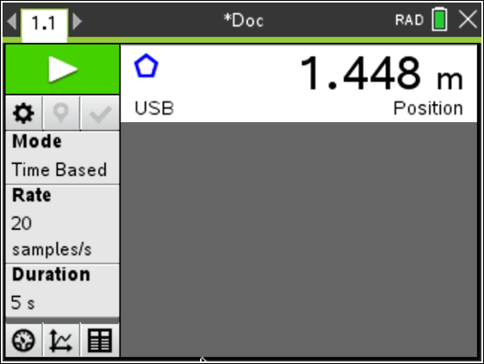
Step 2  Select Menu > View. There are three views. The first view displayed was Meter. Choose the Graph View for additional menu options. (Alternatively, click on the Graph View icon at the bottom of the screen.)  To display only the position versus time graph, select Menu > Graph > Show Graph > Graph 1. | 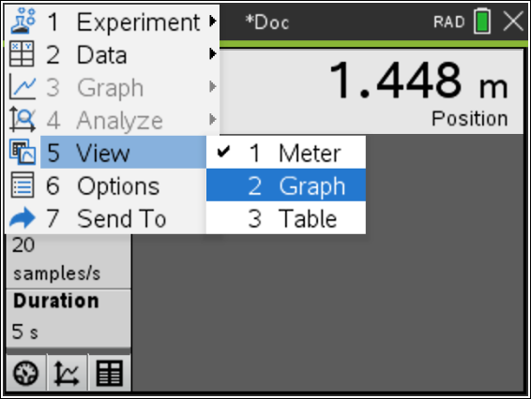  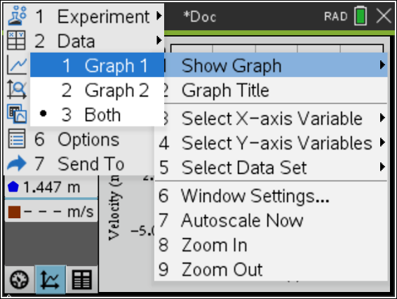
Step 3:
Work in groups of two. One person will operate the handheld and also point the CBR 2 toward the torso of the other person, the “walker.” The walker should be standing approximately two meters from the motion sensor. The walker will walk slowly toward the motion sensor at a constant rate for five seconds.
Step 4:  Before collecting data, make a prediction of what the graph of position versus time should look like. Sketch your prediction on the grid to the right. | 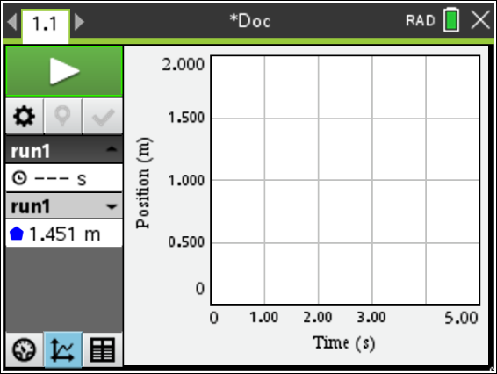
Step 5:
When ready, the handheld operator should click the Start Collection arrow in the upper-left corner of the screen, or press Tab until the start collection arrow is highlighted, and then press enter. Remember, the walker should walk SLOWLY toward the CBR 2 at a constant rate for 5 seconds.
Step 6:
A graph of position versus time is displayed. Repeat as necessary by clicking the Start Collection arrow until you generate a graph for position versus time that is approximately linear.
How does the graph compare with your prediction?

Step 7:  Sketch the actual graph of your position versus time graph on the grid to the right. | 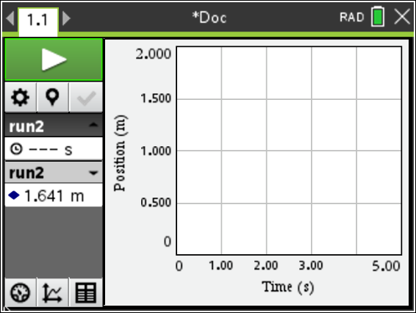
Step 8:
Manual Analysis of Data
Include appropriate units in your answers.
- What does the position at time t = 0 seconds represent?

- What was the position of the walker at time t = 0 seconds? At time t = 5 seconds?

- How did the position of the walker change over the five seconds?

- The slope (change in position divided by change in time) is the average velocity of the walker during the five second walk. Why should the velocity be negative for this walk?

- Show your work to calculate the slope.

- Write an equation in the form y = m*x + b, where y is the position at time x, m is the slope (velocity), and b is initial position.

Step 9:  Select Menu > Analyze > Model. Select m*x + b to create a linear model, and press OK.  Type the values for the coefficients m and b that you estimated in Step 8 in the spaces provided. Click OK. | 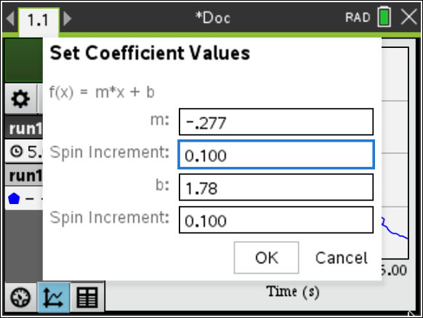
Step 10:  The model can be adjusted by clicking on the values of m and b displayed on the left side of the screen and editing them or by clicking the slider arrows. See the sample shown to the right. If you made adjustments, record the new values below.  m =  b = | 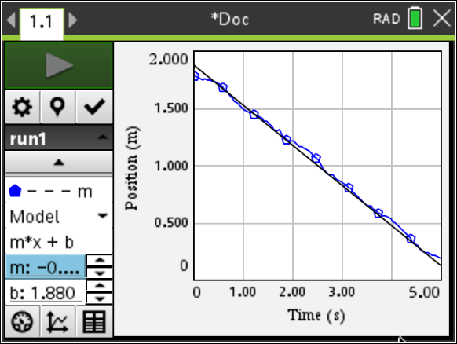
Curve Fit with the DataQuest app  Step 11:  Analyzing the data with a linear regression curve can be performed within the Vernier DataQuest app.  Select Menu > Analyze > Curve Fit > Linear. This will give the equation of the linear regression model. Scroll down the dialog box to see the values of m and b for the linear model. Record the values for m and b below.  m =  b = | 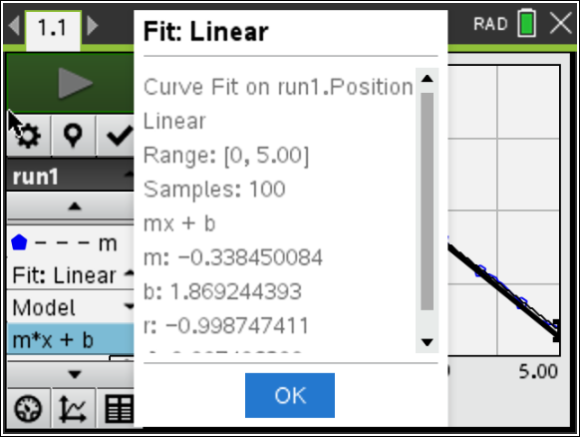
Step 12:  Click OK to see the graphical results of the regression computation. How does the graph of the linear regression equation compare with the graph of the equation you found? How do the values for m and b compare? | 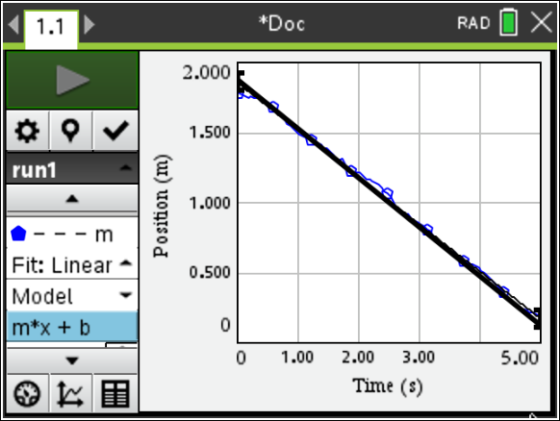
Explorations
- As you might have gathered from previous walks, the CBR 2 collects data by measuring how far an object is located from the sensor.
In this first exploration, you will walk in front of the CBR 2 to collect a set of data which appears linear and has a positive slope. Before collecting data, sketch a prediction of this position versus time graph on the grid at the right. After walking, describe the connections between the slope and y-intercept and the physical actions.

- By walking in front of the CBR 2, collect a set of data that represents a piecewise function with two parts, both of which are linear. One part should have a slope that is approximately zero.
Before collecting data, sketch a prediction of this position versus time graph on the grid at the right.
After walking, describe the connections between the slope and y-intercept and the physical actions.

- The distance versus time graphs below are not linear; the slope (velocity) is not constant.
For each of these graphs, write a description for a walk that would produce the graph. Be sure to use language that describes the physical actions taken during the walk. Then, walk in front of the CBR 2 to create the graphs.
 | 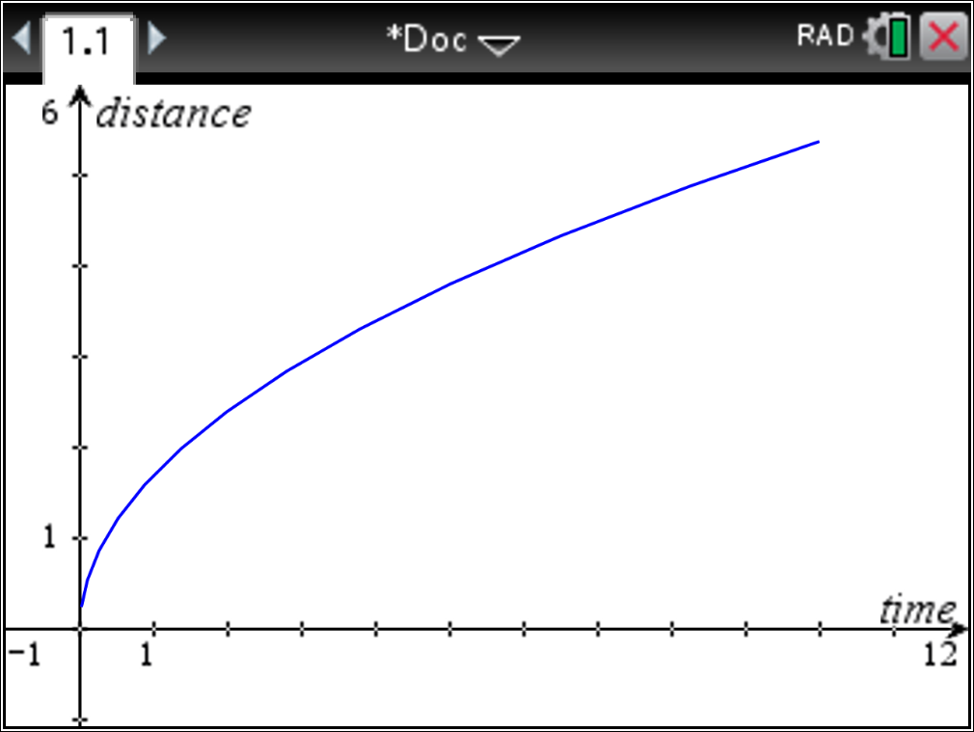
 | 