Problem 1 – The Derivative of y = ln(x)
If (x, y) is a point on y = f(x) and y = g(x) is the inverse of f(x), then (y, x) is a point on g(x). We know that e⁰ = 1 and ln(1) = 0, so (0, 1) is a point on y = e^{x} and (1, 0) is a point on y = ln(x). We could do this for several points and keep getting the same inverse results.
Thus, if y = e^{x}, then x = e^{y} will be equivalent to y = ln(x) because they are inverses of one another. Now we can take the implicit derivative with respect to x of x = e^{y}.
Use the limit command to test this formula. Be careful with your parentheses.  - Find  - Do the same with  - What is | 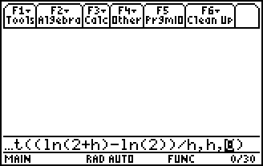
- Use the derivative command to find the derivative of the logarithmic function f(x) = ln(x). | 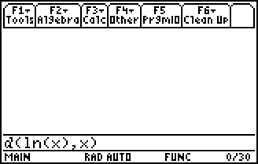
Problem 2 – The Derivative of y = log_{a}(x)
What happens if our logarithm has a base other than e? We need to know how to take the derivative of the function y = log_{a}(x).  First we want to compare y1 = ln(x) and y2 = log₂(x).  To enter log₂(x), use the alpha keys to spell out log.  Within the parentheses, enter the expression, then the base. | 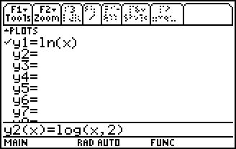
- Graph both functions (y1 = ln(x) and y2 = log₂(x)) on the same set of axes. Sketch your graph to the right. What do you notice? | 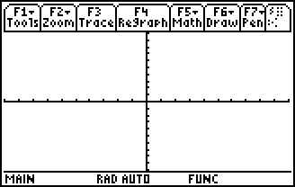
- Do the same steps with y1 = ln(x) and y3 = log₄(x). What do you notice?
- Simplify the following ratios.

Sometimes the ratio is written as ln(x) = ln(a) ∙ log_{a}(x). We can rewrite this ratio as and call it an identity.
- Graph the following functions on the same set of axes: y1 = ln(x), y2 = ln(2) ∙ log₂(x), y3 = ln(3) ∙ log₃(x). What was the result?
What happens when we take the derivative of y = log_{a}(x). Use the derivative command to find the derivatives of the functions below.
f(x) = log₂(x) g(x) = log₃(x) h(x) = log_{a}(x)

- Do you notice a pattern?
What does log₂(e) equal? If we use the formula from earlier in this class, we get .
Therefore, the general result is
Problem 3 – Derivative of Exponential and Logarithmic Functions Using the Chain Rule
Now we want to take the derivative of more complicated functions:
Recall: where u depends on x.
- Suppose that y = log_{a}(u), where u depends on x. Using the chain rule, take the derivative of this function.

Find the derivative of the following functions with the chain rule.
Identify u(x) and a for each function before you find the derivative.
- f(x) = u(x)=__________ a = ____________
f′(x) = ________________

- g(x) = u(x)=__________ a = ____________
g′(x) = ________________

- h(x) = log₃(x⁴ + 7) u(x)=__________ a = ____________
h′(x) = ________________

- j(x) = u(x)=__________ a = ____________
j′(x) = ________________

