Creating an APPVAR: RHOMBUS
 | After turning on your handheld press the key and then select CabriJr.  
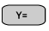scroll to New | 
Draw a segment    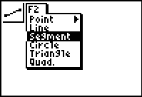 | Select a point press  Select a second point press  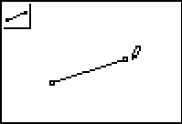

Construct the perpendicular bisector of the segment   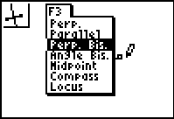 | Move cursor to segment  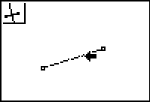
Select a point on the perpendicular bisector  scroll to Point on  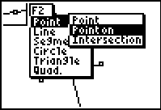 | Move cursor to perpendicular bisector  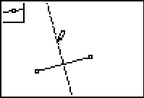
Locate midpoint of segment  scroll to Midpoint  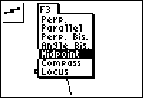 | Move cursor to segment  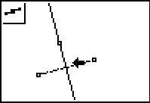

Construct circle with center midpoint and radius midpoint to point on  scroll to Compass  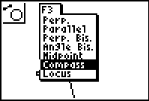 | Select midpoint as Center  Select radius by selecting point on and then midpoint  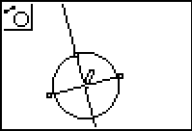
Find point of intersection of Circle and perpendicular bisector  scroll to Point Intersection  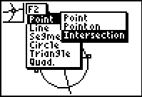 | Select Circle  Select perpendicular bisector  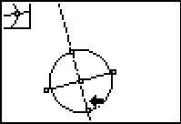
Hide Circle, perpendicular bisector, segment, midpoint  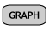scroll to Hide/Show Object  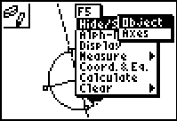 | Move cursor to each object you want to hide then press  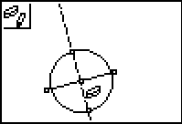  As you hide an object it goes to a dashed object when all are selected press 

Label the points RSTU  scroll to Alph-Num  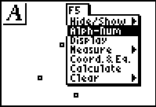 | Move the cursor to the point to be labeled press label the point press and repeat  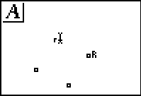
Draw segments RS, ST, TU and UR  scroll to Segment  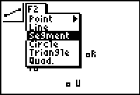 | Finished product  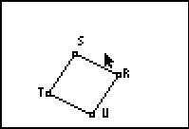

This is the finished product that the student should receive and work with to answer the questions on the student worksheet.

For student exploration you will want to give them the finished product. Creation of the APPVAR is a good extra credit project.

