Math Objectives  Students will  - analyze temperature-loss data graphically;  - use Newton’s Law of Cooling to predict temperature loss;  - solve the Newton’s Law of Cooling formula for the exponential constant of cooling (k); and  - determine the time required for tank temperature to equalize with room temperature.  Vocabulary  - Exponential • Logarithmic • Inverses  - Ambient Temperature • Neutral Buoyancy  About the Lesson  - In this lesson, students will use prior knowledge of exponential functions and their inverses. Along with knowing how to convert between exponential and logarithmic form.  - Students will solve both exponential and logarithmic equations algebraically.  - Students will identify characteristics about exponential functions and their graphs.  - Students will discuss exponential functions and their graphs in the context of real world situations.  Teacher Preparation and Notes  - This activity is done with the use of the TI-84 family as an aid to the problems.  .  Activity Materials  - Compatible TI Technologies:  TI-84 Plus*, TI-84 Plus Silver Edition*, TI-84 Plus C Silver Edition, TI-84 Plus CE  * with the latest operating system (2.55MP) featuring MathPrintTM _{functionality.} | 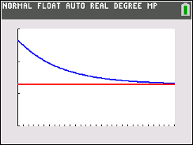  Tech Tips:  - This activity includes screen captures taken from the TI-84 Plus CE. It is also appropriate for use with the rest of the TI-84 Plus family. Slight variations to these directions may be required if using other calculator models.  - Watch for additional Tech Tips throughout the activity for the specific technology you are using.  - Access free tutorials at http://education.ti.com/calculators/pd/US/Online-Learning/Tutorials  Lesson Files:  Student Activity  Cool_in_the_Pool_Student-84.pdf  Cool_in_the_Pool_Student-84.doc
Background
This problem is part of a series that applies mathematical principles in NASA’s human spaceflight. The original activity was a collaboration between NASA and TI. This activity has since been modified for the TI-84 Plus CE platform.
Human spaceflight is an important part of NASA’s mission. From lunar exploration to the completion of the International Space Station (ISS), NASA has been preparing humans to explore the unknown. The research and innovation required to explore space has led to technological advancements on Earth. Space exploration has brought benefits to medicine, medical care, transportation, public safety, computer technology, and many other areas that enrich our everyday lives.

Exploring space is a complex endeavor, and missions that involve humans require extensive research, precise planning, and preparation. This includes spacewalks, which are critical for current and future missions.

To prepare for spacewalks, astronauts train at NASA’s Neutral Buoyancy Laboratory (NBL) – the largest indoor pool in the world, located at the Sonny Carter Training Facility in Houston, Texas. Besides astronaut training and the refinement of spacewalk procedures, NASA also uses the NBL to develop flight procedures and verify hardware compatibility – all of which are necessary to achieve mission success.

The NBL is 202 ft (61 m) long, 102 ft (31 m) wide, and 40 ft (12 m) deep. It is sized to perform two suited test activities simultaneously, and it holds 6.2 million gallons (23.5 million liters) of water. Even at this size, the complete International Space Station, with dimensions of 350 ft (106 m) by 240 ft (73 m), will not fit inside the NBL (see Figure 1).

The water within the NBL is recycled every 19.6 hours. It is automatically monitored and controlled to a temperature of 82°-88° Fahrenheit to minimize the potential effects of hypothermia on support divers. It is also chemically treated to control contaminant growth while minimizing the long-term corrosion effect on training mockups and equipment.
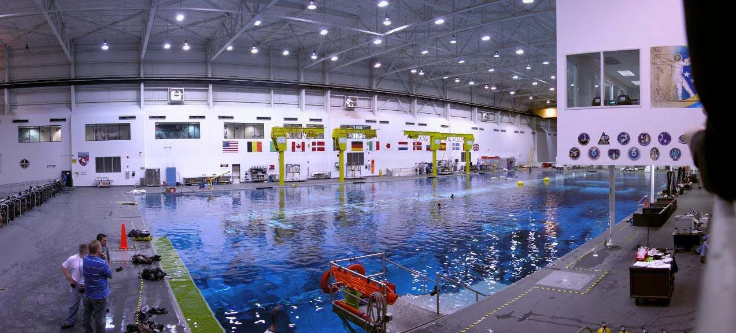
Figure 1: View of the entire pool at the Neutral Buoyancy Lab (NBL)

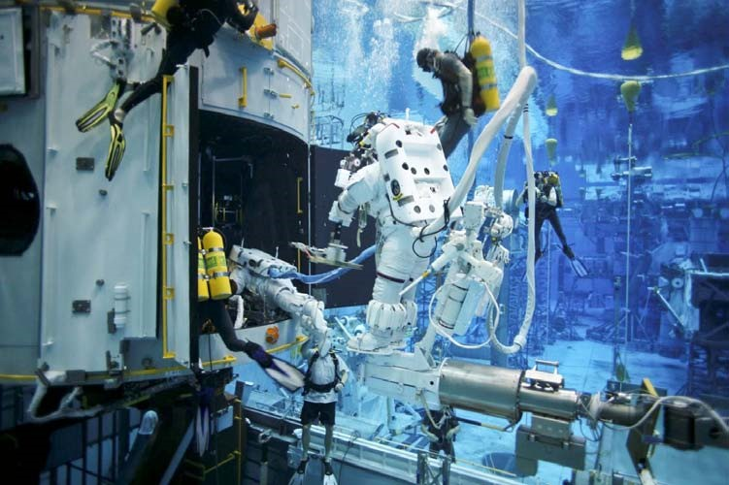
Figure 2: Astronauts practicing for a spacewalk to repair the Hubble Telescope in the NBL
The NBL allows crewmembers to properly train by experiencing the simulation of a weightless environment in space. With the assistance of divers, suited astronauts are weighted in the pool in order to perform simulated extra-vehicular activities (EVAs) on full mockups of parts of the International Space Station (ISS), the space shuttle cargo bay, and on various payloads.
You may wonder, what is neutral buoyancy and how does it resemble weightlessness? Neutral buoyancy is the equal tendency of an object to sink or float. If an item is made neutrally buoyant through a combination of weights and flotation devices, it will seem to hover under water. In such a state, even a heavy object can be easily manipulated, as is the case in microgravity of space. However, there are two important differences between neutral buoyancy (as achieved in the NBL) and weightlessness. The first is that suited astronauts training in the NBL are not truly weightless. While the suit/astronaut combination is neutrally buoyant, the astronauts can still feel their weight while underwater in their suits. The second is that water drag hinders motion, making some tasks easier to perform in the NBL than in microgravity. While these differences must be recognized by spacewalk trainers, neutral buoyancy is still the best method currently available to train astronauts for spacewalks.

Students should have prior knowledge of exponential functions and their inverses, written in both exponential and logarithmic form.

Lesson Development
Following are the phases of the 5-E’s instructional model in which students can construct new learning based on prior knowledge and experiences. The time allotted for each activity is approximate. Depending on class length, the lesson may be broken into multiple class periods.
1 – Engage (10 minutes)
- With students in small groups of two to four, ask them to review and discuss the main points of the Background section for several minutes to be sure that they understand the material.
Circulate to help facilitate discussion in small groups. Ask if any group needs clarification.
Play the video, Fluid Dynamics – What a Drag! (7:13 minutes), accessible at the following link: http://www.nasa.gov/audience/foreducators/nasaeclips/search.html?terms=Neutral Buoyancy&category=0010
- Stop the video after three minutes to conserve time. (optional)
- Encourage student discussion of the Background and video, and ask if there are any questions.

2 – Explore (15 minutes)
- Distribute the Cool in the Pool Student Activity to the students.
- Ask students to work as a team on Problems 1 and 2.

3 – Explain (10 minutes)
- Have students remain in teams to work on Problems 3 – 5.
- Call on students to give their answers and discuss.

4 – Extend (5 minutes)
- Have students remain in teams to work on Problems 6 - 8.
- Encourage student discussion and ask if there are any questions.

5 – Evaluate (10 minutes)
• Have students work independently to complete Problems 9 - 12.
• This may be done in class or assigned as homework.

Teacher Tip: Although the topic of exponential functions and their inverses (logarithms) and their algebraic and graphical relationships is learned and reviewed in Algebra 1, Algebra 2, and Precalculus, many students forget about these relationships and how to apply them to different problems. Make sure you are circling the classroom as they discuss each of these problems to ensure they are making the connections.

Activity
Using your TI-84 CE to aid in the process, answer the problem set and use the following temperature data to create a scatter plot on the handheld.
Time (days) | Temperature (Fahrenheit)
0 | 86.6°
1 | 85.3°
2 | 83.7°
3 | 82.2°
4 | 80.7°

Problem 1

On the handheld, press STAT $→$ EDIT, and enter the Time in $L_{1}$ and the Temperature in $L_{2}$.
Press 2nd, y =, enter, enter to turn your Plot 1 on. Make sure that your XList matches with $L_{1}$ and your YList matches with $L_{2}$. Press Zoom, 9 Stat, to see your data graphed. Do not change this graph as it will be used later in the activity.

Solution:

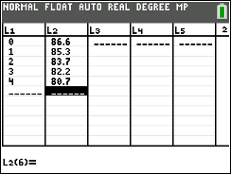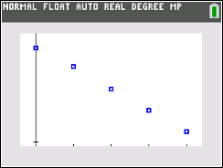

Problem 2

Newton's Law of Cooling states that the rate of change of the temperature of an object is proportional to the difference between its own temperature and the ambient temperature (i.e. the temperature of its surroundings). The formula for Newton's Law is:

$T\left(t\right)= T_{a}+ \left(T_{0}- T_{a}\right)e^{-kt}$

$T\left(t\right)=$ pool temperature, ºF, at a given time
$T_{a}=$ ambient temperature, ºF
$T_{0}=$initial temperature of the pool, ºF
$t=$ time,days

Solve for k in the formula for Newton’s Law of Cooling for each daily temperature difference.
Use 73º F as the ambient temperature. Round to the nearest thousandth.

Solution:

$T\left(t\right)= T_{a}+ \left(T_{0}- T_{a}\right)e^{-kt}$
$85.3=73+ \left(86.6-73\right)e^{-k(1)}$
$85.3-73=\left(13.6\right)e^{-k}$
$12.3=\left(13.6\right)e^{-k}$
$\frac{12.3}{13.6}= e^{-k}$
$0.904412= e^{-k}$
$ln\left(0.904412\right)= -k$
$-0.100= -k$
$T\left(1\right), k=0.100$

Follow the same steps to solve for other T values.

Day 1: $k=$____0.100____________

Day 2: $k=$____0.120____________

Day 3: $k=$____0.130____________

Day 4: $k=$____0.142____________

Teacher Tip: This is a great problem to review a rounding skills. Having a discussion how, and more importantly when, to round is key to getting the correct solutions for this activity.

Problem 3

Notice that the k-values are different for each day. Explain why the k-value is not constant in this
situation.

Solution: Since this is real data, there may be other things that affect pool temperature, such
as evaporation and ambient temperature.
Problem 4

Use the average of the calculated k-values to determine the pool temperature on Day 4. Round the
temperature you found to the nearest tenth. How close is the calculated temperature to the actual pool
temperature on Day 4 (from the data table)?

Solution: $avg. k= \frac{0.100 + 0.120 + 0.130 + 0.142 }{4}=0.123$
$T\left(t\right)= T_{a}+ \left(T_{0}- T_{a}\right)e^{-kt}$
$T\left(t\right)=73+\left(86.6-73\right)e^{-0.123(4)}$
$T\left(t\right)≈81.3°$

The calculated temperature is 0.6° F higher than the actual temperature.

Problem 5

Find the function that represents the data, from the table, by substituting your average k- value into the
Newton’s Law equation. Write the function below, and then graph the function together with the scatter
plot from Problem 1. (To graph the function, press y =, enter the function into $Y_{1}$, graph.)

Solution:

$T\left(t\right)= 73+ \left(86.6-73\right)e^{-0.123t}$

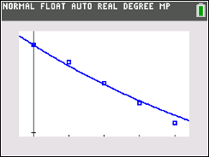

Problem 6

Determine the number of days it will take the pool to reach a temperature of 74° F. Round to the nearest
day. Support your answer graphically on your graph from Problem 5.

Solution:
$74=73+ \left(86.6-73\right)e^{-0.123t}$
$1=13.6e^{-0.123t}$
$\frac{1}{13.6}= e^{-0.123t}$
$\ln\left(0.073529\right)= -0.123t$
$t= \frac{-2.61}{-0.123} ≈21.230$
$t ≈21 days$
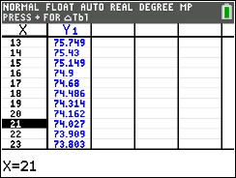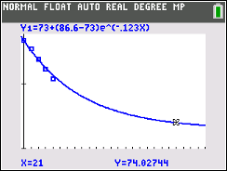
Problem 7
On your graph from Problem 5, show when the pool approaches ambient temperature. Adjust the
window of the graph.

Solution:

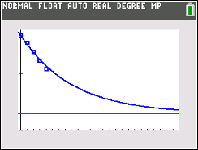
Problem 8
What temperature would the pool reach in 10 days? Round to the nearest tenth.

Solution:
$T\left(10\right)=73+(86.6-73)e^{-0.123(10)}$
$T\left(10\right) ≈77.0° F$

Use the function you graphed in Problem 5 to answer the next three problems.

Problem 9

Is the function increasing or decreasing? How can this be determined from the function rule?

Solution: The function is decreasing due to the coefficient of the exponent being
Negative.
Problem 10

Is the function asymptotic? Explain.

Solution: Yes. The horizontal asymptote is 73° F. This is the lowest temperature that
the pool would reach.
Problem 11
What is the range of the function?

Solution: $y>73° or (73°, ∞)$
Problem 12
What is the range of the data?

Solution: $80.7° ≤y ≤86.6° or \left[80.7°, 86.6°\right]$
Teacher Tip: Please know that in this activity there is a lot of time dedicated to students talking with one another and sharing their thoughts with the class. The goal here is to not only review exponential and logarithmic functions, but also to generate discussion.

Contributors
This problem was developed by the Human Research Program Education and Outreach (HRPEO) team with the help of NASA subject matter experts and high school mathematics educators.

NASA Expert
Kurt Otten – Sonny Carter Training Facility, Neutral Buoyancy Laboratory, NASA Johnson Space Center, Houston, Texas

Mathematics Educator
Suzanne Moyers – C.E. Byrd High School, Caddo Parish Schools, Louisiana

