Math Objectives  - Students will explore sine, cosine, and tangent with respect to the ratios of the sides of right triangles.  - Students will use the TI-84 Plus CE to discover the relationship of these three trig functions.  - Students will solve any right triangle given an angle and the lengths of the opposite side, adjacent side or the hypotenuse.  - Students will try to make a connection with how to understand these topics in IB Mathematics courses and on their final assessments.  Vocabulary  - SOHCAHTOA • sine, cosine, tangent  - adjacent • opposite  About the Lesson  - This lesson is aligning with the curriculum of IB Mathematics Applications and Interpretations SL/HL and IB Mathematics Approaches and Analysis SL/HL  - This falls under the IB Mathematics Core Content Topic 3 Geometry and Trigonometry:  3.2a Use of sin, cos, and tan ratios to find the sides and angles of right angled triangles  3.3a Applications of right-angled trig  - As a result, students will:  Apply this information to real world situations  Teacher Preparation and Notes  - This activity uses the TI-84 family handhelds as an aid to the problems, specifically downloading and using a Cabri Jr. file, TRIG. Extra time should be allotted for new Cabri Jr. users.  - This activity serves as an introduction to trigonometry.  Activity Materials  - Compatible TI Technologies:  TI-84 Plus*, TI-84 Plus Silver Edition*, TI-84 Plus C Silver Edition, TI-84 Plus CE  * with the latest operating system (2.55MP) featuring MathPrintTM _{functionality.} |  |  | 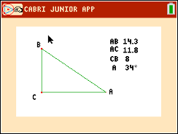  Tech Tips:  - This activity includes screen captures taken from the TI-84 Plus CE. It is also appropriate for use with the rest of the TI-84 Plus family. Slight variations to these directions may be required if using other calculator models.  - Watch for additional Tech Tips throughout the activity for the specific technology you are using.  - Access free tutorials at http://education.ti.com/calculators/pd/US/Online-Learning/Tutorials  Lesson Files:  Trig_Ratios_Student-84.pdf  Trig_Ratios_Student-84.doc  TRIG.8xv
Tech Tip: Before beginning the activity, the file TRIG.8xv needs to be transferred to the students’ calculators via handheld-to-handheld transfer or transferred from the computer to the calculator via TI-ConnectTM CE Software.

Problem 1 – Exploring trigonometric ratios
Start the Cabri Jr. app by pressing Œ and choosing it from the menu. |  | 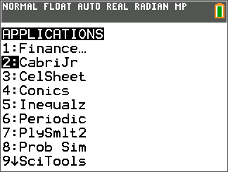
Open the file TRIG by pressing o to open then F1: File menu, choosing Open, and choosing it from the list. |  | 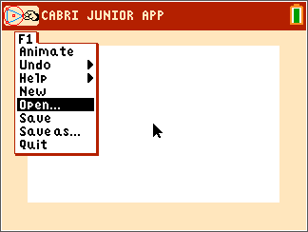
Teacher Tip: You may manipulate the side lengths of the triangle as well as the measure of angle A to any measurements you want. The examples below illustrate three such configurations.

In right triangles, there is a relationship between the ratios of the side lengths and the trigonometric functions.  Using the triangle in the Cabri Jr. app, find the following ratios and trigonometric values to three decimal places.  1. $\frac{CB}{AC}= _______ ≈$_____; $\frac{AC}{AB}= _______ ≈$ _____;  $\frac{CB}{AB}= _______ ≈$ _____  Sample Answers:  $$\frac{CB}{AC}= \frac{4.0}{5.9} ≈ 0.68; \frac{AC}{AB}= \frac{5.9}{7.1} ≈0.83; \frac{CB}{AB}= \frac{4.0}{7.1} ≈0.56$$  $\sin{A}$ = ______ ; $\cos{A}$ = ______ ; $\tan{A}$ = ______  Sample Answers:  $\sin{A ≈0.56};\cos{A ≈0.83};\tan{A ≈0.68}$ |  | 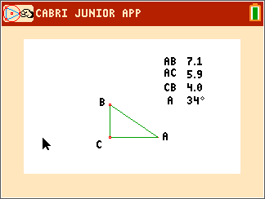
2. Based upon your answers, match each ratio with its correct trigonometric operation.
Answers:
$\frac{CB}{AC}$ $\sin{A}= \frac{CB}{AB}$
$\frac{AC}{AB}$ $\tan{A}= \frac{CB}{AC}$
$\frac{CB}{AB}$ $\cos{A}= \frac{AC}{AB}$

Test your hypothesis to see if your chosen relationships holds true. Repeat this for two more different triangles by moving either point A or B to a different location. To resize the triangle, place the cursor over either point A or B. Press ƒ to grab the point and use the arrow keys to move it to any desired location.
Triangle #2  3. $\frac{CB}{AC}= _______ ≈$_____; $\frac{AC}{AB}= _______ ≈$ _____;  $\frac{CB}{AB}= _______ ≈$ _____  $\sin{A}$ = ______ ; $\cos{A}$ = ______ ; $\tan{A}$ = ______  Sample Answers:  $\frac{CB}{AC}= \frac{9.2}{6.0} ≈1.48; \frac{AC}{AB}= \frac{6.0}{11.1} ≈0.56; \frac{CB}{AB}= \frac{9.2}{11.1} ≈0.83$  $$\sin{A ≈0.83;\cos{A≈0.56;\tan{A≈1.48}}}$$  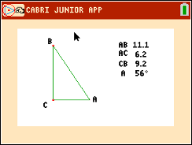 | Triangle #3  4. $\frac{CB}{AC}= _______ ≈$_____; $\frac{AC}{AB}= _______ ≈$ _____;  $\frac{CB}{AB}= _______ ≈$ _____  $\sin{A}$ = ______ ; $\cos{A}$ = ______ ; $\tan{A}$ = ______  Answers:  $\frac{CB}{AC}=\frac{4.0}{11.4}≈0.35; \frac{AC}{AB}= \frac{11.4}{12.1} ≈0.94; \frac{CB}{AB}= \frac{4.0}{12.1} ≈0.33$  $$\sin{A ≈0.33;\cos{A≈0.95;\tan{A≈0.34}}}$$  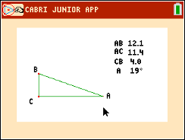
Based upon your answers hypothesize which ratio goes with each trigonometric function.
5. $\sin{A}$ = ______ ; $\cos{A}$ = ______ ; $\tan{A}$ = ______
Answer:
$\sin{A}$ = $\frac{CB}{AB}$ ; $\cos{A}$ = $\frac{AC}{AB}$ ; $\tan{A}$ = $\frac{CB}{AC}$

Teacher Tip: Make sure that students set the calculator’s mode to degrees. To do this, move the cursor to the top right corner of the screen and if it says RAD, click on it with the touch pad and it will automatically change to degrees (DEG).

A good acronym to use to help remember these relationships is SOHCAHTOA.  $$\sin{A}= \frac{opposite}{hypotenuse}$$  $$\cos{A}= \frac{adjacent}{hypotenuse}$$  $$\tan{A= \frac{opposite}{adjacent}}$$ | 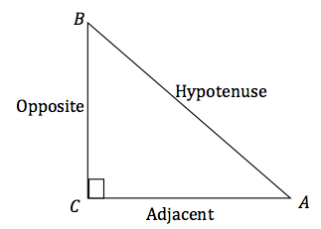
Problem 2 – Trigonometry, what is it good for?
One of the uses of trigonometry is finding missing side lengths of a triangle. In questions 6 – 12, all of the triangles given are right triangles.

6. a. To find the length of side BC in the triangle to the right,  write the sine relationship.  Answer: $\sin{A= \frac{BC}{AB}}$  b. Now solve for BC and calculate using your calculator.  Answer: $\sin{27°}= \frac{BC}{24}$  $24\sin{27°}=BC$  $BC=10.90$ |  | 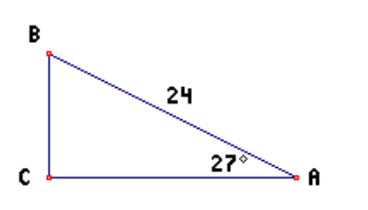
7. a. To find the length of side AC in the triangle to the right, write the cosine relationship.  Answer: $\cos{A= \frac{AC}{AB}}$  b. Now solve for AC and calculate using your calculator.  Answer: $\cos{47°}= \frac{AC}{19}$  $19\cos{47°}=AC$  $AC=12.96$ |  | 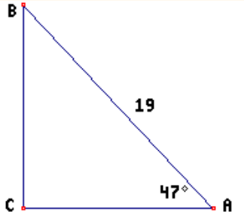
8. a. To find the length of side AC in the triangle to the right, write the tangent relationship.  Answer: $\tan{A= \frac{BC}{AC}}$  b. Now solve for AC and calculate using your calculator.  Answer: $\tan{49°}= \frac{10}{AC}$  $AC\tan{49°}=10$  $AC= \frac{10}{\tan{49°}}$  $AC=8.69$ |  | 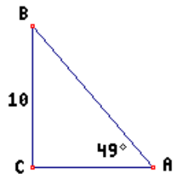
Write the correct trigonometric function for each triangle below and solve for the missing side.
9. Find AC.  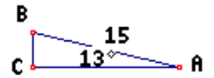  Answer: $AC≈14.62$ | 10. Find BC.  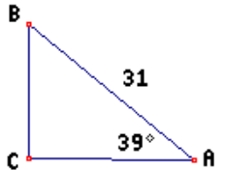  Answer: $BC≈19.51$
11. Find AC. Answer: $AC ≈49.52$ 12. Find AC. | Answer: $AC ≈95.09$
Further IB Extension
Another use of trigonometry is to use the ratio of sides of a right triangle to find the acute angles of a
right triangle. In the following problem, you will not only find missing sides, but also missing angles of
a right triangle.

First, let’s do an example of finding a missing angle of a right triangle given its sides.
Find angle $θ$:

Since the sides given with respect to angle $θ$ are the opposite side
and the adjacent side, you will need to use tangent.
7
$\tan{θ= \frac{7}{8}}$
$θ$
How do we find the missing angle $θ$, given the sides? We will use
8 The inverse tangent function $\left(\tan^{-1} or arctan\right)$.
$\tan^{-1}\left(\frac{7}{8}\right)=41.2°$

Problem
Suzie has realized that there is a problem with her dog. She loves to sleep in the bed with her, but she is too small to jump up on the bed or jump down off the bed. Being handy, she decides to construct a ramp that will allow her dog to easily get on and off the bed. Suzie realizes that she needs to do a little trigonometry to make this work. Unfortunately, her bedroom is not very large so she does not have unlimited space for the ramp. She measures the height of the bed to be 3 feet high and that there is 5 feet of floor space for the ramp.

Using the trigonometric relationships discussed earlier in the activity, in parts (a) and (b) find:
(a) The angle of the ramp created with the floor, also known as the angle of elevation.

Answer:

ramp
3 ft. $\tan{θ}= \frac{3}{5}$
$θ$ $θ= \tan^{-1}\left(\frac{3}{5}\right)$
5 ft. of floor $θ ≈31.0°$

(b) The length of the ramp.

Answer:

ramp
3 ft. $\sin{31°}= \frac{3}{ramp}$ or $\cos{31°}= \frac{5}{ramp}$
$θ=31°$ $ramp=\frac{3}{\sin{31}°}$ $ramp=\frac{5}{\cos{31}°}$
5 ft. of floor $ramp ≈5.82 ft.$ $ramp ≈5.83 ft.$

(c) With a classmate, discuss other ways to find the length in part (b) and what other
considerations you must think of for the ramp.

Possible Answer: Students can find the length of the ramp using sin or cos, but also the
Pythagorean Theorem. Some considerations students should discuss
is the weight of the dog, materials to use, the ramp surface material, is
the ramp permanent or could is be movable, etc.

**Note: This activity has been developed independently by Texas Instruments and aligned with the IB Mathematics curriculum, but is not endorsed by IB™. IB is a registered trademark owned by the International Baccalaureate Organization.

