Math Objectives  - Students will explore tree diagrams and expected values.  - Students will be asked to differentiate between independent and dependent events, as well as combining probabilities.  - Students will try to make a connection with how to understand these topics in IB Mathematics courses and on their final assessments.  Vocabulary  - Expected Value • Tree Diagrams • Probabilities  About the Lesson  - This lesson is aligning with the curriculum of IB Mathematics Applications and Interpretations and IB Mathematics Approaches and Analysis SL/HL  - This falls under the IB Mathematics Core Content Topic 4 Statistics and Probability:  4.6: (a) Use of Venn Diagrams, tree diagrams, sample space  diagrams and tables of outcomes to calculate probabilities.  (b) Combined events: $P\left(A∪B\right)=P\left(A\right)+P\left(B\right)-P(A ∩B)$  (e) Independent events: $P\left(A ∩B\right)=P\left(A\right)∙P(B)$  4.7: (b) Expected value (mean), E(x) for discrete data.  (c) Applications  As a result, students will:  - Apply this information to real world situations.  Teacher Preparation and Notes.  - This activity is done with the use of the TI-84 family as an aid to the problems.  Activity Materials  - Compatible TI Technologies: TI-84 Plus*, TI-84 Plus Silver Edition*, TI-84 Plus C Silver Edition, TI-84 Plus CE  * with the latest operating system (2.55MP) featuring MathPrintTM _{functionality.} | 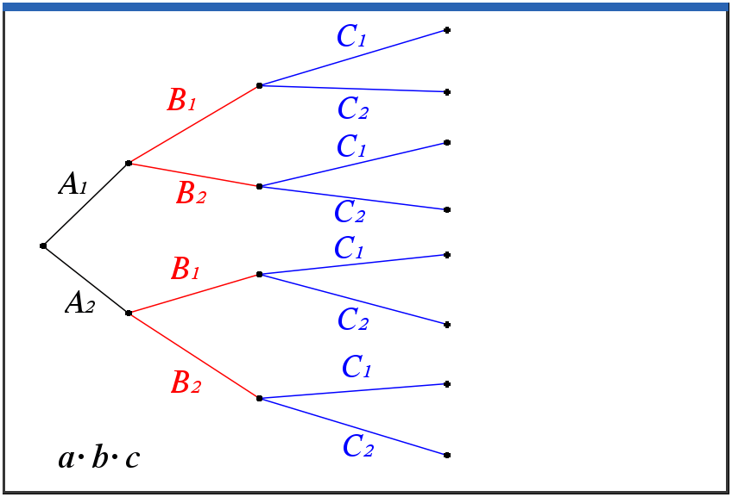  Tech Tips:  - This activity includes screen captures taken from the TI-84 Plus CE. It is also appropriate for use with the rest of the TI-84 Plus family. Slight variations to these directions may be required if using other calculator models.  - Watch for additional Tech Tips throughout the activity for the specific technology you are using.  - Access free tutorials at http://education.ti.com/calculators/pd/US/Online-Learning/Tutorials  Lesson Files:  Student Activity  84CE-ItsToBeExpected-Student.pdf  84CE-ItsToBeExpected-Student.doc
In this activity, students will use a tree diagram to find theoretical probabilities and use this information in lists to find the expected value. Students will be asked to differentiate between independent and dependent events and how to navigate the handheld when finding these probabilities.
______________________________________________________________________________
Problem 1 – Creating a Tree Diagram

Three basketball players are in a contest, hoping to win money for a charity. There is a 63% chance that Aisha will make a shot, a 74% chance that Bria will make a shot, and a 56% chance that Carmen will make a shot.
1. List the sample space for the three shots. Use an A, B, or C to represent each girl in the sample space.
Solution: (8 outcomes, ^{m} means miss)
ABC, AB^{m}C, ABC^{m}, AB^{m}C^{m},A^{m}BC, A^{m}B^{m}C, A^{m}BC^{m}, A^{m}B^{m}C^{m}
2. Find the probability that Aisha will make her shot. Find the probability she will miss her shot.
Solution: 0.63; 0.37
3. Find the probability that Bria will make her shot. Find the probability she will miss her shot.
Solution: 0.74; 0.26
4. Find the probability that Carmen will make her shot. Find the probability she will miss her shot.
Solution: 0.56; 0.44
One way to organize the results of the scenario is to create a diagram where each girl’s shots are represented. Next to the labels of each branch write the appropriate probabilities. (A = Aisha, B = Bria, C = Carmen, 1 = made, 2 = miss.)
Teacher Tip: The diagram given represents one way to calculate the probabilities. Discuss with students other ways to set up the diagram, such as with Bria or Carmen shooting first, and whether that would change the probabilities.
With the help of the diagram, students can calculate the eight probabilities. From these probabilities, they will determine the probabilities of none, one, two, or all three of the girls making their shots. The students should follow a path through the diagram to guide their calculations.  Discuss with students the multiplication rule that allows them to calculate the probabilities. Ask students what other probabilities they can calculate. For example:  Find the probability that Aisha will make her shot and Bria will miss her shot.  ((0.63)(0.26) = 0.1638 or 16.38%) | 0.63*0.74*0.56 0.261072  0.63*0.74*0.44 0.205128  0.63*0.26*0.56 0.091728  0.63*0.26*0.44 0.072072  0.37*0.74*0.56 0.153328  0.37*0.74*0.44 0.120472  0.37*0.26*0.56 0.053872  0.37*0.26*0.44 0.042328

C1
C1
C1
C1
C2
C2
C2
C2
A1
A2
B1
B1
B2
B2

Since the events of each girl making her shot are independent, the multiplication rule for probability can be used. Use the diagram to help calculate the eight probabilities.
5. Find the probability that none of the girls make their shots.
Solution: 0.042328

6. Find the probability that one girl makes her shot. (Hint: Find which of the eight probabilities that must be added together to find the answer.)
Solution: 0.072072+0.12047+0.053872 = 0.246416
7. Find the probability that two girls make their shots.
Solution: 0.205128+0.091728+0.153328 = 0.450184

8. Find the probability that all the girls make their shots.
Solution: 0.261072

Problem 2 – Introducing Expected Value

If only one of the players makes her shot, they earn $5,000. If two make shots, they earn $12,500. If all three are successful, they earn $20,000. All of the money earned goes to charity. You will need to find the expected value of the contest for the charity.

Press stat, enter.  L1: Enter the possible outcomes (number of shots).  L2: Enter the probabilities from Questions 5 – 8.  L3: Enter the payoffs.  L4: Calculate probabilities*payoff by arrowing to the top of L4, typing L2 × L3, and pressing enter. | 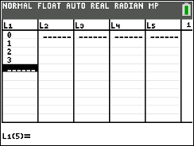

Expected Value is defined as the sum of the products of probabilities of the outcomes and their payoffs. Add the values in list L4 using the sum command to find the expected value of the contest. From the Home screen, press 2nd, stat [list] and arrow to the MATH menu. Select sum(, enter L4, and press enter.
9. Find the expected value of the contest.
Solution: $12,080.80

10. State if the charity should expect this amount of money. Explain why or why not.

Possible Discussion: Students may be tempted to say yes based on the term “expected value.”
Use the tree diagram to show students that it is very possible that the charity will earn no
money from the contest. The expected value is simply what they would earn on average if the
contest were repeated many times.

The following table encompasses the calculations of the entire activity. The first three columns display the chance of each girl making or missing the shot.

Aisha | Bria | Carmen | Probability | Success
0.63 | 0.74 | 0.56 | 0.261072 | 3 | 0.261072 | 20000
0.63 | 0.74 | 0.44 | 0.261072 | 2 | 0.450184 | 12500
0.63 | 0.26 | 0.56 | 0.091728 | 2
0.63 | 0.26 | 0.44 | 0.072072 | 1 | 0.246416 | 5000
0.37 | 0.74 | 0.56 | 0.153328 | 2
0.37 | 0.74 | 0.44 | 0.120472 | 1
0.37 | 0.26 | 0.56 | 0.053872 | 1
0.37 | 0.26 | 0.44 | 0.042328 | 0 | 0.042328 | 0
Teacher Tip: To drive this concept home, calculate the expected value of purchasing a lottery ticket for a 3-digit lottery where the three digits chosen must exactly match the winning digits (order is important). The payoff for matching all three digits in the correct order is $5,000. Otherwise the payoff is $0. There are 720 (₁₀P₃) different permutations of the three digits, so the probability of winning is = 0.001389. The expected value is (0.001389 * 5,000) ≈ $7. But should you expect to win $7 each time you buy this type of lottery ticket? No! The probability of winning nothing (and losing the $1 you paid for the ticket) is greater than 99%.
Note: In the lottery described in the Extension problem, the order in which the numbers are chosen does not matter. That problem involves a combination.

Problem 3 – Putting it All Together

In a lottery game, players may pick six numbers from two separate pools of numbers — five different numbers from 1 to 56 and one number from 1 to 46. You win the jackpot by matching all six winning numbers in a drawing.

MATCH |  | MATCH | PRIZE | CHANCES
5 | + | 1 | Jackpot | 1 in 175,711,536
5 | + | 0 | $250,000 | 1 in 3,904,701
4 | + | 1 | $10,000 | 1 in 689,065
4 | + | 0 | $150 | 1 in 15,313
3 | + | 1 | $150 | 1 in 13,781
3 | + | 0 | $7 | 1 in 306
2 | + | 1 | $10 | 1 in 844
1 | + | 1 | $3 | 1 in 141
0 | + | 1 | $2 | 1 in 75
Overall chances of winning a prize: |  |  |  | 1 in 40

1. Verify the chances to win the jackpot from your knowledge of counting principles.
Solution: See the table below and match the probabilities for each row above.
Prob | Payoff | Prob*Payoff
5.69115E-9 | 4.2 E7 | 0.239028
2.56102E-7 | 250000 | 0.064025
0.0000001 | 10000 | 0.014512
0.000065 | 150 | 0.009796
0.000073 | 150 | 0.010885
0.003268 | 7 | 0.022876
0.001185 | 10 | 0.011848
0.007092 | 3 | 0.021277
0.013333 | 2 | 0.026667

2. Calculate the expected value for the lottery assuming the jackpot is $42 million.
Solution: $0.42
3. Tickets cost $1.00 per play. Find how much the lottery will make/lose for each ticket sold.
Solution: $0.58

4. Find the expected value that would be needed for the lottery to break even.
Solution: $1 (The break-even point is when the expected value is equal to what someone
pays to play.)

5. Find what the jackpot would need to be for the lottery to break even.
Solution: Approx. $144,000,000 (To determine the break-even point for mega millions lottery
students may use the solve command to find the value for x in the equation):
(, or they can solve the equation by hand. Let the jackpot be x.)

Tech Tip: To use the Numerical Solve command, press math and choose C: Numerical Solver. In the top box enter the left side of the equation and in the bottom box enter 0. Press graph [OK] and graph [SOLVE].
The students can also calculate the number of different sets of five numbers out of 56 numbers by using the nCr command, found in the PRB menu under math. They should multiply the calculated value by 46 to determine the number of different sets of lottery numbers for this type of lottery.
Note: The calculator uses E to display some of the numbers in scientific notation.

Further IB Application

After the Bills vs the Patriots game on Sunday, a sample of 50 attendees was randomly selected as they were leaving Highmark Stadium. They were asked how many times they visited the concessions stands for food or drink. The information is summarized in the following frequency table.

Number of times visited concession stands | Frequency
0 | 5
1 | 20
2 | 18
3 | 4
4 | 3

It can be assumed that this sample is representative of all attendees to the stadium for next week’s game vs the Dolphins. For next week’s game, estimate

(a) the probability that a randomly selected attendee will visit a concession stand.

Solution: Summing the frequencies or finding the complement.
Probability = $\frac{45}{50} or \frac{9}{10} or 0.90$

(b) the expected number of times an attendee will visit a concession stand.

Solution: Attempt to find the expected value
$\left(0 × \frac{5}{50}\right)+ \left(1 × \frac{20}{50}\right)+ \left(2 × \frac{18}{50}\right)+ \left(3 × \frac{4}{50}\right)+ \left(4 × \frac{3}{50}\right)$
$\frac{80}{50}= \frac{8}{5}=1.6 times$

**Note: This activity has been developed independently by Texas Instruments and aligned with the IB Mathematics curriculum, but is not endorsed by IB™. IB is a registered trademark owned by the International Baccalaureate Organization.

