Activity Overview: Students will be given piecewise functions and asked to evaluate both the left-hand limit and the right-hand limit of the function as x approaches a given number, c. Using sliders, students will estimate the value of the missing variable that makes the left-hand limit and the right-hand limit equal.

Topic: Limits
- One Sided Limits

Teacher Preparation and Notes
- Students should already have been introduced to one-sided limits. They should also know how to evaluate a one-sided limit graphically.
- Students should know that a limit exists if and only if the left-hand limit and the right- hand limit are equal.
- Estimated time = 20 minutes

Associated Materials
- OneSidedLimits_Student.doc
- OneSidedLimits.tns

Students will read and follow the directions on page 1.2. For Problems 2 and 3, students are asked whether the function table of values is consistent or inconsistent with the value of a that ensures that the limit exits, and to find the value of a algebraically.

Problem 1
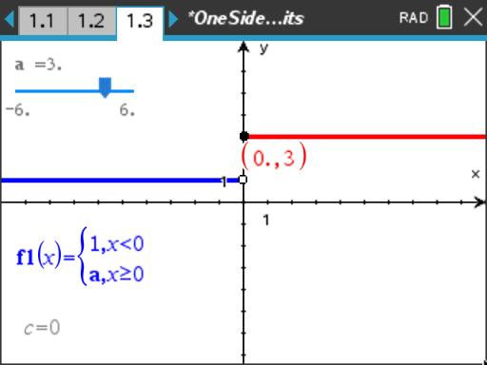
On page 1.3, before moving the slider, students will graphically estimate the limit of f1(x) as x approaches 0 from the left and the right.
Students will then use the slider to graphically estimate the value of a that will ensure that the limit of f1(x) as x approaches zero exists.

Student Worksheet solutions
- lim f1( x ) ≈ 1
x →0⁻
- lim f1(x ) ≈ 5
x →0⁺
- a ≈ 1

Problem 2
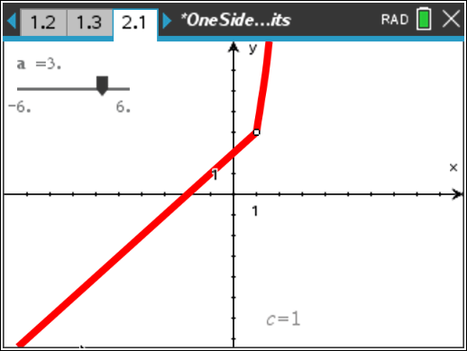
On page 2.1, before moving the slider, students will graphically estimate the limit of f1(x) as x approaches 1 from the left and the right.
Students will then use the slider to graphically estimate the value of a that will ensure that the limit of f1(x) as x approaches one exists.

Student Worksheet solutions
- lim f1( x ) ≈ 3
x →1⁻
- lim f1( x ) ≈ 5
x →1⁺
- a ≈ 3
- Consistent
- 1 + 2 = a • 1²; a = 3

Problem 3
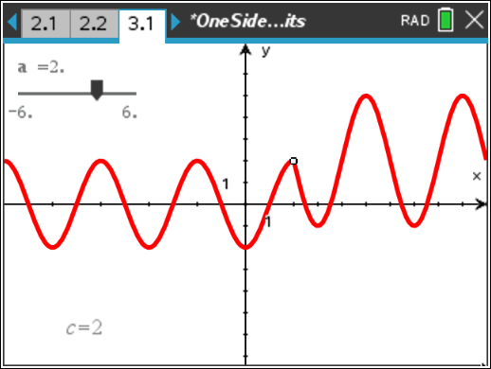
On page 3.1, before moving the slider, students will graphically estimate the limit of f1(x) as x approaches 2 from the left and the right.
Students will then use the slider to graphically estimate the value of a that will ensure that the limit of f1(x) as x approaches two exists.

Student Worksheet Solutions
- lim f1( x ) ≈ 2
x →2⁻
- lim f1(x ) ≈ 5
x →2⁺
- a ≈ 2
- Consistent
- 2 sin ⎛ π (2 − 1)⎞ = 3 sin ⎛ π (2 − 4)⎞ + a
⎜ 2 ⎟ ⎜ 2 ⎟
⎝ ⎠ ⎝ ⎠
2 sin ⎛ π ⎞ = 3 sin (−π ) + a
⎜ 2 ⎟
⎝ ⎠
2 ⋅1 = 3 ⋅ 0 + a
2 = a

Extension – Continuity
Students are introduced to the concept of continuity and are asked if each of the functions in Problems 1–3 is continuous at c given the value of a found earlier. For the functions that are not continuous, they are asked how the function can be modified to make it continuous.

Student Worksheet Solutions
- Continuous because all of the x-values in the neighborhood of x = 0 are included in the domain of the function.
- Not continuous because x = 1 is not included in the domain of the function. To make the function continuous at x = 1, either change the interval in the first branch to x ≤ 1 or change the interval in the second branch to x ≥ 1.
- Not continuous because x = 2 is not included in the domain of the function. To make the function continuous at x = 2, either change the interval in the first branch to x ≤ 2 or change the interval in the second branch to x ≥ 2.

