Topic 3.6: Sinusoidal Transformations | Using the Parameters of Sinusoidal Functions to Identify their Graphs
Practice Problem 1
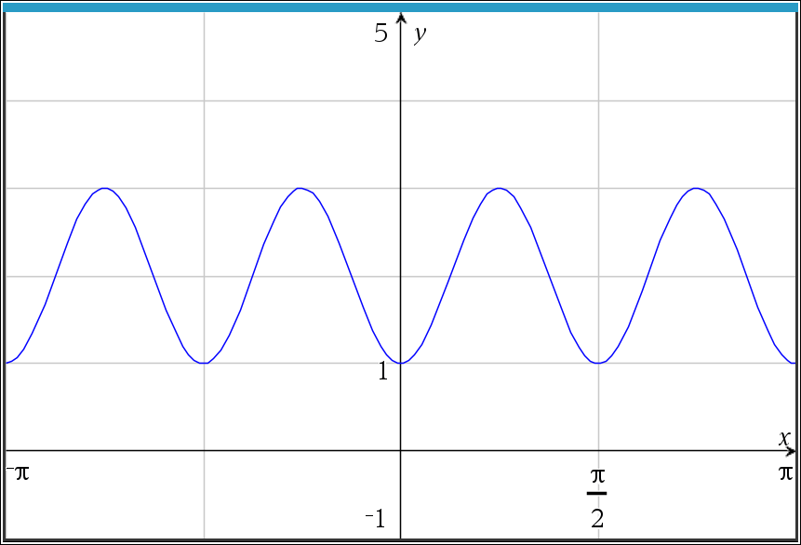
A portion of the graph of a sinusoidal function $g$ in the $xy$ plane is given for $-π ≤x≤ π$. Which of the following could define $g(x)$?
(a) $1+\sin{(4x)}$
(b) $1-\cos{(4x)}$
(c) $2+\sin{(4x)}$
(d) $2-\cos{(4x)}$

Practice Problem 2
The function $h$ is given by $h\left(x\right)=\cos{x}$. In the xy-plane, the graph of $k$ is the image of $h$ after a translation of $\frac{π}{3}$ to the right. Which of the following define $k(x)$?
(a) $\cos\left(x+ \frac{π}{3}\right)$
(b) $\cos{x+ \frac{π}{3}}$
(c) $\cos\left(x- \frac{π}{3}\right)$
(d) $\cos{x- \frac{π}{3}}$

Practice Problem 1 Solution:
(d) $2-\cos{(4x)}$
From the given choices, the graph has been vertical translated up 2, there are 4 complete curves from $-π ≤x≤ π$, and on the $y-axis$, the graph is starting at a minimum which means it is a reflected cosine function over the $x-axis$.

Practice Problem 2 Solution:
(c) $\cos\left(x- \frac{π}{3}\right)$
Since this is a horizontal translation (to the right), the value must affect the x (input) only, and with it moving right, it must be of the form $x- \frac{π}{3}$.

**Note: This activity has been developed independently by Texas Instruments. AP is a registered trademark of the College Board, which was not involved in the production of, and does not endorse, this product. Policies subject to change. Visit www.collegeboard.org.

