Open or create the TI-Nspire document Chords_of_a_Circle.tns.

Students will explore the relationship between chords of a circle and their perpendicular bisectors. It is strongly suggested that the student create the document if possible.

Move to page 1.2. | Press / ¢ and / ¡ to navigate through the lesson.
is a chord of circle O because its endpoints lie on the circle. Construct the perpendicular bisector of by pressing Menu > Construction > Perpendicular Bisector. Click and press d to exit.  1. Drag point A or B. What do you observe about the perpendicular bisector of ? | 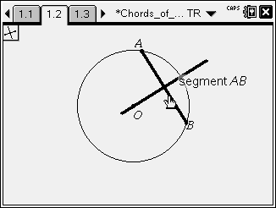
Move to page 1.3.  Construct a line through point O that is perpendicular to . Press Menu > Construction > Perpendicular. Click point O, and then click .  - Plot the intersection point of and the perpendicular line. Press Menu > Points & Lines > Intersection Point(s). Click and the line perpendicular to . Label this point M by immediately pressing g M. Press d to exit.  - Measure the lengths of and . Press Menu > Measurement > Length. Click point A, click point M, move the measurement to the inside of the circle close to the middle of, and press x. Then click point M, click point B, move the measurement to the inside of the circle close to the middle of , and press x. Then press d to exit. | 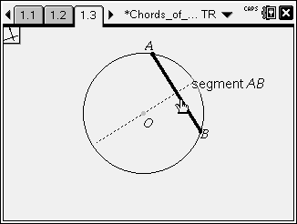  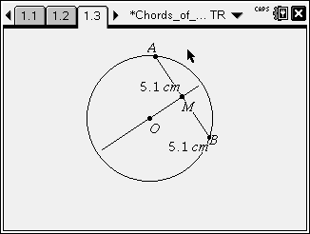
2. Drag point A or B. What is the relationship between and ?

3. When the length of is as short as possible, what do you observe about ?

4. When the length of is as long as possible, what do you observe?

Move to page 1.4.  Construct the midpoint of . Press Menu > Construction > Midpoint. Click , and label this point M by immediately pressing g M. Press d to exit.  - Create by pressing Menu > Points & Lines > Segment. Click point O, and then click point M. Press d to exit.  - Measure by pressing Menu > Measurement > Angle. Click point A, then click point M, and then click point O. Press d to exit. Note: you may need to grab and move either the letter M or the 90º.  - Create radius by pressing Menu > Points & Lines > Segment. Click point A, and then click point O. Press d to exit. | 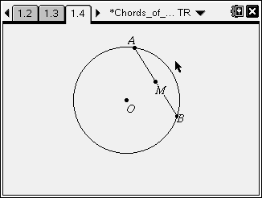  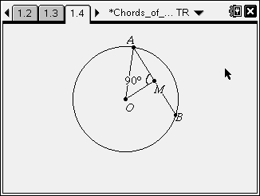
5. What type of triangle is ∆AMO?
6. When given the lengths of any 2 sides of ∆AMO, what equation can be used to find the length of the third side?
7. If and , find the length of .
Move to page 1.5.
Drag points A, B, and C until .  8. What is the relationship between and ? | 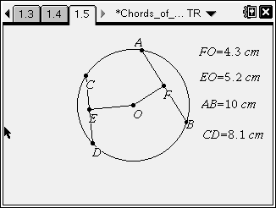
9. Drag points A, B, C, and D until . What is the relationship between and ?

