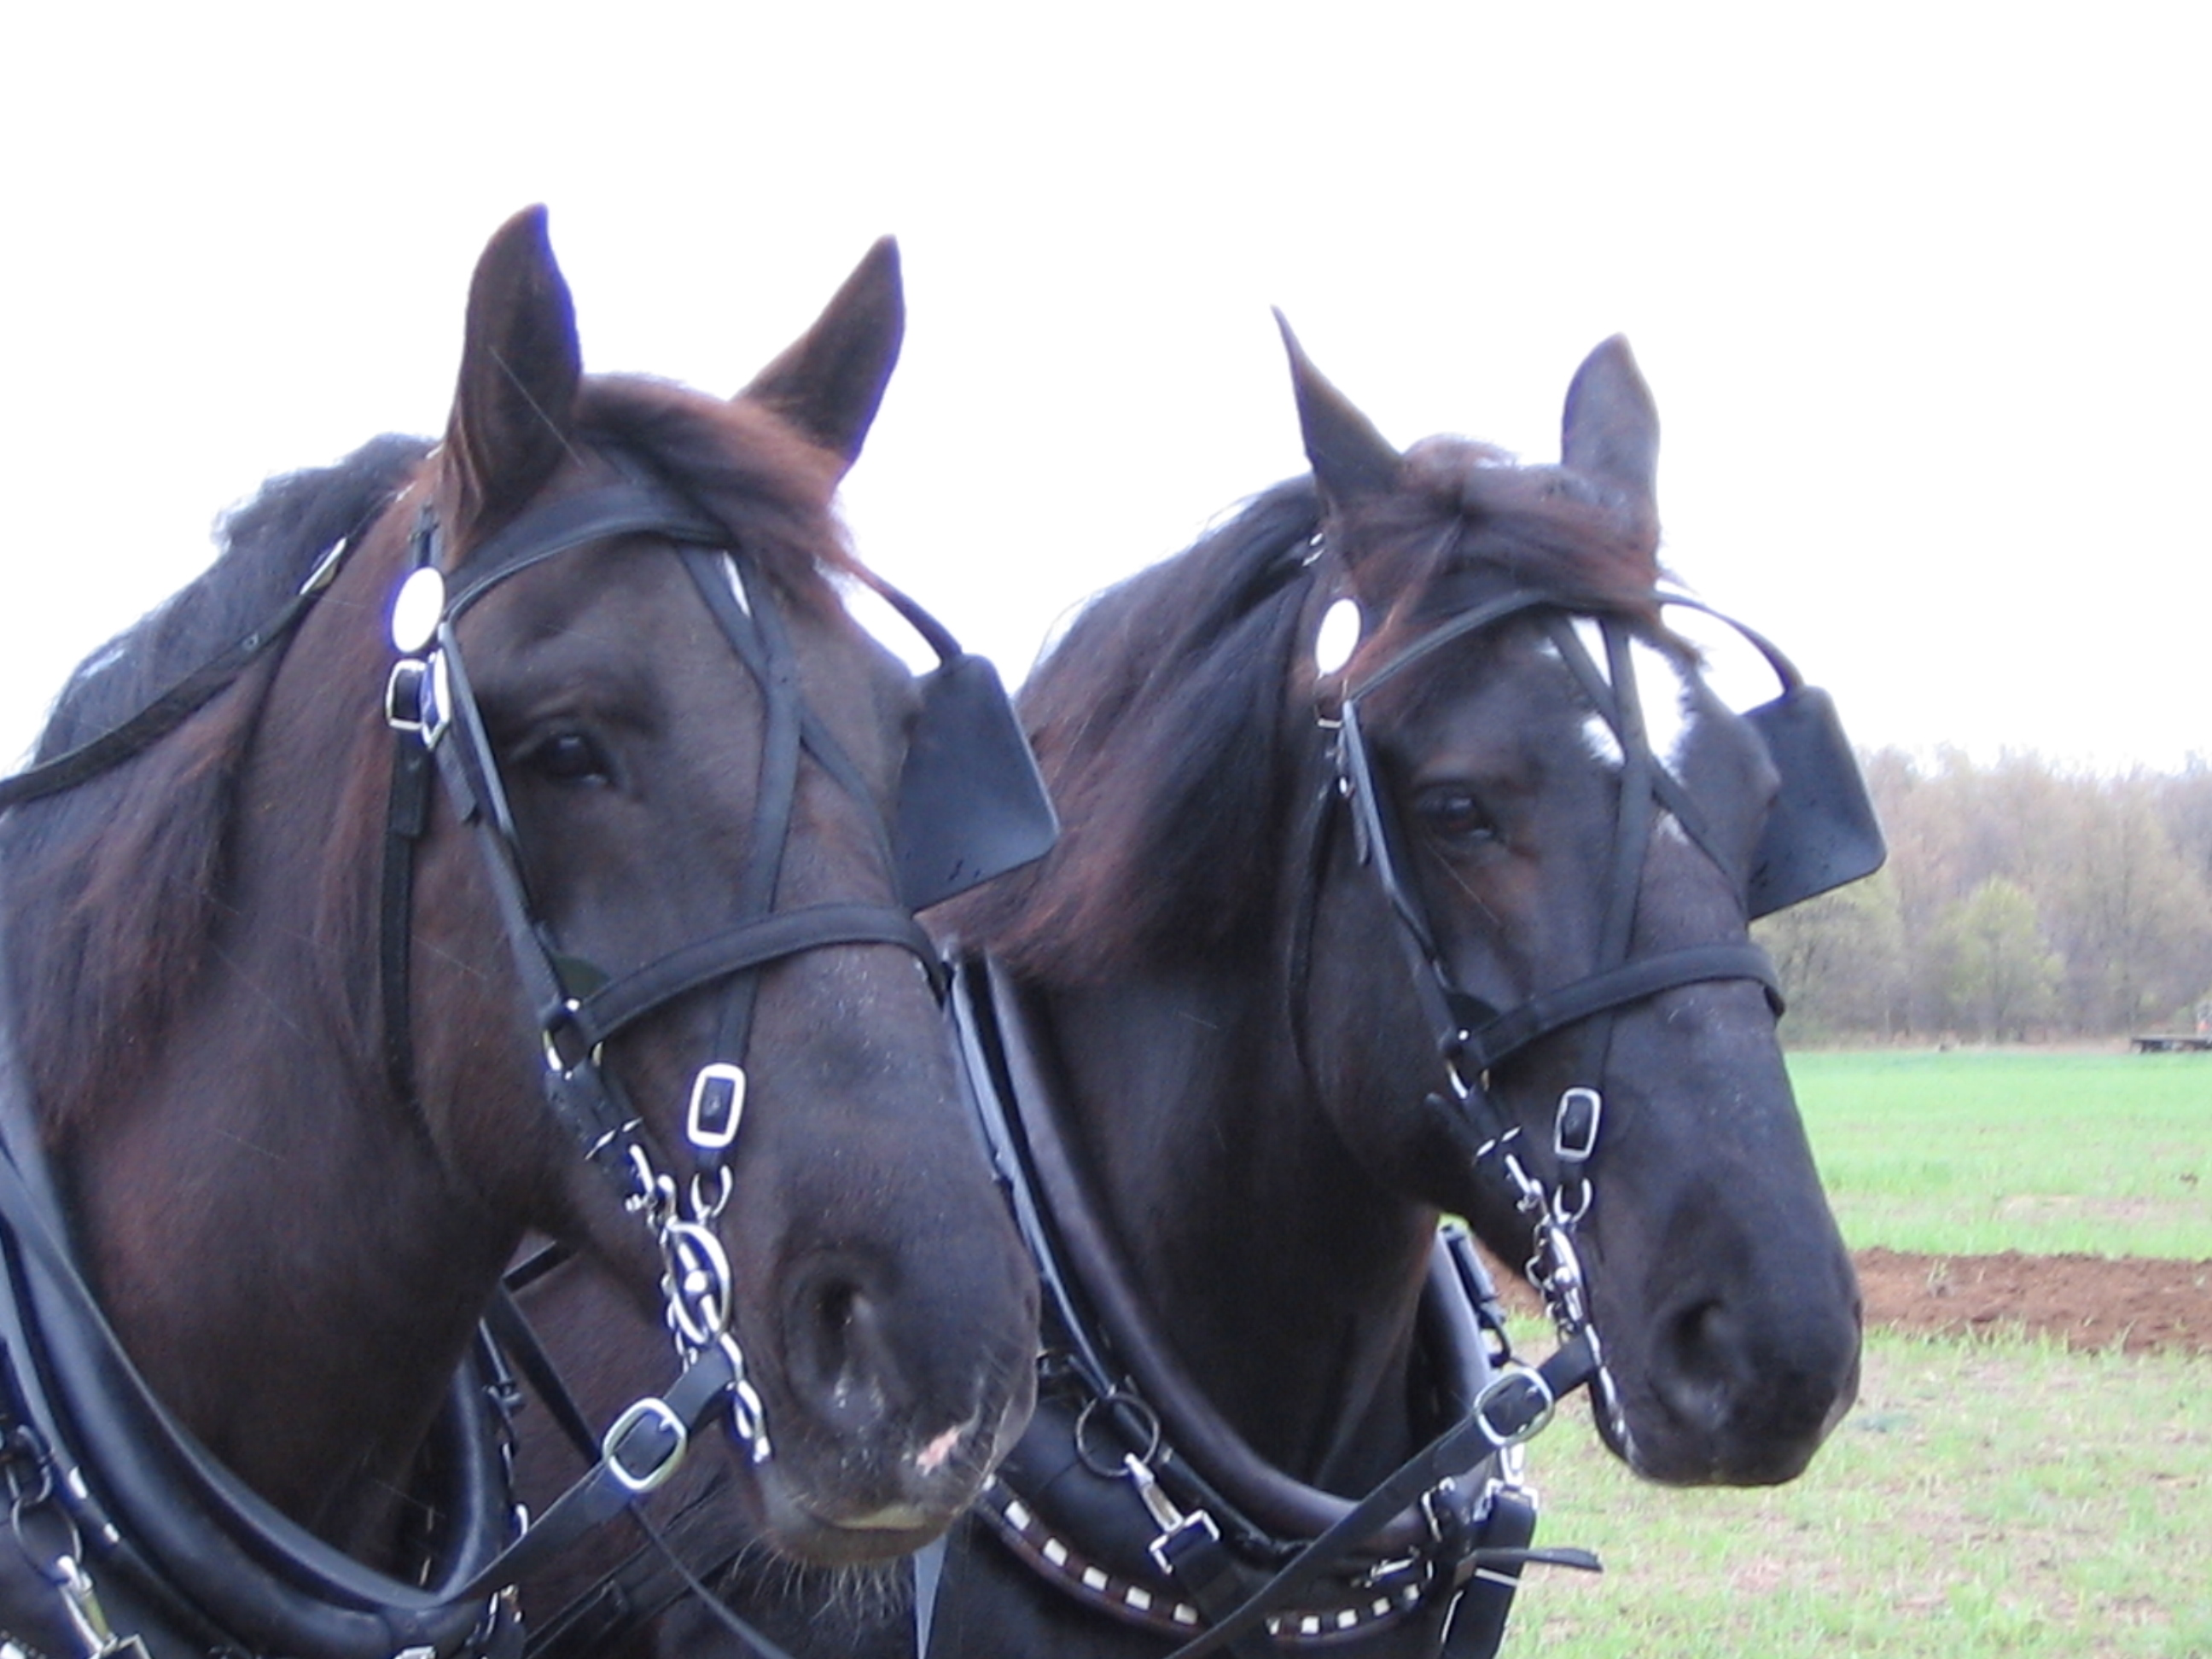 Parallel Horses by Peg Alofs Becker

Activity Overview: Using the activity center and the Navigator software, the students will review ordered pairs, and the equations for horizontal, parallel, and perpendicular lines.

Grade Level: 7-12
Activity Time: 30 minutes if used as a review and more if used to teach concepts
Author: Peg Alofs Becker
Subject area(s): Math: Algebra: Linear Equations/Functions
Calculators: TI-83 Plus, TI-83 Plus silver, TI-84 Plus, TI-84 Plus silver
Computer Software: TI-NavigatorTM
Before the Activity starts: Teacher should use the computer to “Load” the background image “Horses” behind the graph in the Activity Center.
While in the Activity Center:
Under the pull-down menu “File”
Remove Background image if there is one already
Load Background Image
Find the image wherever you downloaded it.
Under the pull-down menu “View”
- use the default -10 to 10 screen window
- select “individualize student cursors

If the class need to review the placement of ordered pairs select “contribute points” and under “configure” use the following:

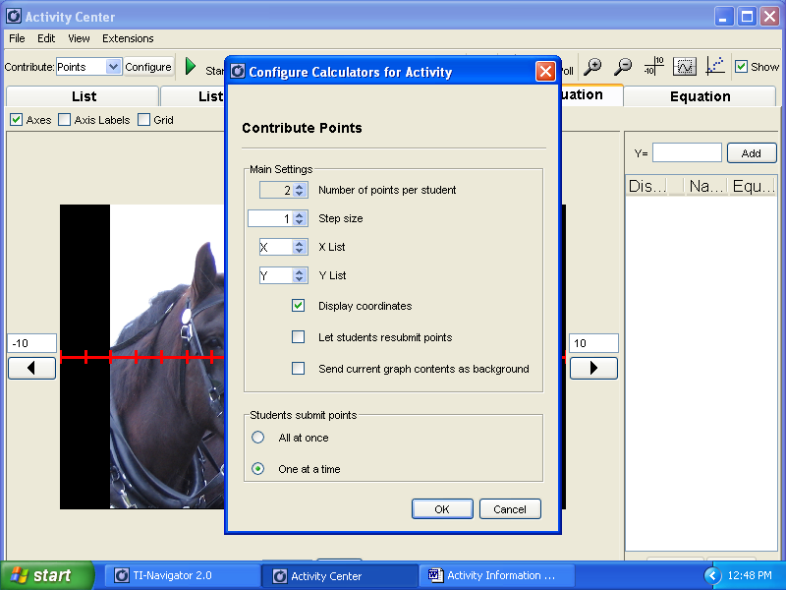

Students should be logged in and have them enter the activity center. Start the activity.

Tell the students to place a point on the nose of the right horse, just to get them use to moving their cursor around.

Stop the activity. Discuss points if some are wrong.
Clear Activity Data (under the “Edit” pull down menu)

Next, tell them to place a point at (-4,7). After everyone has placed one or two points, hold the cursor on some of the incorrect ones, such as a probable (7,-4), and discuss what was done wrong. Don’t have the names turned on at this point.
You might show the names of those who found the right position. You can either hold the mouse on that position until the names and coordinates show up or click on “equation” or “graph-equation” to show list of ordered pairs, with or without names.

Now change to “contribute equations” and configure to :
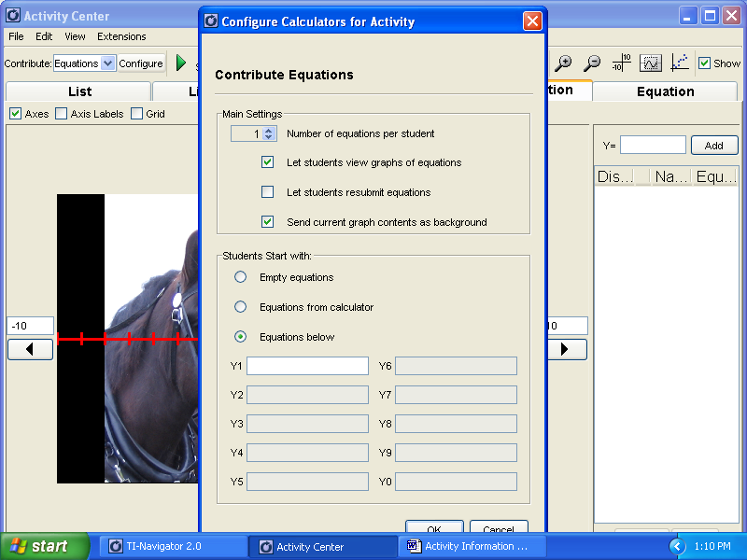

Stop the activity. Discuss points if some are wrong.
Clear Activity Data (under the “Edit” pull down menu)

Tell students to submit equations for lines that go through BOTH horses’ noses.
Start activity and wait until all lines are drawn. Discuss incorrect lines with the names turned off. Discuss lines that hit both noses, with the names turned on.
(example of a correct answer Y= -7) Allow for horizontal and non-horizontal submissions and discuss the difference in these equations using the equation screen.

Stop the activity. Discuss lines if some are wrong.
Clear Activity Data (under the “Edit” pull down menu)

Have the students submit equations for lines that go through a certain part of the halter.
Point at it with your cursor.
(I selected Y = -5x –22 to use first. )

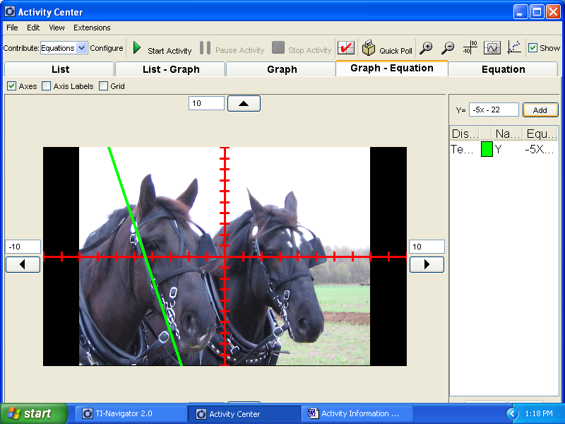

Next, leave only that line up and challenge them to get lines that go through the same part of the halter on the other horse by making a horizontal translation.
(example Y = -5x +10) This can be repeated for many similar matching parts.

Next Stop activity, clear data, and leave only Y = -5x –22 graphed.
RESIZE the graph by going under the “view” pull-down menu and doing a “zoom square.” The line will no longer go through the halter in the same place but that’s ok.

Ask them to draw lines (any lines) that are perpendicular to the line left on the screen.
If you left Y= -5x –22 visible the simplest line would be Y = (1/5) x or Y = .2x

Hopefully you will have a lot of perpendicular lines and a few wrong ones to discuss.

Then ask them to draw a perpendicular line that also goes through the very tip of any ear.
An example would be Y = .2x + 8.85

To make their task more difficult, start with a line they don’t have the equation for, and then ask them to draw a line perpendicular to the given line, which goes through some point on a horse. You can “mask teacher input” under the pull down menu “view.”

To assess individual learning, turn names on and record who submitted correct and incorrect responses, use a “quick poll” and note answers submitted, or a simple “learn check”

