PROJECT OVERVIEW: Building Paper Bridges
In this project, students will collect data to explore the relationship between force, mass and acceleration due to gravity. In the context of a challenge, students are engaged in a competition to determine which group can build the strongest bridge, and then predict and verify a model for the system prior to making any measurements on the system. Finally, the students will collect the data and determine how well their model fits the outcome they observe.
PROJECT OUTLINE:
The goal:
The goal here is to find out two things: First, which group can build the strongest bridge while following the guidelines and then to verify that the model they predict for relating mass and force makes sense. The intent is for students to model the system prior to building or taking measurements. Students should think about what kind of data they are collecting, how increasing the mass in the cup will show up in the force measurements and how the two are related. The coolest part – the slope and y-intercept will have real meaning.
The challenge:
Build the strongest bridge possible using only one sheet of paper. Students use a single sheet of paper to fold the strongest bridge they can following the guidelines.

Materials list (per group):
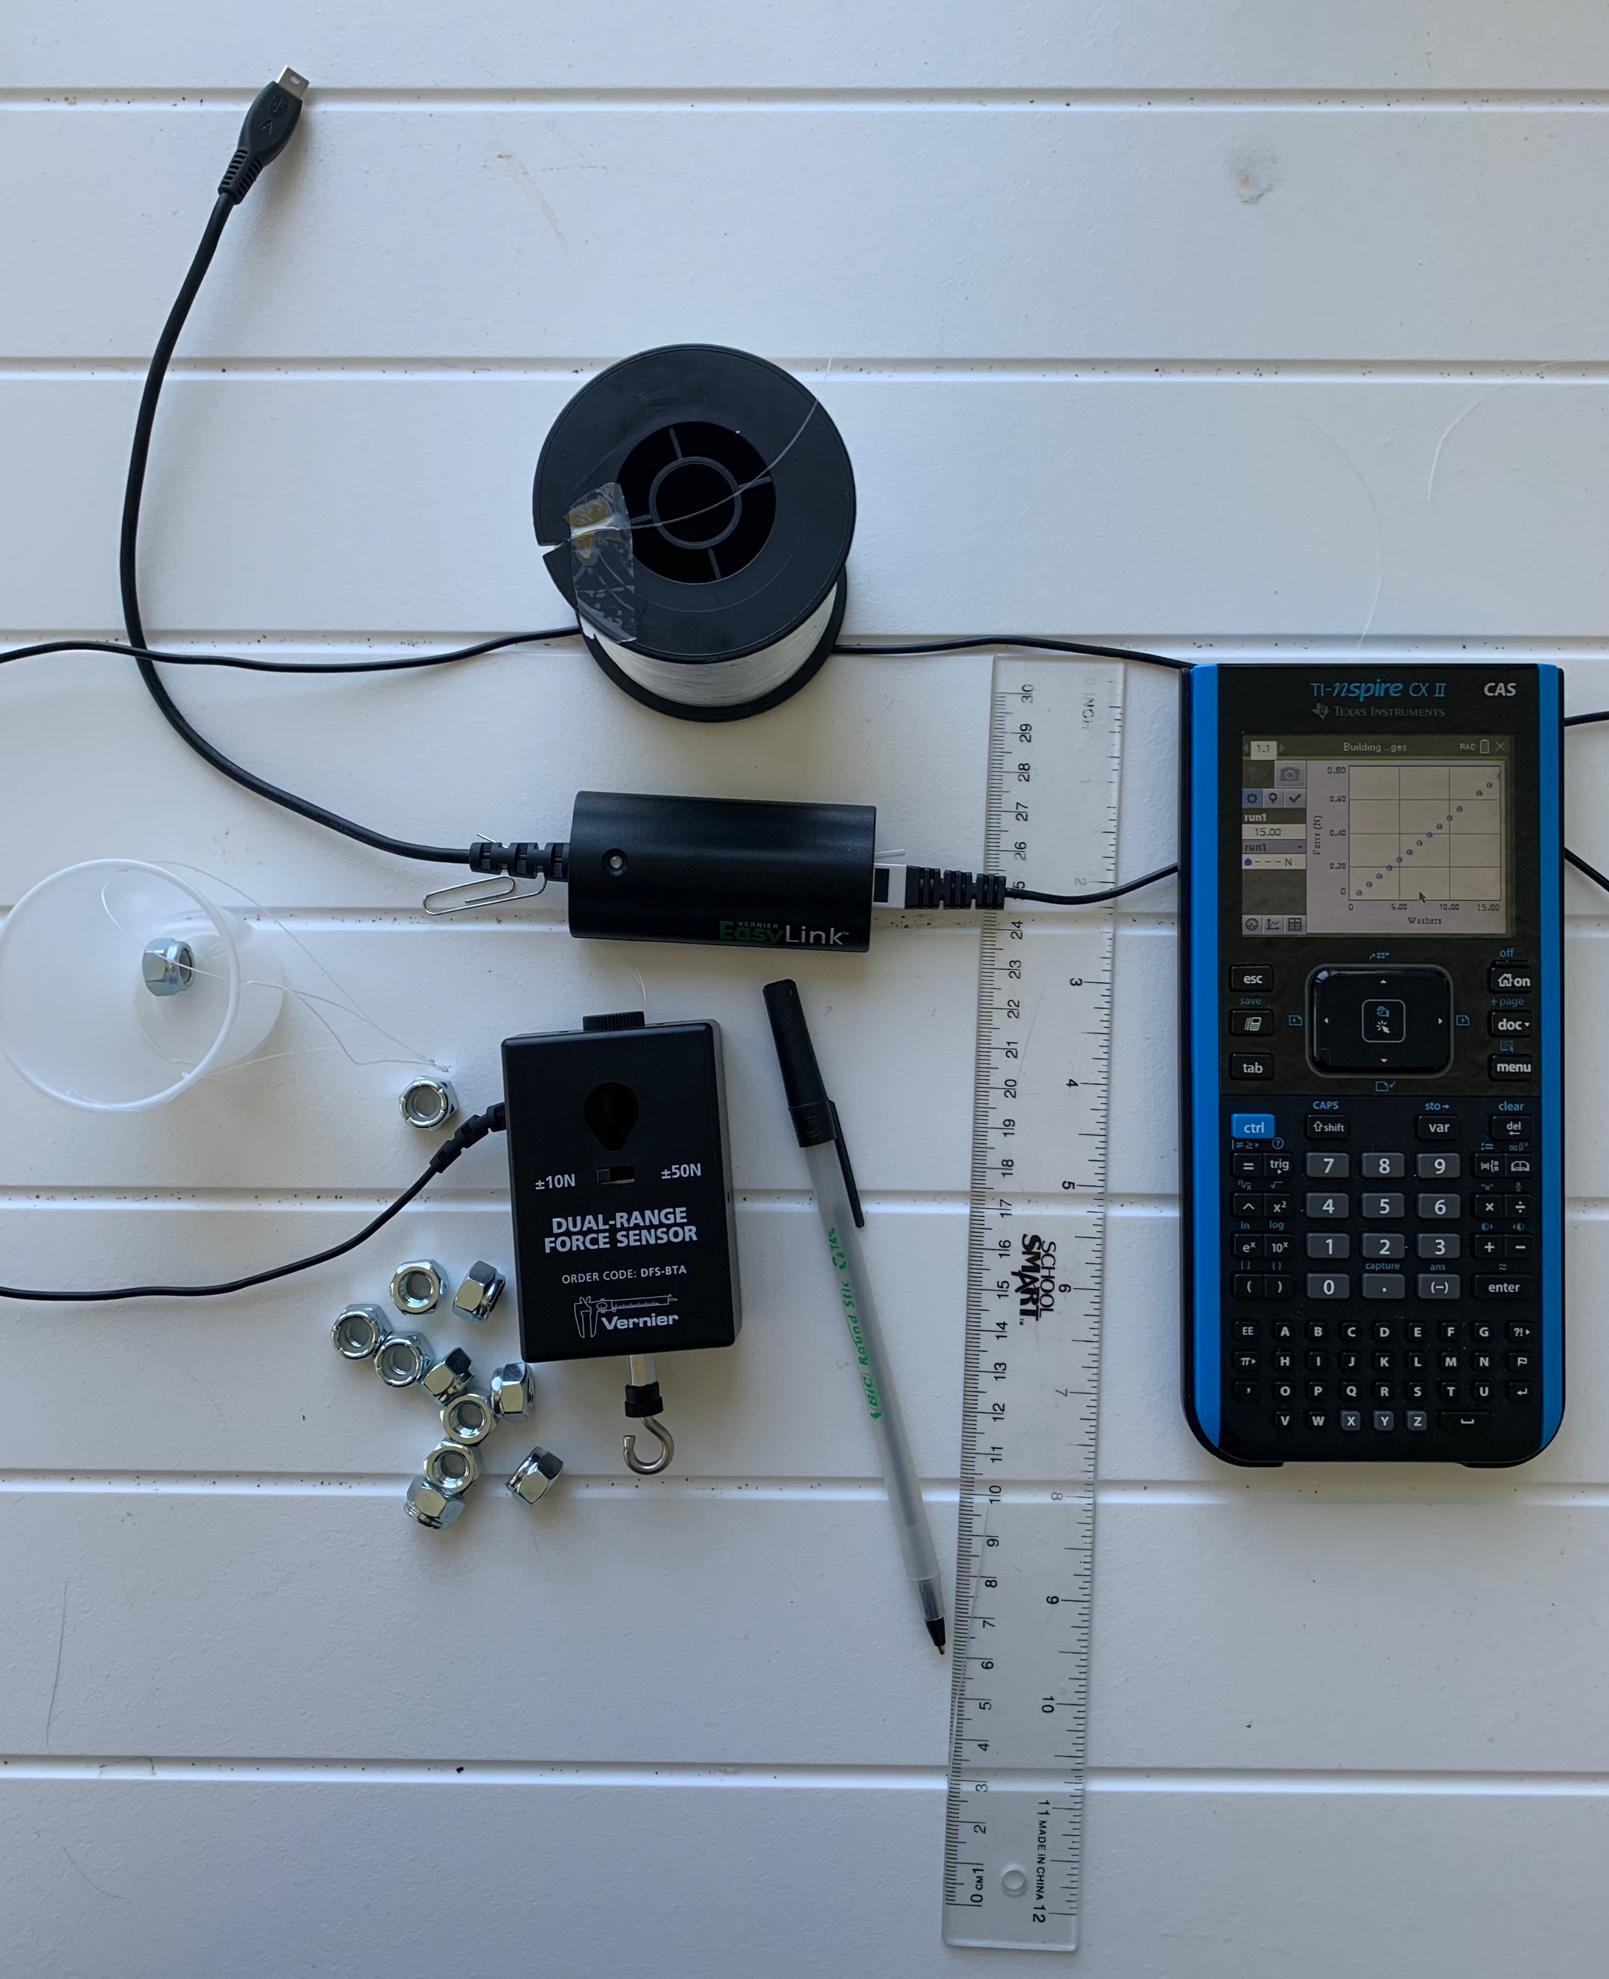
- 1 – 8.5”X11” sheet of paper
- 1 sheet of graph paper
- 20 identical washers (or other small weights)
- 1 – popsicle stick
- 12” to 24” of string or fishing line
- 1 – ½” screw eye
- 1 – small paper cup
- 1 – Vernier Dual Range Force sensor (in 10 N mode)
- 1 – Vernier EasyLink™ Interface

Rules for building your bridge:
- You must span a gap of 8”;
- You have 1 sheet of 8.5”X11” paper and no other materials (no tape, no glue, etc.);
- Your bridge must have a “guardrail” that is at least 0.5” high on both sides;
- You have one “car” represented by the popsicle stick;
- The “car” should be placed at the very middle of the bridge while data is collected;
- The screw eye goes through the bridge and attaches to the “car” and the force sensor hangs from the screw eye;
- Secure the cord for the force sensor so it doesn’t interfere with the data collection.

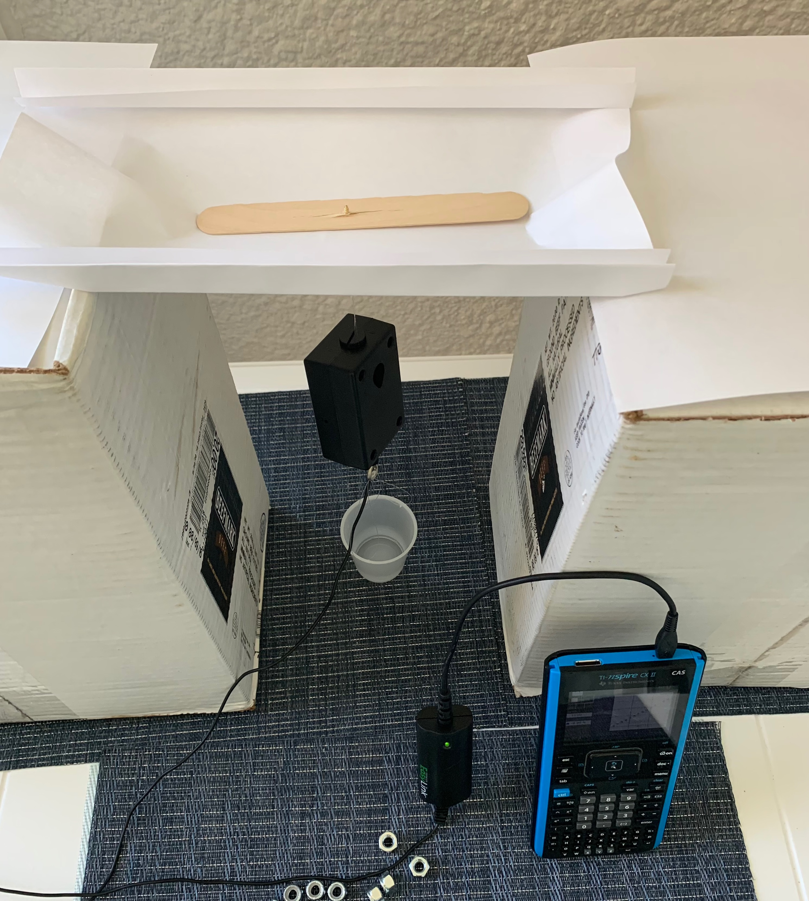
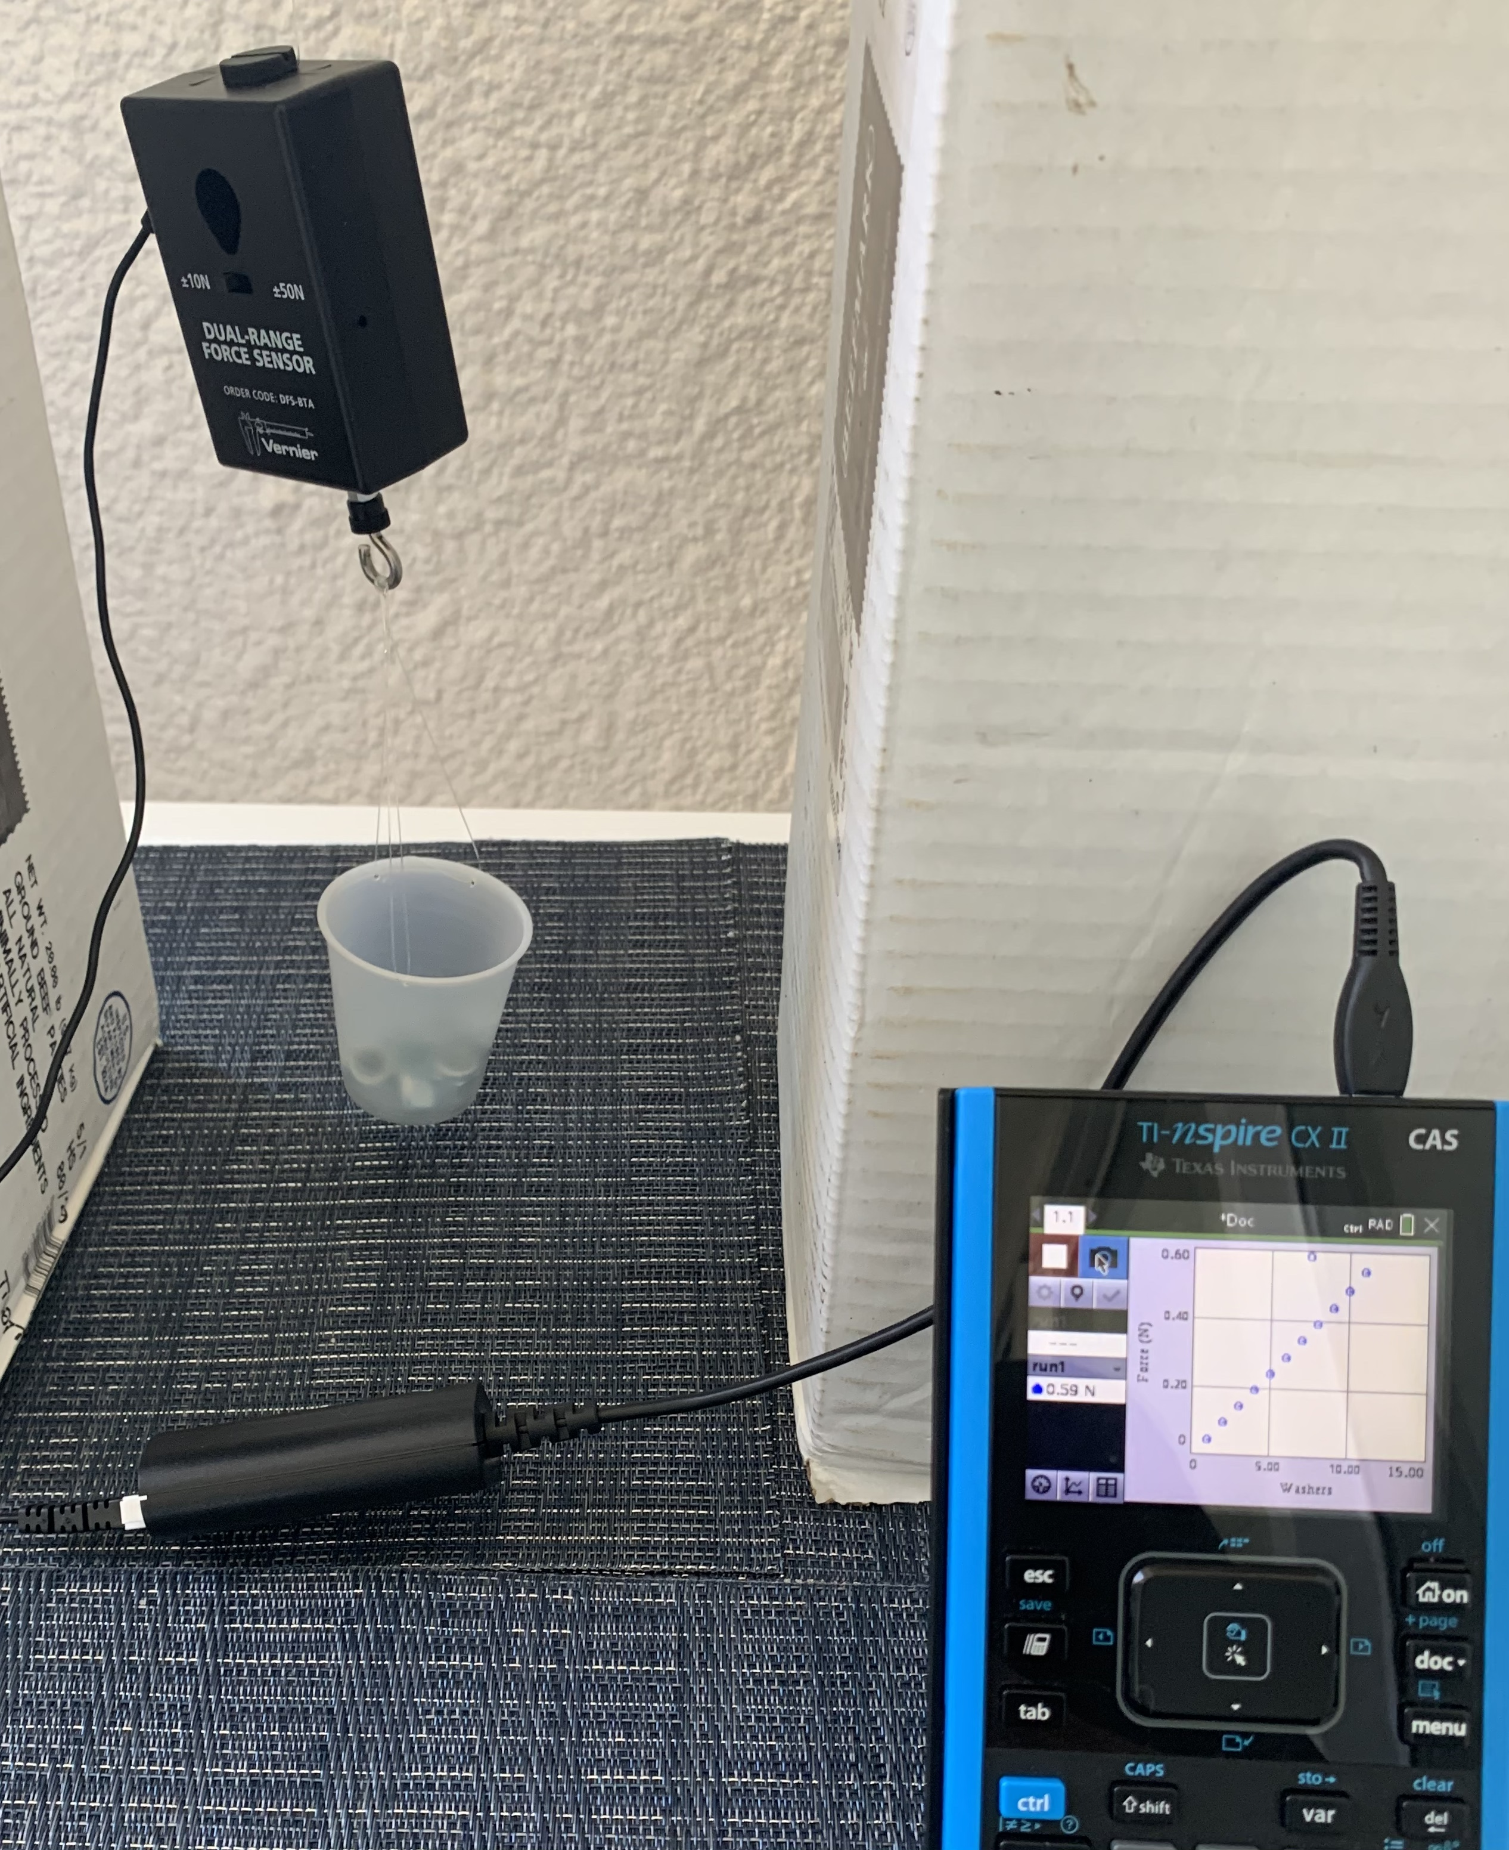

Think it through and build a mathematical model:
Students should decide what type of relationship they expect to see between force measured and the number of washers in the cup. Have them write a generic equation to model this relationship.
Ready for Data Collection:
Once students have a model they think will work, they should begin collecting data. First, they should determine, using a balance, the mass (in kg) of the force sensor and empty cup. They should also measure the mass (in kg) of a single washer. Ask how they expect to see this information turn up in their data.
Setting up the DataQuest App:
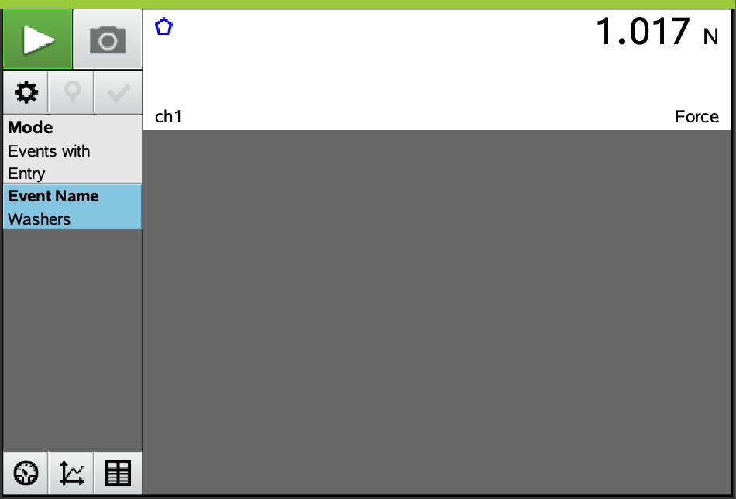
Once the setup is completed as pictured above, students should make sure the TI-Nspire is on the homescreen. Once they connect the sensor to the TI-Nspire using an EasyLink™ interface, the DataQuest app will open. They will need to set up the force sensor by selecting Mode > Events with Entry and Event Name > Washers.

Data Collection:
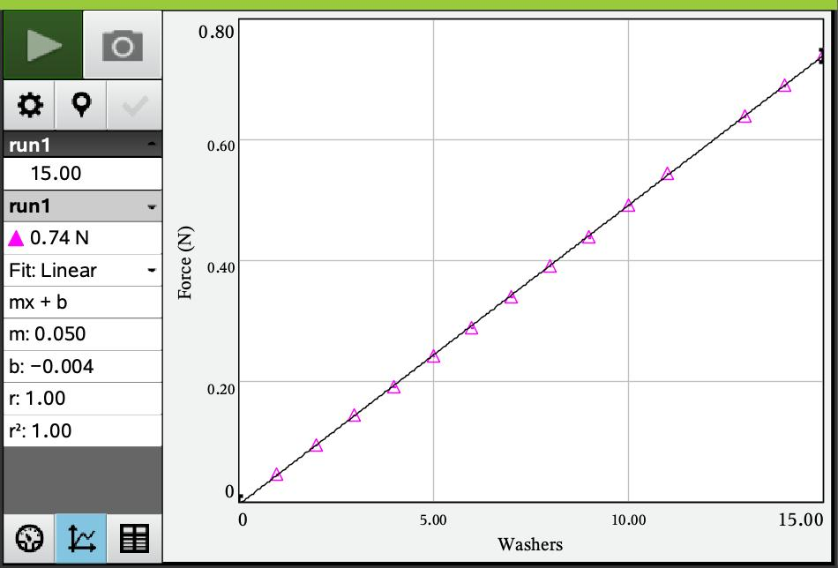
To begin data collection, students press the green START arrow and then select the “camera icon” to store a data point. Students should start with one washer in the cup and take a data point. Then add washers one at a time, taking a data point with each new washer, until they run out of washers or the bridge breaks.
Note: Remind students not to press the red STOP icon until they have collected all data.
Interpreting the Data:
In DataQuest, the data will be stored in a table, (number of washers and force in Newtons respectively.) Have students create a scatterplot of Newtons vs. number of washers and discuss whether the model they wrote earlier fits the relationship they see in their data. Using the regression capability of their calculator, they should analyze their data, using a linear regression model.
Menu > 4-Analyze > 6-Curve Fit >1-Linear. Remind students to write down the values for m and b they get from the regression analysis.
Ask students:
- What is the value of the slope? What does it represent?
- What about the y-intercept? What does it represent?

Fun Physics Extension:
Have students add two pages to their document, List and Spreadsheet and Data and Statistics. From the table on the DQ page, have them copy both columns into the L&S page and label columns A and B ‘washers’ and ‘force.’ They should label columns ‘C’ and “D’ mass and ‘neg_force.’ In column ‘C’ multiply the number of washers in column A by the mass of a single washer (in kg). Then multiply the force in ‘B’ by negative 1 since the force is in a downward direction and store in ‘D.’ Now the students should plot a new plot of force (in N) vs. “mass of car” (column ‘D’ vs. column ‘C’).
Ask students:
- What does the slope of this relationship (newtons) represent? Could you have guessed it?
- Compare the y-intercept to the first model. Why do you think that happened?

- Size of the washers
- Sheets of paper
- Height of the “guardrail”

Extension # 2: Changing Variables
Challenge students to change different factors in the setup and see how that impacts the outcome. Possible things to change:
- Length of the span
- Length of the popsicle stick

