Vocabulary  equivalent fractions:  improper fraction: | In this activity, you will generate equivalent fractions and compare two fractions referring to the same whole.
Vocabulary  equivalent fractions:  improper fraction: | 1. Write the fraction equivalent to whose  a. denominator is 8.  b. numerator is 9.
Vocabulary  equivalent fractions:  improper fraction: | 2. Is there a fraction equivalent to that has a denominator less than 3? Why or why not? (Hint: Think about fractions with consecutive numerators and denominators of 1 or 2.)
Vocabulary  equivalent fractions:  improper fraction: | 3. Tomas says that is greater than because 8 is bigger than 3. What would you tell Tomas? Draw the fractions on the number lines to illustrate your answer.  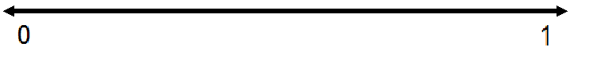

4.  Apply what you have learned about equivalent fractions to explain why and are not equivalent.

3

