Math Objectives  - Students will explore the family of logarithmic functions of the form  $f\left(x\right)=c∙ \log_{b}\left(x+a\right)$ and describe the effect of each parameter on the graph of $y=f(x)$.  - Students will determine the equation that corresponds to the graph of a logarithmic function.  - Students will understand how a vertical shift in the graph of a logarithmic function is related to properties of logarithmic functions.  - Students will look for and express regularity in repeated reasoning (CCSS Mathematical Practice).  - Students will look for and make use of structure (CCSS  Mathematical Practice).  Vocabulary  - Logarithmic function • natural logarithm • translation  - parameter • reflection  About the Lesson  - This lesson involves the family of logarithmic functions of the form $f\left(x\right)=c∙\log_{b}\left(x+a\right)$.  - As a result, students will:  - Manipulate minimized sliders, and observe the effect on the graph of the corresponding logarithmic function.  - Make a general statement about the effect of each parameter on the graph of the logarithmic function.  - Match specific logarithmic functions with their corresponding graphs.  - Relate properties of logarithmic functions to vertical translations of their graphs.  TI-Nspire™ Navigator™  - Transfer a File.  - Use Class Capture to examine patterns that emerge.  - Use Live Presenter to demonstrate.  - Use Teacher Edition computer software to review student documents.  - Use Quick Poll to assess students’ understanding  Activity Materials  Compatible TI Technologies:  TI-Nspire™ CX Handhelds,   TI-Nspire™ Apps for iPad®,  TI-Nspire™ Software | 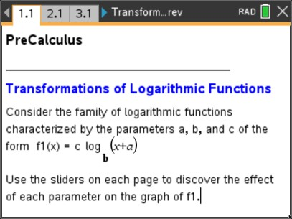  Tech Tips:  - This activity includes screen captures taken from the TI-Nspire CX II handheld. It is also appropriate for use with the TI-Nspire family of products including TI-Nspire software and TI-Nspire App. Slight variations to these directions may be required if using other technologies besides the handheld.  - Watch for additional Tech Tips throughout the activity for the specific technology you are using.  - Access free tutorials at http://education.ti.com/calculators/pd/US/Online-Learning/Tutorials  Lesson Files:  Student Activity  Transformations of Logarithmic Functions_Nspire_Student.pdf  Transformations of Logarithmic Functions_Nspire_Student.doc  Transformations_of_Logarithmic_Functions.tns
In this activity, you will explore the family of logarithmic functions and describe the effect of each parameter on their graphs. You will describe transformations while using properties of logarithmic functions. All this will be done while using technology to help visualize each situation. | 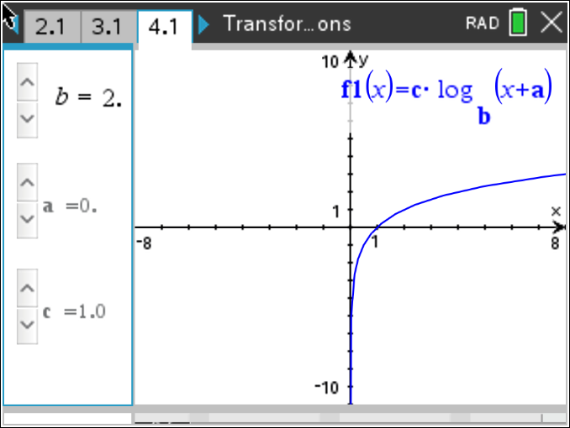

____________________________________________________________________________

Discussion Points and Possible Answers

Tech Tip: To change a slider setting, right-click in a slider box and selection option 1. Consider changing the (start) value, minimum and/or maximum value, and/or the step size in order to help discover or confirm the effect of a specific parameter. You can also change the specific values in the column labeled blist of the Lists & Spreadsheets page.

Teacher Tip:
- There is a separate Lists & Spreadsheet page with a column labeled blist on Pages 2.2, 3.2, and 4.2, respectively. These pages are not dynamically linked. That is, if you change a value in the column labeled blist on Page 2.2, the column labeled blist on Pages 3.2 and 4.2 does not change automatically.
- The Slider_Template_Values document provides instructions to create a slider that takes on specific values. Use these guidelines to change the slider type associated with the variables a and c in this activity, if desired. 3. It is possible to increase (or decrease) the number of values that the variable b can assume. Change the maximum (or minimum) in the slider settings for b, and add (or delete) values to the column labeled blist in the appropriate Lists & Spreadsheet page.

The parameter $b$ is the base of the logarithmic function and $b>0, b≠1$. Using the sliders in the left panel of each page, change the value of a parameter, and record the effect of each parameter change on the graph of the corresponding logarithmic function. At the end of this activity, use your results to match each function with its corresponding graph.
Note: The slider for the base $b$ is constructed to use the specific values in the column labeled blist in the Lists & Spreadsheets page.

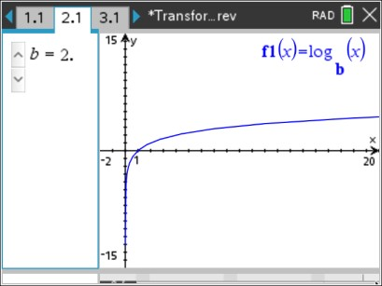
Move to page 2.1.

1. The graph of $y=f1\left(x\right)=\log_{b}{x}$ is shown in the right panel.
Click the arrows to change the value of $b$, and observe the changes in the graph of $f1$.
- Explain why for every value of $b$, the graph of $f1$ passes through the point (1,0).

Sample Answers: The graph of $y=f1\left(x\right)=\log_{b}{x}$ passes through the point (1,0) for all values of $b>0$ since
$f1\left(0\right)=\log_{b}{1}=0$. The x -intercept is 1. There is no
y - intercept.
- For $b>1$, describe the graph of $y=f1\left(x\right)=\log_{b}{x}$.

Sample Answers: The graph is always increasing. As x increases without bound, the values of f1 also increase without bound. As x gets closer to zero from the right $\left(x →0^{+}\right)$, the values of f1 decrease without bound, go to $-∞$. The graph is smooth with no sharp edges or corners, and
is also continuous with no jumps or breaks.
Note: For some values of b, the graph of f1 might not appear to be decreasing quickly near 0. However, the function values do continue to decrease such that $f1 → -∞$. Consider asking students to construct a table of function values as x gets closer to 0.

- For $0<b< 1$, describe the graph of $y=f1\left(x\right)= \log_{b}{x}$.

Sample Answers: The graph is always decreasing. As x increases without bound, the values of f1 decrease without bound, go to $-∞$. As x gets closer to zero from the right $\left(x → 0^{+}\right)$, the
values of f1 increase without bound, go to $∞$. This graph is also smooth and continuous.
Note: For some values of b, the graph of f1 might not appear to be increasing quickly near 0. However, the function values do continue to increase such that $f1 → ∞$. Consider asking students to construct a table of function values as x gets closer to 0.

- Find the domain and range of function $f1\left(x\right)= \log_{b}{x}$ for all possible values of $b$.

Sample Answers: The domain is $x>0$, and the range is all real numbers: $\left(-∞, ∞\right)$.

- Describe the behavior of the graph of $y= \log_{b}{x}$ near the y –axis in words and using limit notation.

Sample Answers: For $b>1$: as x approaches 0 from the right, the values of the function decrease without bound and the graph gets closer and closer to the y -axis, but never touches it (0 is not in the domain of the function). $\lim_{x → 0^{+}}{f1\left(x\right)= -∞}$
For $0<b<1$: as x approaches 0 from the right, the values of the function increase without bound and the graph gets closer and closer to the y -axis, but never touches it. $\lim_{x → 0^{+}}{f1\left(x\right)= ∞}$
The y -axis, or the line $x=0$, is a vertical asymptote to the graph of $y= \log_{b}{x}$.

Note: The slider for b is set to minimized, style: vertical, and references the specific values in the column labeled blist. The purpose of using a specific values slider is to avoid the case $b=1$. The logarithm function is not defined for $b=1$.

TI-Nspire Navigator Opportunity: Quick Poll See Note 1 at the end of this lesson.

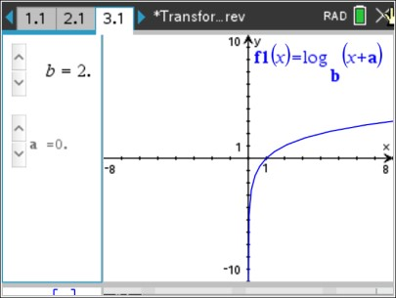
Move to page 3.1.

- The graph of $y=f1\left(x\right)= \log_{b}{(x+a)}$ is shown in the right panel. For various (fixed) values of b, click the arrows to change the value of a, and observe the changes in the graph of f1. Describe the effect of the parameter a on the graph of $y= \log_{b}{(x+a)}$.

Sample Answers: For $a>0$, the graph is translated horizontally, or moved, left a units. For $a<0$, the graph is translated right a units.

TI-Nspire Navigator Opportunity: Quick Poll See Note 1 at the end of this lesson.

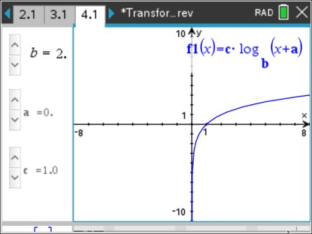
Move to page 4.1.

- The graph of $y=f1\left(x\right)=c∙\log_{b}{(x+a)}$ is shown in the right panel. For various (fixed) values of a and b, click the arrows to change the value of c, and observe the changes in the graph of f1. Describe the effect of the parameter c on the graph of
$y=c∙\log_{b}{(x+a)}$.

Sample Answers: For $\left|c\right|>1$, the graph is stretched vertically. For $\left|c\right|<1$, the graph is
contracted vertically. If $c<0$, the graph is reflected across the x -axis.

TI-Nspire Navigator Opportunity: Quick Poll See Note 1 at the end of this lesson.

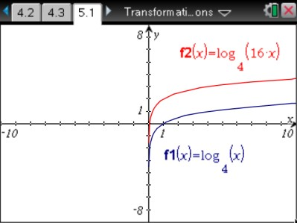
Move to page 5.1.
- Consider a logarithmic function of the form $f\left(x\right)= \log_{b}{(dx)}$ where d is a constant. Use this Graphs Page (without sliders) to interpret the graph of $y=f\left(x\right)$ as a common transformation.

  - Display the graphs of $y=f1\left(x\right)= \log_{4}\left(x\right)$ and
$y=f2\left(x\right)= \log_{4}{(16x)}$.
- How is the graph of $f2$ related to the graph of $f1$?

Sample Answer: The graph of f 2 is a vertical shift, up 2 units, of the graph of
f1.
- Using the properties of logarithms, rewrite the function $f2$ in terms of $f1$ to justify your answer.

Sample Answer: $f2\left(x\right)= \log_{4}\left(16x\right)= \log_{4}\left(16\right)+ \log_{4}{x}=2+ \log_{4}{x}=f1\left(x\right)+2.$This equation, $f2\left(x\right)=f1\left(x\right)+2$, illustrates the vertical shift, or translation.

- Describe the two equivalent transformations that $f2\left(x\right)= \log_{4}{(16x)}$ performs on the parent function $f1\left(x\right)= \log_{4}{x}$.

Sample Answer: The vertical shift, or translation, of 2 was equivalent to a horizontal dilation by a factor of $\frac{1}{16}$.

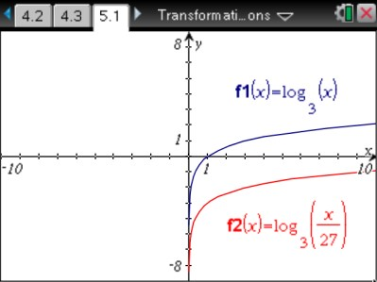
  - Display the graphs of $y=f1\left(x\right)= \log_{3}{(x)}$ and
$y=f2\left(x\right)= \log_{3}\left(\frac{x}{27}\right)$.
- How is the graph of f 2 related to the graph of f1?

Sample Answer: The graph of f 2 is a vertical shift, down 3 units, of the graph of f1.
- Using the properties of logarithms, rewrite the function f 2 in terms of f1 to justify your answer.

Sample Answer: $f2\left(x\right)= \log_{3}\left(\frac{x}{27}\right)= \log_{3}{x}- \log_{3}{27}= \log_{3}{x}-3=f1\left(x\right)-3$
This equation, $f2\left(x\right)=f1\left(x\right)-3$, illustrates the vertical shift, or translation.
- Describe the two equivalent transformations that $f2\left(x\right)= \log_{3}\left(\frac{x}{27}\right)$ performs on the parent function $f1\left(x\right)= \log_{3}{x}$.

Sample Answer: The vertical shift, or translation, of -3 is equivalent to a horizontal dilation by a factor of 27.

- Without using your calculator, match each equation with its corresponding graph below.

(a) $f\left(x\right)= \log_{3}{(x+4)}$ | (b) $f\left(x\right)= \log_{1/4}{(x)}$
(c) $f\left(x\right)= -\log_{4}{(x-2)}$ | (d) $f\left(x\right)= -3\log_{1/2}{(x+1)}$
(e) $f\left(x\right)= \log_{e}{x}=\ln{x}$ | (f) $f\left(x\right)=5\log_{1/5}{(x+5)}$

Sample Answers: (a) $→$ (iv), (b) $→$ (iii), (c) $→$ (vi), (d) $→$ (v), (e) $→$ (ii), (f) $→$ (i) Note: Ask students to explain their reasoning.

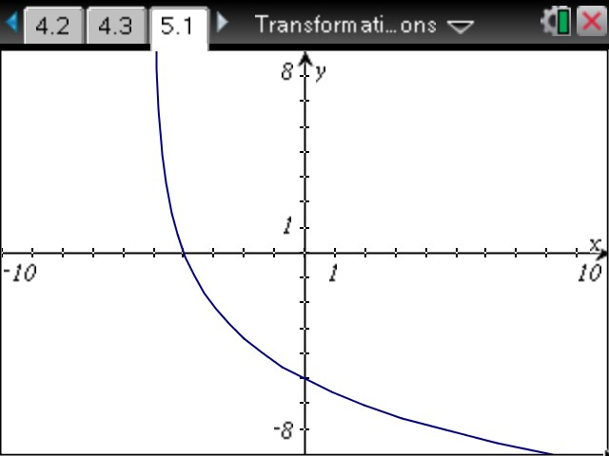
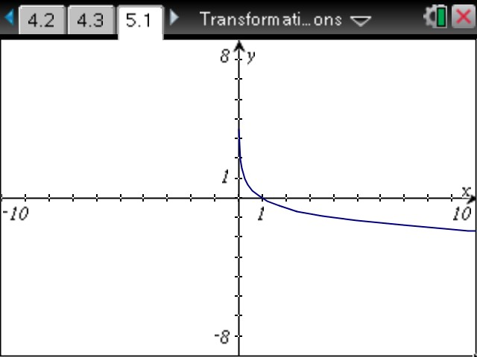
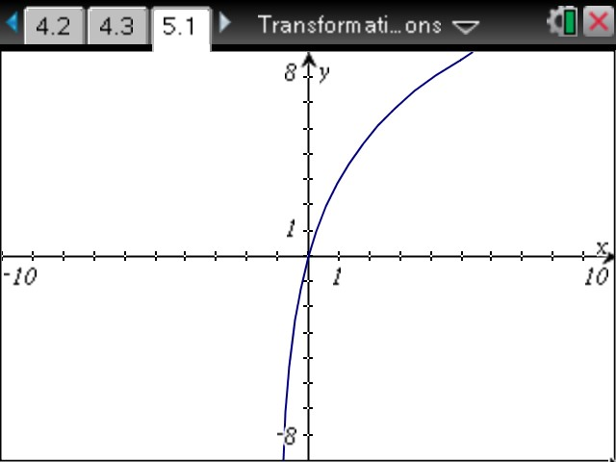
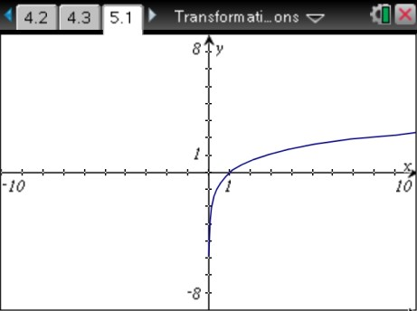
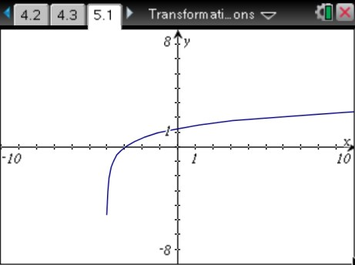
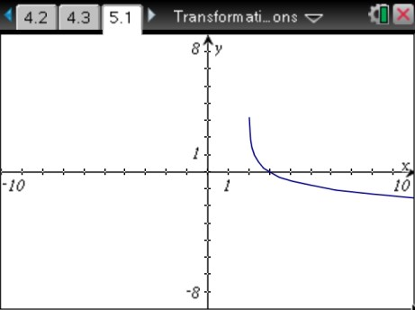
(i) (ii)

(iii) (iv)

(v) (vi)

Extensions
- Ask students to display the graph of various logarithmic functions and to find the domain. For example, consider $y= \log_{3}{(2-x)}$ and $y= \log_{5}\left(x^{2}\right)$.
- Ask students to display and compare the graphs of $y=\ln{x}$ and $y=\ln{(-x)}$.
- Ask students to display the graph of $y= \log_{b}\left(b^{x}\right)$ for various values of b and to explain the result.

Wrap Up
Upon completion of the lesson, the teacher should ensure that students are able to understand:
- How to graph a logarithmic function of the form $f\left(x\right)=c∙\log_{b}{(x+a)}$.
- How to explain the concepts of reflection and translation.

TI-Nspire Navigator
Note 1
Name of Feature: Quick Poll
A Quick Poll can be given at several points during this lesson. It can be useful to save the results and show a Class Analysis.

A sample multiple choice question:
How does the graph of $y= \log_{1/3}{(x-5)}$ compare with the graph of $y= \log_{1/3}{(x)}$?
- Stretched vertically
- Stretched horizontally
- Translated 5 units to the left
- Translated 5 units to the right
- Same

