Topic 3.14 Polar Function Graphs | Limaçon Curves

Practice Problem 1

The polar function $r=f\left(θ\right),$ for $0 ≤ θ ≤2π,$ is given by $f\left(θ\right)=4-3sin\left(θ\right)$ Which of the following describes the limaçon?
A. The limaçon has an inner loop.
B. The limaçon is a cardioid.
C. The limaçon has a dimpled shape and has an appearance of a kidney bean.
D. The limaçon is convex and has an appearance of nearly circular.

Practice Problem 2
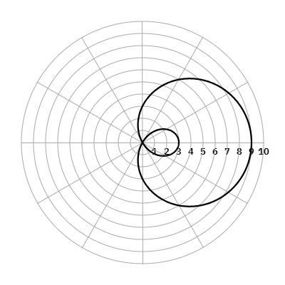
The graph of the polar function $r=f\left(θ\right),$ where $f\left(θ\right)=3+6cos\left(θ\right),$ is shown in the polar coordinate system for 0$≤ θ ≤2π.$ The inner loop of the limaçon corresponds to the values of θ in the interval $c<θ<d.$ What are the values of c and d?
A. $c=\frac{2π}{3}$ and $d=\frac{4π}{3}$
B. $c=\frac{π}{3}$ and $d=\frac{5π}{3}$
C. $c=\frac{π}{6}$ and d$=\frac{5π}{6}$
D. $c=\frac{7π}{6}$ and d$=\frac{11π}{6}$

Solutions:
C. The limaçon has a dimpled shape and has an appearance of a kidney bean.
The ratio of a to b is $\frac{4}{3}$. A limaçon in which the ratio of a and b is between 1 and 2 results in a dimpled shape or, it may be described as a kidney bean shape.

Practice Problem 2 Solution:
A. $c=\frac{2π}{3}$ and $d=\frac{4π}{3}$
The graph of the corresponding sinusoidal function $f\left(x\right)=3+6sin\left(x\right)$ shown to the right has gridline spacing of $\frac{π}{6}$ on the interval $\left[0, 2π\right]$. The sinusoidal function has negative y-values on the interval $\left(\frac{2π}{3}, \frac{4π}{3}\right)$. The negative $y-$values on the sinusoidal function correspond to the negative r-values of the polar function and those values create the inner loop. | 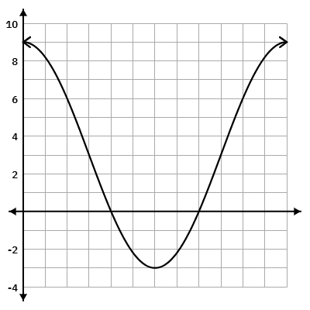

**Note: This activity has been developed independently by Texas Instruments. AP is a registered trademark of the College Board, which was not involved in the production of, and does not endorse, this product. Policies subject to change. Visit www.collegeboard.org.

