Name _____________________________ Date ______________ Period _______

Angle Sums in Triangles
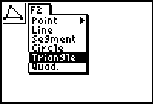

In this exploration you’ll construct a triangle, measure the interior angles and make a conjecture about the sum of the measures of the angles in a triangle. Then you’ll use a parallel line and rotation to demonstrate and prove why your conjecture is true.

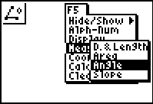
1. Construct and label ΔABC. Press the F2 key and select the triangle drawing tool. Use the Alpha-Num tool from the F5 menu and label the vertices.

2. Measure the three angles. Select the angle measurement tool from the measurement submenu. To measure an angle, select three point with the vertex of the angle being the middle selection. For example, to measure ∠B, first select point A, then vertex B, and third select C.
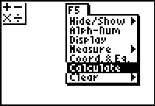
3. Calculate the sum of the angle measures. Select calculate form the F5 menu and then add the three angles. Cabri Jr. can add three numbers, the other operations can only use two numbers at a time.

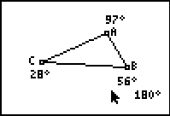
4. Drag a vertex of the triangle and observe how the angle sum changes when the angles are changed. The triangle on your screen should resemble the one to the right.

5. Make a conjecture. What is the sum of the angles in any triangle?

Follow these steps to investigate and prove why your conjecture is true.

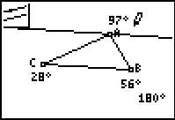
6. Construct a line through point A parallel to AC. Use the parallel tool from the F3 menu and select CB and the line to be parallel with and then point A as the place to anchor the new parallel line.

7. Construct the midpoints of AC and AB.

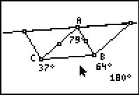
8. Rotate the triangle around one midpoint by 180° and the do the same with the other midpoint. Use the rotation tool from the F4 menu. Select the triangle as the object to rotate, one of the midpoints as the center of rotation and the 180° as the angle of rotation. Your triangles should look similar to the one at the right.

9. Drag point A around and observe how the three triangles are related to each other and to the parallel line.

10. Explain how each of the three angles at point A is related to one of the three angles in the triangle. Explain how this demonstrates your conjecture from question 5. It may be helpful to measure the other two angles around point A.

