Introduction
In this activity you will examine some data about bacteria, graph the data and draw some conclusions based on the data and the graph.  Of all the organisms in the world, few could compete with bacteria for the title of “Fastest Reproducer.” Bacteria are unicellular, like lots of other organisms, but the unique characteristic they possess is the absence of a true nucleus. Organisms that do not have a nucleus are called prokaryotes. Because the cells of a tree, a frog, a mushroom, and even an amoeba do have a nucleus, they are called eukaryotes. | 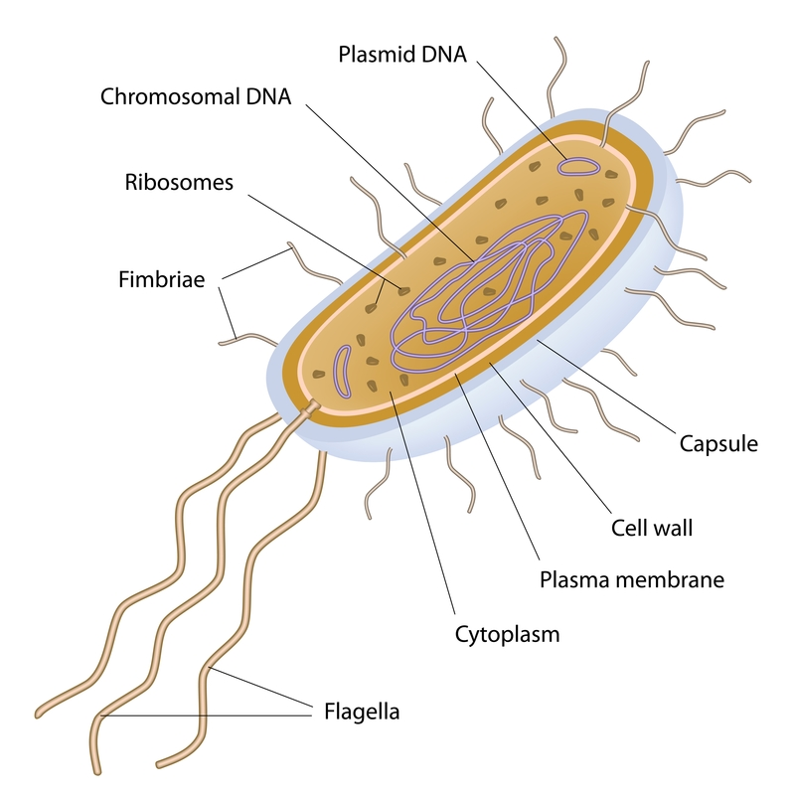  ©Alila07 | Dreamstime.com
Objectives
In this activity you will:
- examine some data about bacteria.
- graph the data.
- draw some conclusions based on the data and the graph.
You'll Need

- TI-84 Plus CE calculator

Problem
Which group do you think you fit into—the prokaryotes or the eukaryotes? On the next page is a table that shows the reproductive capability of bacteria. After looking at the table, you will graph the data to get an idea of the type of population growth the bacteria can accomplish. These bacteria were grown in a flask in a laboratory setting, and kept in the same container throughout the experiment.
Time in Minutes | Number of Bacteria
30 | 4,000
60 | 4,500
90 | 5,200
120 | 6,100
150 | 7,200
180 | 8,500
210 | 10,000
240 | 11,700

Entering the Data:
Enter the data from the table above into your TI-84 Plus CE.
- Press … Í.
- Press } to move to the heading L1. Press ‘ Í.
- Follow the same procedure to clear L2, if needed.
- Navigate back to L1, making sure that your cursor is in the first row of the list, and not at the very top. Using the data table, enter the data from the first column (Time in Minutes) in L1. Type in the number and then press Í or †. Repeat this until you have entered all of the data in L1.
- Enter the data from the Number of Bacteria column in the data table into L2. Make sure you have the same number of data entries in L1 as you do in L2.
- Press y , to define the plot.  - Press Í to select 1:Plot1. Set your TI-84 Plus CE as shown at right.  - Press y . and make sure the defaults are set.  - Press z and make sure the defaults are set there as well.. |  | 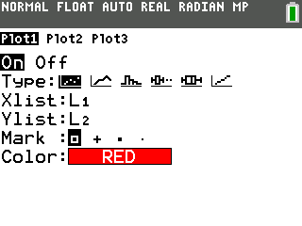
- Press p and set an appropriate window for the data you have entered. Which of the variables (time or number of bacteria) is dependent on the other? Set Xmin and Xmax appropriately, according to your data, then choose whatever Xscl (scale along the X-axis) you would like. Set Ymin and Ymax appropriately, and choose a Yscl (scale along the Y-axis).
- Press o. If there are any equations on this screen, press † to place the cursor next to Y1=, and then press ‘ to clear the equation. Repeat this sequence to clear all equations.
- Press s.
Data Analysis
- What will you plot along the X-axis (the independent variable)?

- What will you plot along the Y-axis (the dependent variable)?

- Is there a constant difference between consecutive values in the Time in Minutes data list (the X list)? If so, what is that difference? If not, explain.
- Look at the graph of your data. Does the graph look linear? Explain.
- Press r and move from point to point on your graph by using | or ~. Estimate how many bacteria you would expect to find after 300 minutes.
- Without using the r button, estimate how many you would have expected to find after 100 minutes.
- Now user to estimate the number of bacteria you would have after 100 minutes. How does your answer compare to the one you estimated in #6?
- Estimate how many bacteria you would expect to find after 12 hours.
Hint: you will need to change your p settings!
- Estimate how many you would expect to find after 24 hours.
- In reality, can this rate of growth in bacterial numbers continue forever? Explain
- Populations of organisms can only grow as large as their environments allow them to grow. Natural population controls are called limiting factors, and the number of organisms of a particular species that can be supported by the environment is called the environment’s carrying capacity for that species. You may want to consider these things as you look again at your answer to #10. What are some limiting factors influencing the population sizes of plants and animals in a deciduous forest?
- What are some limiting factors at work in the desert? In the arctic? In the tropical rain forest?
- Go back into the lists of your TI-84 Plus CE (press …·) and extend your list of times in L1 to 600 minutes, using increments of 30. In L2, enter what you think would be realistic population data to correspond with the new times you entered in L1. Remember this data is not linear. Before you press s, make sure you take a look at your pand make necessary adjustments. How long do you think the bacteria population can grow at an unrestricted rate? Then what happens?
- What do you think is the carrying capacity of your classroom for people? On what did you base your answer?
Going Further
Now, let’s build a best-fit (regression) model for the data in your graph.
- Go to the Home screen by pressing y 5.
- Press …, and then press ~ to highlight CALC. You will see a list of regression models from which to choose. Press } a few times until 0:ExpReg is highlighted, and then press Í.
- Press Í to accept the L1 and L2 values. Press ½ ~ Í Í, to place the equation into Y1.
- Highlight Calculate and press Í to paste the correct syntax to the Home screen. You just told the TI-84 to build an exponential regression model based on the data in L1 (time) and L2 (number of bacteria), and then write the regression equation in Y1. To check this, press o. You should see an equation next to Y1=.
- Record the Equation for Y1= _____________________.
- Press s to see your original data points and observe the best-fit line being drawn.
- Press r and then press } or †.
a. Where do you see the cursor?

- Press ~ and | and notice what is displayed at the bottom of the screen.
- What do these numbers mean?

