Science Objectives  - Use a Temperature Probe to measure temperature.  - Produce an increasing and a decreasing graph.  - Analyze the slope of each graph.  - Compare results.  Math Objectives  - Mathematically describe the relationship between temperature and time.  - Evaluate a direct mathematical relationship.  - Generate and analyze linear regression model.  Materials Needed  - TI-Nspire CX II  - Vernier® GDX Temperature Probe  - Calculator Connection Cable (Mini-A to Micro-B USB)  Vocabulary  About the Lesson  - This activity makes use of the Vernier GDX Temperature Probe to create an increasing graph and a decreasing graph.  - Built a mathematical model to show the direct relationship between temperature and time for the first graph.  - Built a mathematical model to show the direct relationship between temperature and time for the second graph.  - Time Required: 45-60 minute class period.  TI-Nspire™ Navigator™ System (if available)  - Class Capture to monitor student progress.  - Live Presenter allows students to show their graphs to the class. | 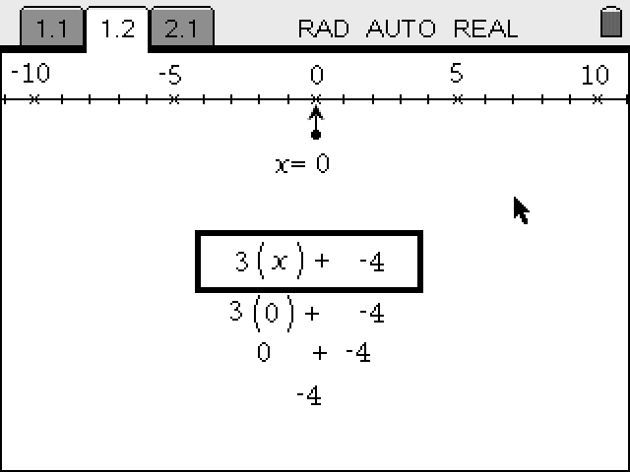  Tech Tip:  Access free tutorials at http://education.ti.com/calculators/pd/US/Online-Learning/Tutorials  Lesson Files:  Student Activity  - Heat_It_Up_Student.pdf  - Heat_It_Up_Student.doc
  - curve fit
  - linear regression
  - slope (m)
  - correlation coefficient (r)
Activity Overview
- Please print the student worksheet and make available to students before beginning the lab. Lab background information as well as lab procedures are included only in the student worksheet. Always remember to review any safety precautions thoroughly with your students prior to starting the lab.
- Vernier Go Direct® (GDX) probes and sensors can be either directly connected to the TI-Nspire CX II with a Calculator Connection Cable (Mini-A to Micro-B USB) or through TI’s Bluetooth Adapter. For this activity, we used the USB direct connection method. Note: A TI-Nspire CX II is required to use the Go Direct probes, but this activity can also be done with the Vernier LabQuest Temperature sensor, which can also be used with the TI-Nspire CX or TI-Nspire CX II.
- Optional procedure for the Bluetooth Adapter (instead of the USB cable), follow these pairing directions:
  - Turn the TI-Nspire™ CX II on.
  - Turn on the GDX Probe or Sensor of choice.
  - Plug the Mini-A end of the cable into the Npsire CX II and the Micro-B into the Bluetooth Adapter.
  - Press [Menu] on the TI-Nspire unit and choose Add Vernier DataQuest.
  - Select Add Bluetooth Sensor on the Handheld screen.
  - On the next screen, > Connect for the Probe or Sensor that you wish to add.
  - Choose OK on that screen and OK on the following screen.
  - The Probe or Sensor is now ready for use wirelessly.
  - For more information on Go Direct Sensors, and TI Technology visit https://education.ti.com/en/product-resources/go-direct

Note: TI-Nspire CX II’s Vernier DataQuest app can also support many of the newer Vernier GoDirect sensors, while also continues to support some of Vernier’s older sensors and probes.

- This experiment can be used at the beginning of the school year to introduce the use of data-collection and analysis of data.
- For trial 2, there are several methods to obtain a negative slope graph. Students may:
- heat the probe up in their hand first, then wave it in the air to cool it.
- place the room temperature probe in cool water.
- place the probe in hand sanitizer and then wave it in the air.
- place the probe against a cooler container such as a soda can.
- Each of the above suggestions opens avenues of discussion on why each method is effective.

Lab Procedure
The lab procedure is in the Student Worksheet and is not duplicated here. Please refer to the student handout.

Discussion Points and Possible Answers

Questions
- In trial 1, who in your class had the hottest hand? The coolest hand?
Answer: (The answer will vary.)
- Comparing the slopes of the graphs from Trial 1 and 2, which had the steepest slope?
Answer: Graph one will have the steepest slope due to direct contact with the palm of the hand.
- Compare the r values for both graphs. Which graph was most linear?
Answer: Graph two will be most linear-obeying Newton’s Law of Cooling.

- What is the significance of the (-) sign of the slope on trial 2?

Answer: The negative sign of the slope signifies a decreasing graph.

Optional Extension
The CSI application involves the examiner placing a temperature probe in the victim’s liver and measuring the temperature. Knowing the ambient temperature of the crime scene and the temperature of the liver, the examiner can calculate the approximate time of death using Newton’s Law of Cooling.

