Consider the functions below.

$y= {5x}^{3}-3x^{2}+7x-4$ $y=\operatorname{atan}{(x+\ln\left(x\right))}$ $y= \frac{4x^{2}+8x-5}{2x^{3}+ x^{2}-15}$ $y=\sec\left(e^{2x}- \frac{4}{x}\right)$

The first function, the polynomial function, is probably the easier to integrate. Although a polynomial can have many terms, its basic structure is a sum of products of numbers (coefficients) and nonnegative integer powers of x, the independent variable. You can evaluate any polynomial at a specific value x by using only the plus, times, and negative buttons on any four-function calculator because whole-number powers of x are only shorthand for repeated multiplication.

Polynomials are so easy to manipulate, in fact, that they are sought after as approximations to more complicated functions. You may have encountered one such kind of approximation in statistics with polynomial regression. A special case of a polynomial regression is the “line of best fit,” y = ax + b, to a scatter plot of data points.

In this activity, you will examine another kind of polynomial approximation that is a generalization of the tangent line approximation. These polynomials are called Taylor polynomials.

Exploration
If $f'(a)$, the derivative of a function, is known at a point (a, f(a)) on its graph, then the point-slope form for the equation of the tangent line can be used with $m=f'(a)$ as the slope. $y-f\left(a\right)=f'(a)(x-a)$ written with y isolated is $y=f\left(a\right)+f'(a)(x-a)$.

The tangent line approximation is sometimes called the best linear local approximation to a function f at the point x = a because it is the only line that has the same y-value and the same derivative value as f at the point x = a. In other words, the tangent line matches the function’s value and its first-order derivative’s
value at x = a.

The tangent line approximation $y=f\left(a\right)+f'(a)(x-a)$ is the first-degree Taylor polynomial approximation to the function f about the point x = a. To obtain higher-degree Taylor polynomial approximations, higher-order derivative values need to be matched.

For example, to find the best quadratic (second-degree) approximation to the function at $y=f\left(x\right)= e^{x}$ at x = 0, a quadratic function $y=ax^{2}+bx+c$ must be found such that y, $\frac{dy}{dx}$, and $\frac{d^{2}y}{dx^{2}}$ match those derivative values of the function $f\left(x\right)= e^{x}$ at x = 0. The calculations that need to match to solve for the coefficients a, b, and c are arranged across the rows in the table below.

$$y\left(x\right)=a∙ x^{2}+b∙x+c$$ | $$y\left(0\right)=a∙0^{2}+b∙0+c=c$$ | $$f\left(x\right)= e^{x}$$ | $$f\left(0\right)=e^{0}=1$$ | $$→c=1$$
$$y^{'}\left(x\right)=2a∙x+b$$ | $$y^{'}\left(0\right)=2a∙0+b=b$$ | $$f^{'}\left(x\right)= e^{x}$$ | $$f'\left(0\right)=e^{0}=1$$ | $$→b=1$$
$$y^{''}\left(x\right)=2a$$ | $$y^{''}\left(0\right)=2a$$ | $$f^{''}\left(x\right)= e^{x}$$ | $$f''\left(0\right)=e^{0}=1$$ | $$→a=\frac{1}{2}$$

The quadratic approximation is $y= \frac{x^{2}}{2}+x+1$.

It is customary to write the terms of a Taylor polynomial in increasing powers, so the
second-degree Taylor polynomial approximation to $f\left(x\right)= e^{x}$ about x = 0 is

$$y=1+x+ \frac{x^{2}}{2}$$
In general, the degree n Taylor polynomial approximation for a function f about the point x = 0 is given by
$$P_{n}\left(x\right)=f\left(0\right)+f^{'}\left(0\right)x+ \frac{f''(0)}{2!}x^{2}+ \frac{f'''(0)}{3!}x^{3}+…+\frac{f^{\left(n\right)}(0)}{n!}x^{n}$$

where $f^{(n)}$ represents the nth derivative of f and $n!=1∙2∙3∙…∙(n-1)∙n$ is “n factorial.”

Taylor polynomial approximations for $f\left(x\right)= e^{x}$about x = 0 are particularly easy to find because all higher-order derivatives of f are exactly the same, namely $f^{\left(n\right)}\left(x\right)= e^{x}$for all n, and so $f^{\left(n\right)}\left(0\right)=1$ for all n. Thus, the sixth-degree Taylor polynomial for $f\left(x\right)= e^{x}$ about x = 0 would be

$$P_{6}\left(x\right)=1+x+ \frac{x^{2}}{2!}+ \frac{x^{3}}{3!}+ \frac{x^{4}}{4!}+\frac{x^{5}}{5!}+\frac{x^{6}}{6!}=1+x+ \frac{x^{2}}{2}+ \frac{x^{3}}{6}+ \frac{x^{4}}{24}+\frac{x^{5}}{120}+\frac{x^{6}}{720}$$

The above example would lead a person to believe that these higher-degree Taylor polynomial approximations are simply better local approximations than a tangent line approximation; that is, that the approximation should only be used for a very small interval about the point. In many cases, but not all cases, higher-degree Taylor polynomials may provide very good approximations of the function over much larger intervals. To illustrate this, you can try graphing a function and several of its Taylor polynomials.

Graph $f\left(x\right)= e^{x}$ and its first through sixth degree Taylor polynomials about x = 0. Use the viewing window below.

Input the first-degree Taylor polynomial in $f1(x)$ on a graphs page, the second-degree Taylor
polynomial in $f2(x)$, and so on up to the sixth degree Taylor polynomial in $f6(x)$. In $f7(x)$, input the original function $f\left(x\right)= e^{x}$. The screen below shows these entries.

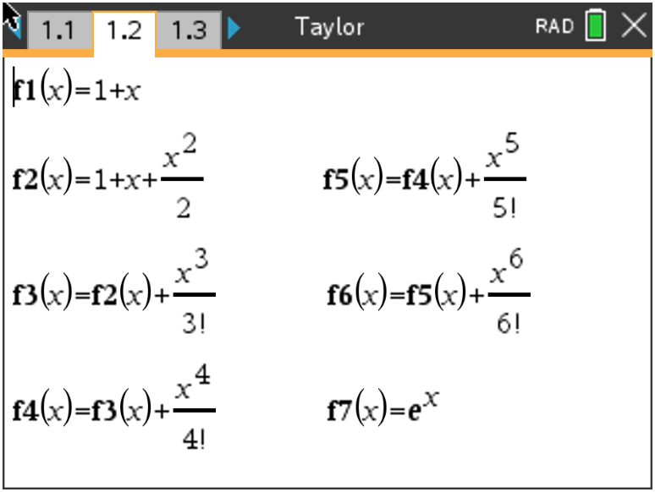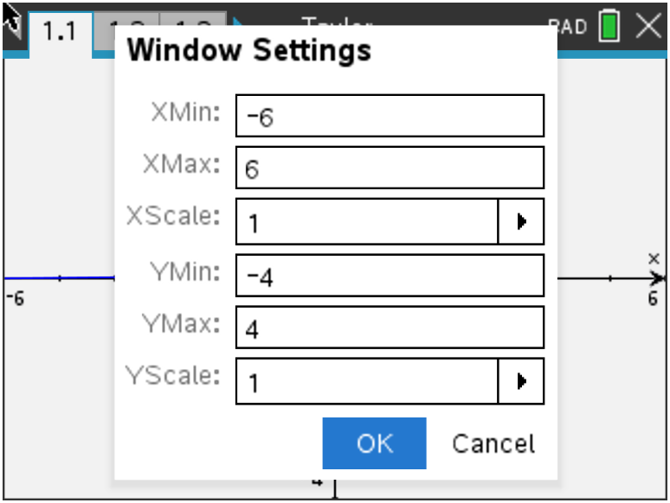

Notice that with each increase in degree of a Taylor polynomial, you can simply add an additional term to the previous Taylor polynomial. The graph of ($f7(x)$) is shown below.

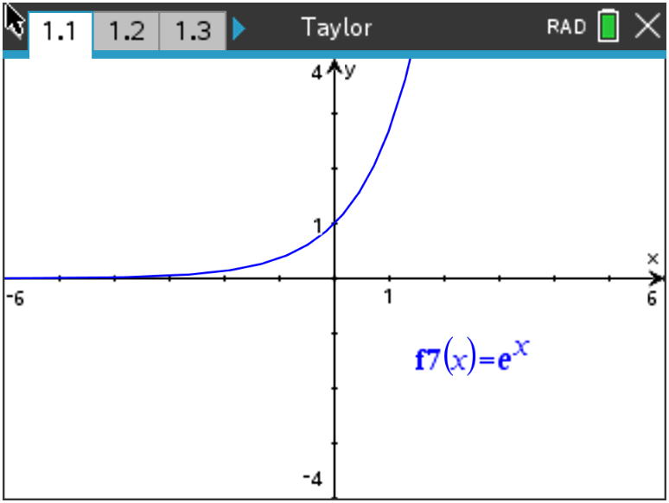

The graphs show the first six Taylor polynomials graphed in the same window with $f\left(x\right)= e^{x}$.

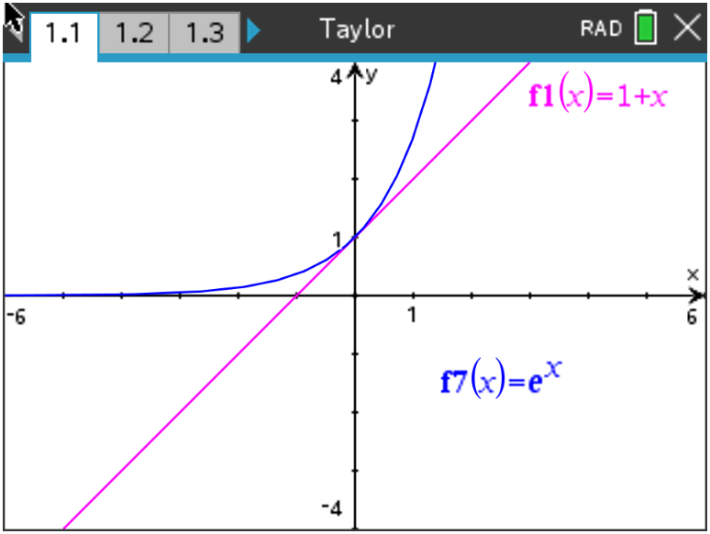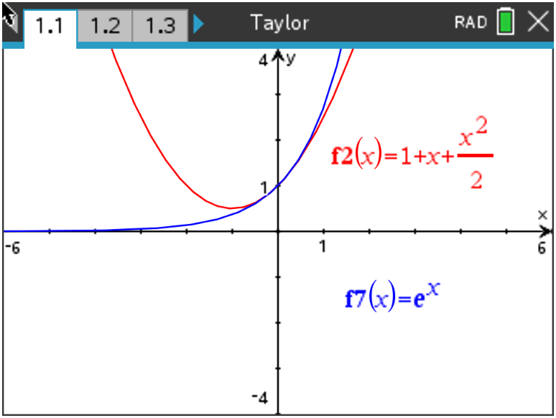

$f1(x)=1+x$ $f2(x)=1+x+ \frac{x^{2}}{2!}$
$f7(x)= e^{x}$ $f7(x)= e^{x}$

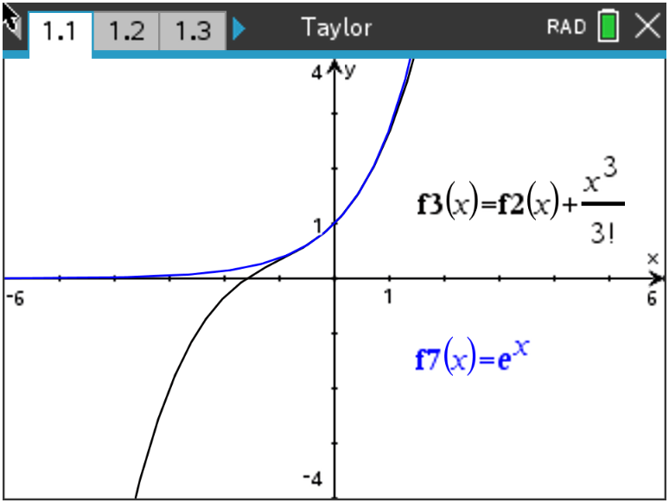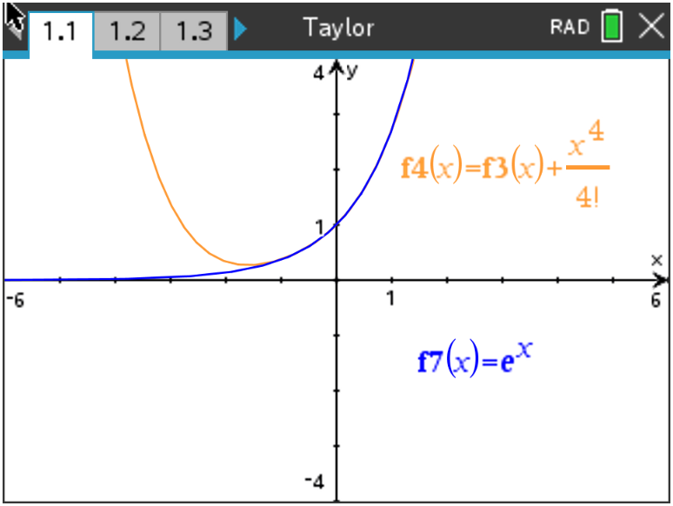

$f3(x)=1+x+ \frac{x^{2}}{2!}+ \frac{x^{3}}{3!}$ $f4(x)=1+x+ \frac{x^{2}}{2!}+ \frac{x^{3}}{3!}+ \frac{x^{4}}{4!}$
$f7(x)= e^{x}$ $f7(x)= e^{x}$

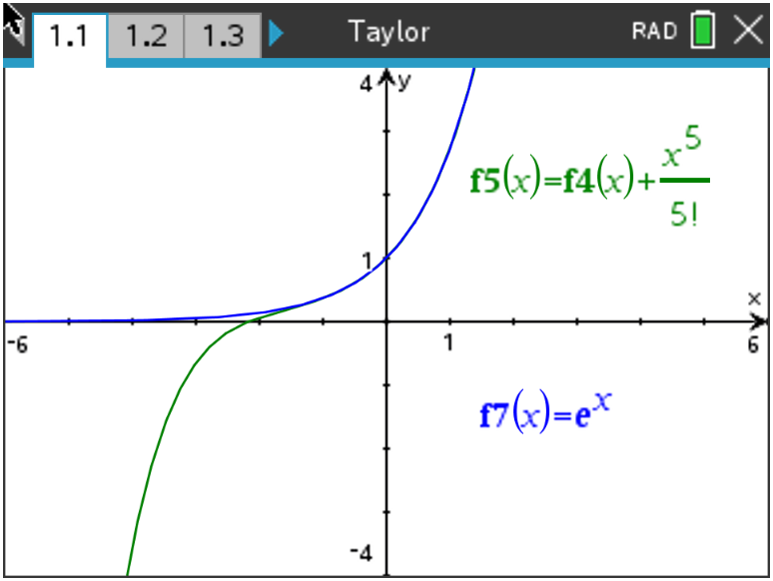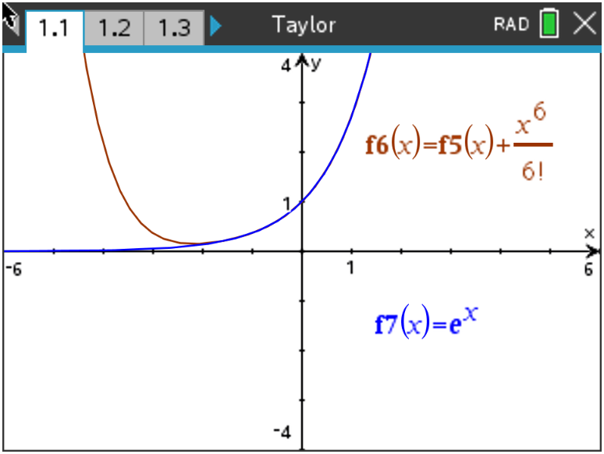

$f5(x)=1+x+ \frac{x^{2}}{2!}+ \frac{x^{3}}{3!}+ \frac{x^{4}}{4!}+ \frac{x^{5}}{5!}$ $f6(x)=1+x+ \frac{x^{2}}{2!}+ \frac{x^{3}}{3!}+ \frac{x^{4}}{4!}+ \frac{x^{5}}{5!}+ \frac{x^{6}}{6!}$
$f7(x)= e^{x}$ $f7(x)= e^{x}$

Notice how the graph of the polynomial visually approximates the graph of $f\left(x\right)= e^{x}$ over a wider and wider interval around x = 0. If you trace to the x = 1 crosshair and compare the values of the two functions, you will see how close the numerical approximations are.

$f7\left(1\right)$ = 2.718281828 (e rounded to 9 decimal places)
$f6\left(1\right)$= 2.718055556 (e accurate to the nearest thousandth)

The degree n Taylor polynomial approximation for a function f about the point x = a
is expanded in powers of (x – a) and has the form

$$P_{n}\left(x\right)=f\left(a\right)+f^{'}\left(a\right)\left(x-a\right)+ \frac{f^{''}\left(a\right)}{2!}{\left(x-a\right)}^{2}+ \frac{f'''(a)}{3!}{(x-a)}^{3}+…+ \frac{f^{n}(a)}{n!}{(x-a)}^{n}$$

The first two terms give exactly the tangent line approximation. Powers of (x – a) might not seem necessary at first glance, but consider a function that is not defined at x = 0 and you can see the need for expanding around some other point.

The function f(x) = ln(x) is not defined for x = 0, but a Taylor polynomial about x = 1 could be found instead. The necessary derivative information is shown below.

$f\left(x\right)=ln⁡(x)$ $f\left(1\right)=\ln\left(1\right)=0$

$f^{'}\left(x\right)= \frac{1}{x}$ $f^{'}\left(1\right)= \frac{1}{1}=1$

$f^{''}\left(x\right)= \frac{-1}{x^{2}}$ $f^{''}\left(1\right)= \frac{-1}{1^{1}}= -1$

$f^{'''}\left(x\right)= \frac{1 ∙ 2}{x^{3}}$ $f^{'''}\left(1\right)= \frac{2}{1^{3}}=2$

$f^{\left(4\right)}\left(x\right)= \frac{-1 ∙ 2 ∙ 3}{x^{4}}$ $f^{\left(4\right)}\left(1\right)= \frac{-1 ∙ 2 ∙ 3}{1^{4}}= -3!= -6$

. .
. .
. .

$f^{\left(n\right)}\left(1\right)= {(-1)}^{n-1}\frac{1 ∙ 2 ∙ 3 ∙ … ∙ (n-1)}{x^{n}}$ $f^{\left(n\right)}\left(1\right)= {(-1)}^{n-1}\frac{1 ∙ 2 ∙ 3 ∙ … ∙ (n-1)}{1^{n}}$
$= {\left(-1\right)}^{n-1}\left(n-1\right)!$
. .
. .
. .

The nth-degree Taylor polynomial for f(x) = ln(x) about x = 1 is

$$P_{n}\left(x\right)=f\left(1\right)+f^{'}\left(1\right)\left(x-1\right)+ \frac{f''(1)}{2!}{(x-1)}^{2}+ \frac{f'''(1)}{3!}{(x-1)}^{3}+…+ \frac{f^{\left(n\right)}(1)}{n!}{(x-1)}^{n}$$

$$=0+\left(x-1\right)- \frac{1}{2!}{\left(x-1\right)}^{2}+ \frac{2}{3!}{\left(x-1\right)}^{3}- \frac{3}{4!}{\left(x-1\right)}^{4}+…+ \frac{{\left(-1\right)}^{n-1}\left(n-1\right)!}{n!}{(x-1)}^{n}$$

$$= \left(x-1\right)- \frac{1}{2}{\left(x-1\right)}^{2}+ \frac{1}{3}{\left(x-1\right)}^{3}- \frac{1}{4}{\left(x-1\right)}^{4}+…+ \frac{{(-1)}^{n-1}}{n}{(x-1)}^{n}$$

For each of the functions on the following pages:

a. Find the indicated Taylor polynomial approximations.

b. Graph each Taylor polynomial approximation using the same viewing window, from the previous
example, along with the original function. Sketch a graph in the screens provided that shows how each
Taylor polynomial compares with the original function.

c. Evaluate the original function and each Taylor polynomial approximation at x = 3.

Problem 1 –

$f\left(x\right)=sin⁡(x)$

Find and graph $P_{1}\left(x\right), P_{3}\left(x\right), P_{5}\left(x\right), P_{7}\left(x\right), P_{9}\left(x\right), and P_{11}(x)$ about x = 0.

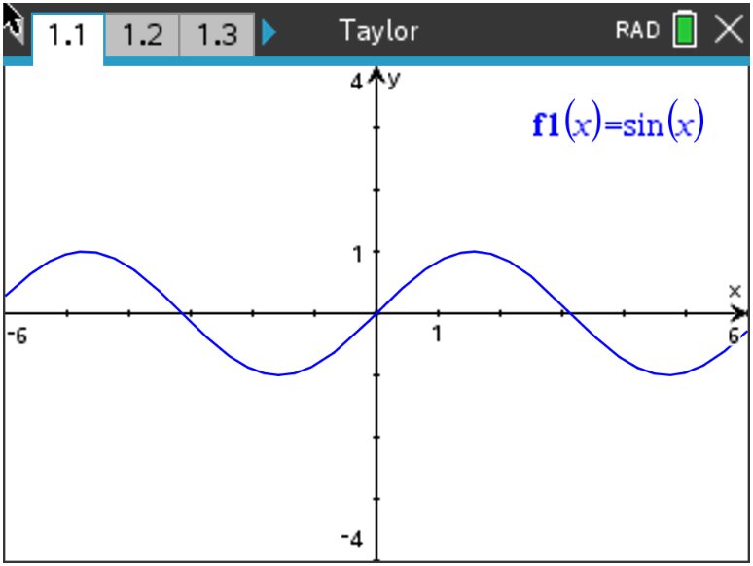

$P_{1}\left(x\right)=$ $P_{3}(x)$ =

$P_{5}\left(x\right)=$ $P_{7}(x)$ =

$P_{9}\left(x\right)=$ $P_{11}(x)$ =

$f\left(3\right)=$ ___________________________

$P_{1}\left(3\right)=$ ___________________________ $P_{3}\left(3\right)=$ __________________________

$P_{5}\left(3\right)=$ ___________________________ $P_{7}\left(3\right)=$ __________________________

$P_{9}\left(3\right)=$ ___________________________ $P_{11}\left(3\right)=$ _________________________
Problem 2 –

$f\left(x\right)=cos⁡(x)$

Find and graph $P_{0}\left(x\right), P_{2}\left(x\right), P_{4}\left(x\right), P_{6}\left(x\right), P_{8}\left(x\right), and P_{10}(x)$ about x = 0.

Note: $P_{0}(x)$ uses only the function output at x = 0 and will be a constant function. In other words, its
graph will be a horizontal line.

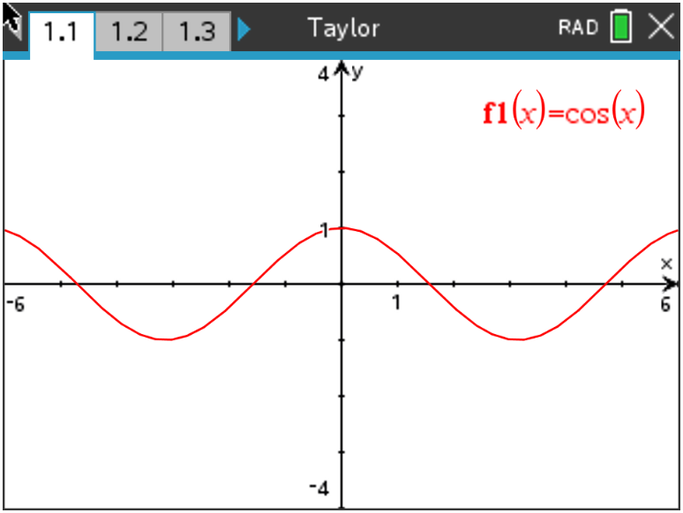

$P_{0}\left(x\right)=$ $P_{2}(x)$ =

$P_{4}\left(x\right)=$ $P_{6}(x)$ =

$P_{8}\left(x\right)=$ $P_{10}(x)$ =

$f\left(3\right)=$ ___________________________

$P_{0}\left(3\right)=$ ___________________________ $P_{2}\left(3\right)=$ __________________________

$P_{4}\left(3\right)=$ ___________________________ $P_{6}\left(3\right)=$ __________________________

$P_{8}\left(3\right)=$ ___________________________ $P_{10}\left(3\right)=$ _________________________
Problem 3 –

$f\left(x\right)= e^{-x/2}$

Find and graph $P_{1}\left(x\right), { P}_{2}\left(x\right), P_{3}\left(x\right), P_{4}\left(x\right), P_{5}\left(x\right), and P_{6}(x)$ about x = 0.

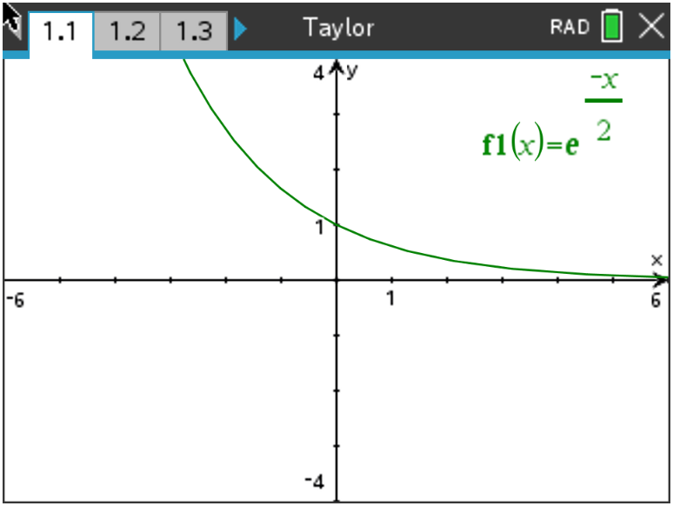

$P_{1}\left(x\right)=$ $P_{2}(x)$ =

$P_{3}\left(x\right)=$ $P_{4}(x)$ =

$P_{5}\left(x\right)=$ $P_{6}(x)$ =

$f\left(3\right)=$ ___________________________

$P_{1}\left(3\right)=$ ___________________________ $P_{2}\left(3\right)=$ __________________________

$P_{3}\left(3\right)=$ ___________________________ $P_{4}\left(3\right)=$ __________________________

$P_{5}\left(3\right)=$ ___________________________ $P_{6}\left(3\right)=$ _________________________

Problem 4 –

$f\left(x\right)=arctan(x)$

Find and graph $P_{1}\left(x\right), P_{3}\left(x\right), { and P}_{5}\left(x\right)$ about x = 0.

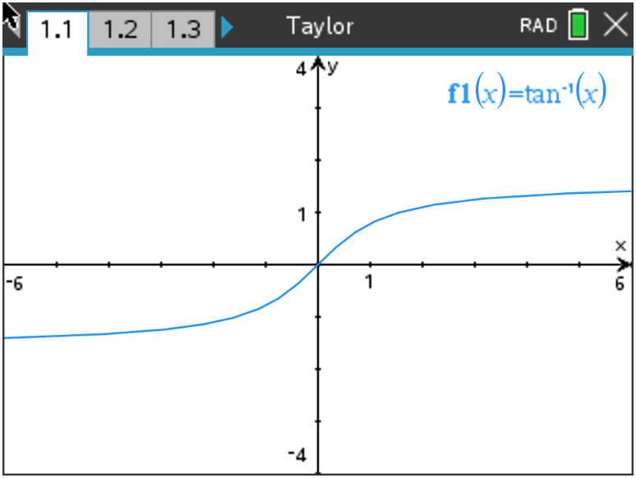

$P_{1}\left(x\right)=$ $P_{3}(x)$ =

$P_{5}\left(x\right)=$

$f\left(3\right)=$ ___________________________ $P_{1}\left(3\right)=$ ___________________________

$P_{3}\left(3\right)=$ __________________________ $P_{5}\left(3\right)=$ ___________________________

Problem 5 –

$f\left(x\right)=\ln{(x)}$

Find and graph $P_{1}\left(x\right), P_{2}\left(x\right), P_{3}\left(x\right), P_{4}\left(x\right), P_{5}\left(x\right), and P_{6}(x)$ about x = 1.

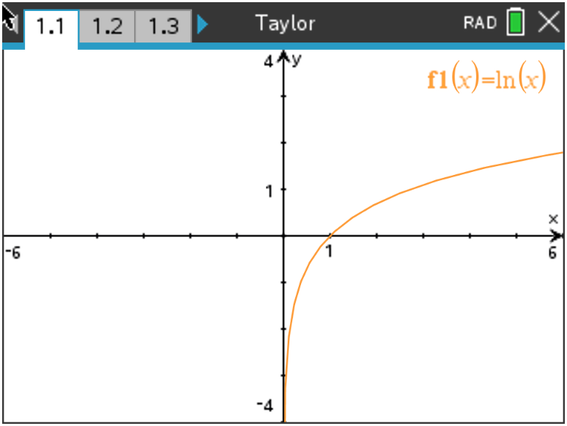

$P_{1}\left(x\right)=$ $P_{2}(x)$ =

$P_{3}\left(x\right)=$ $P_{4}(x)$ =

$P_{5}\left(x\right)=$ $P_{6}(x)$ =

$f\left(3\right)=$ ___________________________

$P_{1}\left(3\right)=$ ___________________________ $P_{2}\left(3\right)=$ __________________________

$P_{3}\left(3\right)=$ ___________________________ $P_{4}\left(3\right)=$ __________________________

$P_{5}\left(3\right)=$ ___________________________ $P_{6}\left(3\right)=$ _________________________

Problem 6 –

$f\left(x\right)=\frac{1}{3 - x}$

Find and graph $P_{1}\left(x\right), P_{ 2}\left(x\right), P_{3}\left(x\right), P_{4}\left(x\right), P_{5}\left(x\right), and P_{6}(x)$ about x = 2.

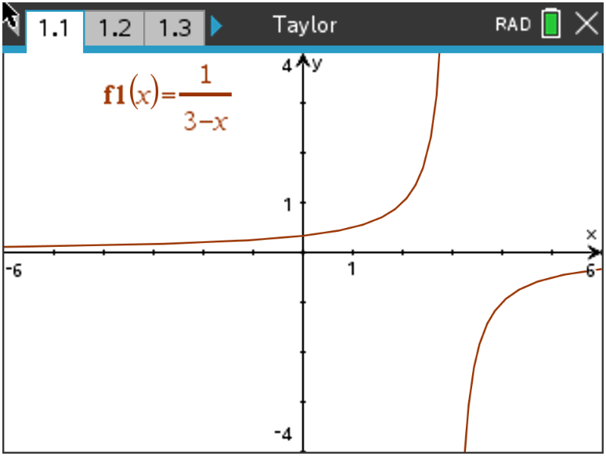

$P_{1}\left(x\right)=$ $P_{2}(x)$ =

$P_{3}\left(x\right)=$ $P_{4}(x)$ =

$P_{5}\left(x\right)=$ $P_{6}(x)$ =

$f\left(3\right)=$ ___________________________

$P_{1}\left(3\right)=$ ___________________________ $P_{2}\left(3\right)=$ __________________________

$P_{3}\left(3\right)=$ ___________________________ $P_{4}\left(3\right)=$ __________________________

$P_{5}\left(3\right)=$ ___________________________ $P_{6}\left(3\right)=$ __________________________

