Introduction
The height versus time data of a ball bounce can be modeled by a quadratic function. This activity investigates the time and height values at a vertex, (h,k), and the coefficient a in the vertex form of the quadratic equation, is y = a(x – h)² + k, which describes the behavior of a ball bounce.
Setup
- This activity is best performed with at least three students: one to hold the CBR™ 2 and press the trigger, one to release the ball, and one to run the calculator.  - Lift the pivot head on the CBR™ 2 and set the sensitivity on the CBR 2 to Normal. | 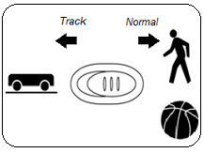
- Open a new document on the TI-Nspire™ CX handheld. Connect the CBR 2 to the handheld with the USB CBR 2 to handheld cable. The Vernier DataQuest® App should open.  Note: The default unit of measurement for the CBR 2 in the DataQuest App is meters. | 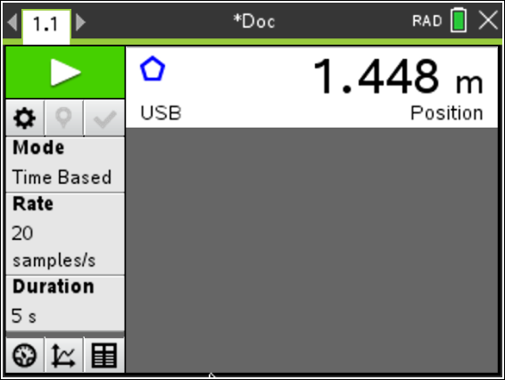
- Practice dropping the ball under the CBR 2. This is a practice run to determine if the ball is bouncing on a flat surface.  - Position the CBR 2 at least 15 centimeters (approximately 6 inches) above the ball.  - Hold the sensor directly over the ball and make sure that there is nothing in the Clear Zone.  - Hold the sides of the ball and then quickly move your hands outward to release the ball. Drop the ball (do not throw it). | 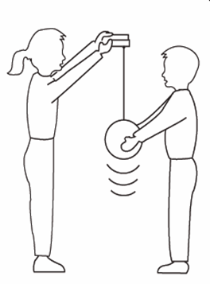
Data Collection
- You cannot place the CBR 2 on the floor and bounce the ball on it, but you can reverse the positions so that the data will appear as though it was collected with the floor as the zero height.  - Set the CBR 2 to a fixed height approximately 1.5 meters above the ground.  - Select Menu > Experiment > Set Up Sensors > CBR 2/Go!Motion, and then select Zero.  Note: Be sure to hold the CBR 2 at this height when collecting data. | 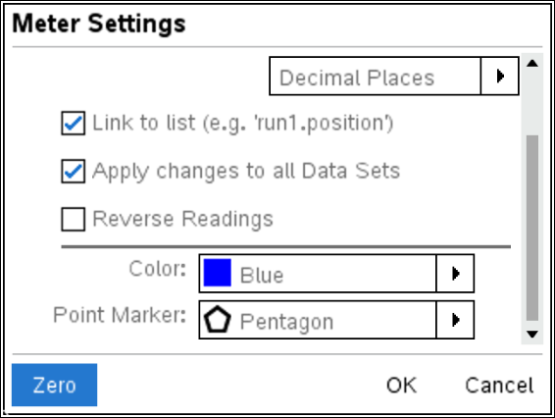
- To reverse the readings, select Menu > Experiment > Set Up Sensors > CBR 2/Go!Motion.  - Select the Reverse Readings setting, and then click OK. | 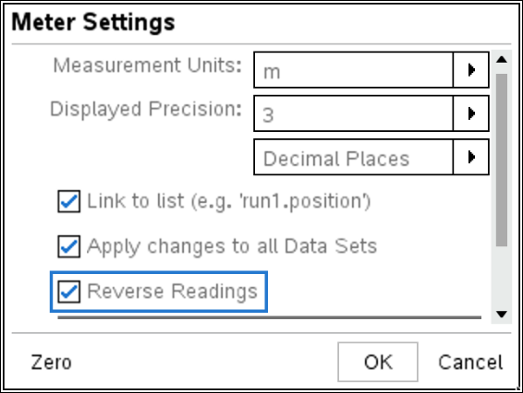
- To show only the position versus time graph, click the Graph View tab . Select Menu > Graph > Show Graph > Graph 1. | 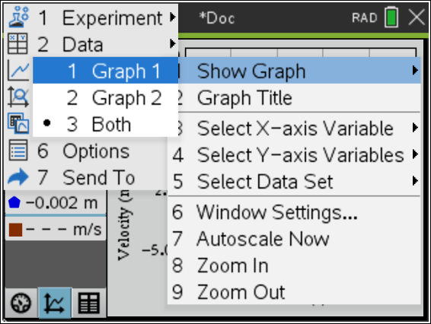  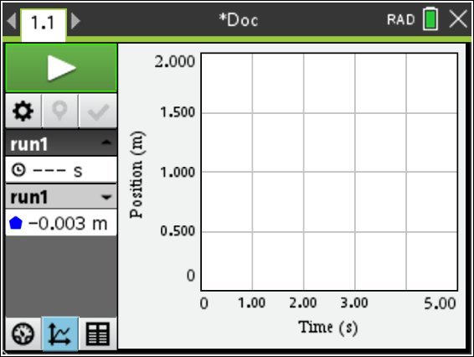
- Press Tab until the Start Collection button  is highlighted. One person holds the CBR 2 while another person holds the ball at least 15 centimeters beneath the CBR 2. Start the data collection by pressing Enter just before dropping the ball. You want the CBR 2 to record the initial height of the ball as well as the bounce heights.

- The handheld displays the position versus time graph. The plot should look like a series of ball bounces. If it does not, try again. (If it’s necessary to repeat the data collection, press the Start Collection button again.) | 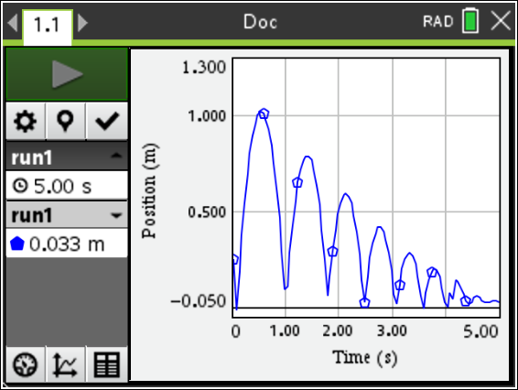
- To trace on the plot, click anywhere on the graph and then use the left or right arrow keys. The coordinates are shown at the left under run1. | 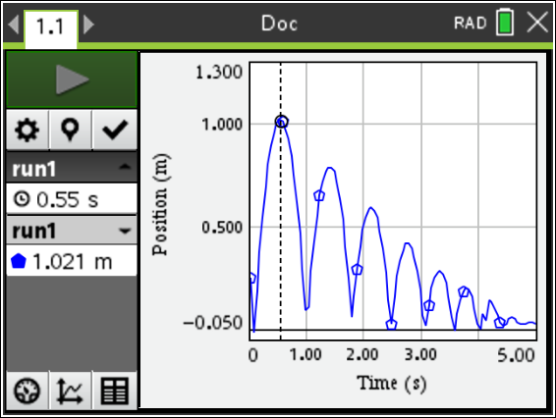
- What quantity is represented along the horizontal axis? What are its units?

- What quantity is represented along the vertical axis? What are its units?

- What does the highest point on the plot represent? What does the lowest point represent?

Select a Region of the Graph
- To model one bounce, select a region that contains only one parabola.  - Click at the beginning of a parabola, hold down the control key until a small vertical segment with two arrows appears. Arrow to the right to the end of the parabola. The selected region containing the parabola should be shaded.  - Press Menu > Data > Strike Data > Outside Selected Region.  - The graph of the selected parabola should be shown. Note that the window settings have been changed.  - Press Menu > Send To > Data & Statistics. | 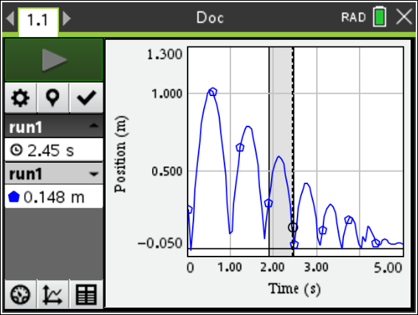  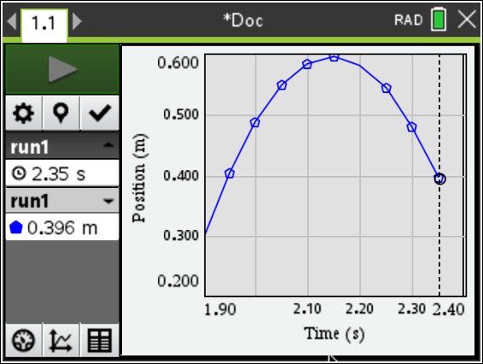  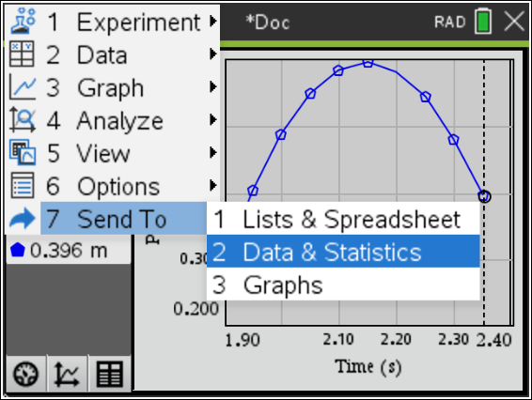  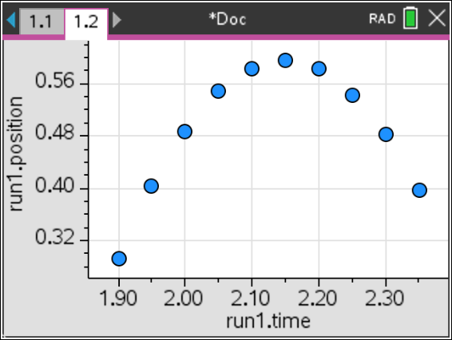
Data Analysis
Method 1 – Vertex Form of a Quadratic Function; Determining the Value of a
- With the data displayed in a Data & Statistics page, press Menu > Analyze > Graph Trace. Use the left and right arrow keys to try to reach a point as close to a vertex as possible. The x- and y-coordinates are displayed.
- For any one bounce, a plot of distance vs. time has a parabolic shape. One form of the equation that describes this motion is y = a(x – h)² + k where (h, k) is the vertex of the parabola and a is the vertical stretch or compression factor of the graph. This equation is called the vertex form.
Record the x- and y-coordinates of the vertex as h and k here:
h = ______ k = ______
- Press / ~ to insert a new page. Select Add Calculator.
- To store the x-coordinate of the vertex as the variable h, enter the x-value of the vertex and then press / h (Ë) followed by H. Press ·.
- To store the y-coordinate of the vertex as the variable k, enter the y-value of the vertex and then press / h (Ë) followed by K. Press ·.

- Before storing a value for a, predict what the graph would look like if a = 1.

- Before storing a value for a, predict what the graph would look like if a = 0.

- To find an equation of the parabola, use a guess-and-check method to find the value of a.
- Store a value for a on the Calculator page.
- On the Data & Statistics page, press Menu > Analyze > Plot Function.
- Enter f1(x) = a(x-h)² + k, and press ·.
- Adjust a by storing new values for a on the Calculator page.
- For each new value of a that you store, return to the Data & Statistics page to determine how well the equation fits.
- Experiment until you find a value of a that provides a good fit for the data.
- Record the value of a that works best: a =
- Using this value of a and the h and k values you reported in Step 2, write the vertex form of the quadratic equation. y =
- What effect does each have on the graph of the parabola?
  - The sign (positive or negative) of a?

  - |a| > 1?
  - |a| < 1?
- For the same bounce, press Menu > Analyze > Graph Trace, and trace along the plot to identify the x- and y-coordinates of a point that is not the vertex. Record the coordinates here.
x = ________ y = ________ (to 2 decimal places)
- Substitute the coordinates of the vertex (from Step 2) and the coordinates of a point on the plot of the parabola ((x, y) from Step 11) into the vertex form of a parabola, y = a(x – h)² + k, to solve for the value of a.
a =
Record the equation of the parabola in vertex form.
y =
- Return to the Data & Statistics page. Press Menu > Analyze > Plot Function.
Enter your equation from Step 12 as f2(x). Press · to graph.

- How does the value of a from Question 8 compare to the value of a from Question 12? Which graph (f1(x) or f2(x)) provides a better fit for the bounce? Explain.
Method 2 – Quadratic Regression
- To compute a regression equation, return to the Data & Statistics page. Press Menu > Analyze > Regression > Show Quadratic.

- What is your regression equation? _________________________

- How does the value of a in the regression equation compare to the values of a you determined in Method 1?

.

Extension:
- Would you expect your classmates to have the same value of a for their trials, or do you think the a value would vary? Explain your answer.

- Determine the values of a found by other groups of students in your class. How do these values compare to your value of a?

- If a ball that was more or less bouncy was used, would it affect the value of a in the equation? Explain your response.

