One way to move from point A to point B is by first going in a vertical direction and then horizontally. When points A and B are on the same line, a special relationship exists between the vertical and horizontal moves. In this activity, you will use coordinates to better understand that relationship, as well as the relationship between coordinates of points and their quadrant locations, slopes and y-intercepts, and parallel and perpendicular lines. | 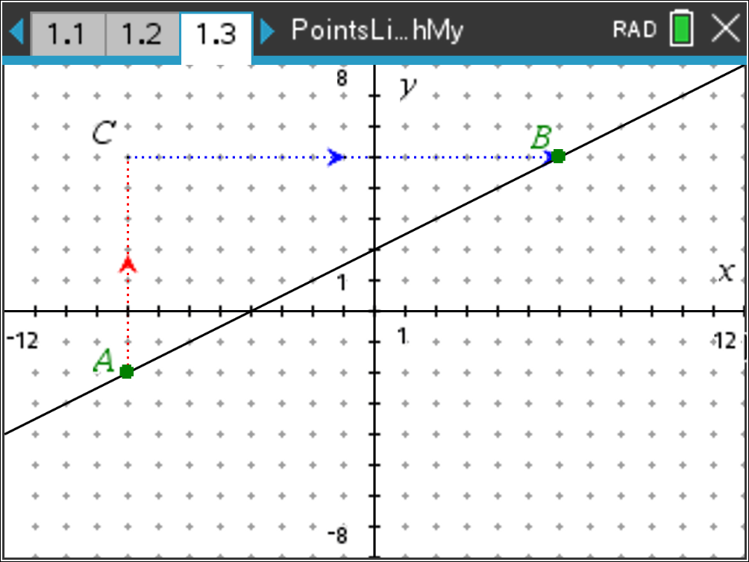
Open the TI-Nspire document PointsLinesSlopesOhMy.tns.
Move to page 1.2
Problem 1 – Coordinates of Points
First, a little review on coordinate location within the four quadrants. Place point P in the top right quadrant (menu, Geometry, Points & Lines, Point). Drag the point around into different quadrants. Complete the sentences by writing positive or negative.

1. A point is in Quadrant 1 (top right) when its x-coordinate is ______________ and its y-coordinate is ______________.
2. A point is in Quadrant 2 (top left) when its x-coordinate is ______________ and its y-coordinate is ______________.
3. A point is in Quadrant 3 (bottom left) when its x-coordinate is ______________ and its y-coordinate is ______________.
4. A point is in Quadrant 4 (bottom right) when its x-coordinate is ______________ and its y-coordinate is ______________.

Move to page 1.3.
Problem 2 – Slope Review

Suppose you wanted to go from A to B, but you could only make a vertical move up or down or a horizontal move right or left. Notice there is an arrow for the vertical trip from A to C and an arrow for the horizontal trip from C to B.
5. Describe the vertical and horizontal moves you would make to get from point A to point B.

6. a. Move point A until the vertical path from point A to point C is up 2 spaces. Describe
the horizontal move to get to point B from point C.
b. Move point A until the vertical path is up 3 spaces. Describe the horizontal move to
get to point B from point C.

c. Write down the horizontal move that will correspond to a vertical move of up 6. Move
the point to check your answer.

7. Make an educated guess about the relationship between the number of units and the direction from A to C and from C to B. Choose some new points for A and B, and verify your conjecture.

8. Describe what happens when point A is above and to the right of point B. Try several points for which this is true. Explain if the results support your conjecture.

In a coordinate system, a move up is considered a positive vertical change; a move down is a negative vertical change; a move right is considered a positive horizontal change; a move left is a negative horizontal change.
9. Using correct signs, find the ratio of vertical change to horizontal change for several pairs of points on the line. Explain what you observe about the ratios.

Move to page 1.4.

10. Move points A and B to fill in the missing information in each line of the table below. Explain your reasoning.

 | Coordinates of Point A | Coordinates of Point B | Vertical Change (A to C)  Horizontal Change (C to B)
1 | ( -8 , ) | ( , 5 )
2 | ( -6 , ) | ( , )
3 | ( , 3 ) | ( , )
4 | ( 6 , ) | ( , )

11. Describe how the information in the table in question 10 relates to your observations in question 9.

12. Suppose points A and B are on the line but not displayed in the window of the document. If the vertical change from point A to point B is 50, find the horizontal change. Explain your reasoning.

13. For a different line, the coordinates of point A are (-3, -4), and the ratio of the vertical change to the horizontal change is equivalent to . Find the coordinates of another point on the line. Explain how you found your answer.

Move to page 2.1.
Problem 3 – Lines, Equations, and Slopes

Look for relationships between the points, slope, and equation as you change the line by grabbing and dragging point A, and then by grabbing and dragging the line itself.
14. Place a point on the line and label its coordinates. Drag the point along the line and record several coordinates of points. Explain how the coordinates relate to the equation of the line.

15. When dragging the line by point A, describe the relationship between the points and the slope.

16. When dragging the line by a point, describe the relationship of the slope and the equation.

17. To the right is a graph with two points labeled. Consider the line through these points. Then, consider the graph of the equation $y= \frac{1}{2}x+2$. Show you work and explain how the two lines compare. Especially consider the slope and y-intercepts.
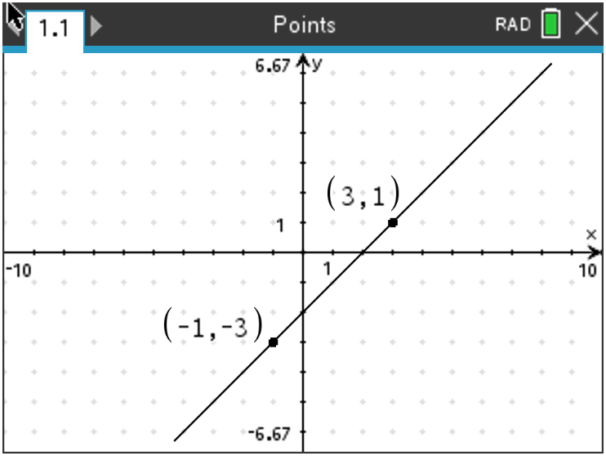

Move to page 2.2.
Problem 4 – Slopes of Parallel and Perpendicular Lines
Drag the lines by points A and B and examine the slopes.
18. Explain what you notice about the slopes of two parallel lines.

Move to page 2.3.
Drag the lines by points A and B and examine the slopes.
19. Explain what you notice about the slopes of two perpendicular lines.

Discuss with a classmate what happens when the slopes of two perpendicular lines are multiplied together. Test your theory on the current slopes of both lines. Now, change the lines by grabbing and dragging point A and test your theory several times.

20. Describe what you observe about the product of the slopes.

Further IB Application

Hannah has always liked the kite shape. She plans to tile her bathroom floor with a pattern made up of kites. For the patter, she will be designing her initial kite PQRS on a set of coordinate axes in which one unit represents 5 cm.

The coordinates of P, Q, and R are (2, 0), (0, 4), and (4, 6) respectively. Point S lies on the x-axis. PR is perpendicular to QS. See the diagram below.

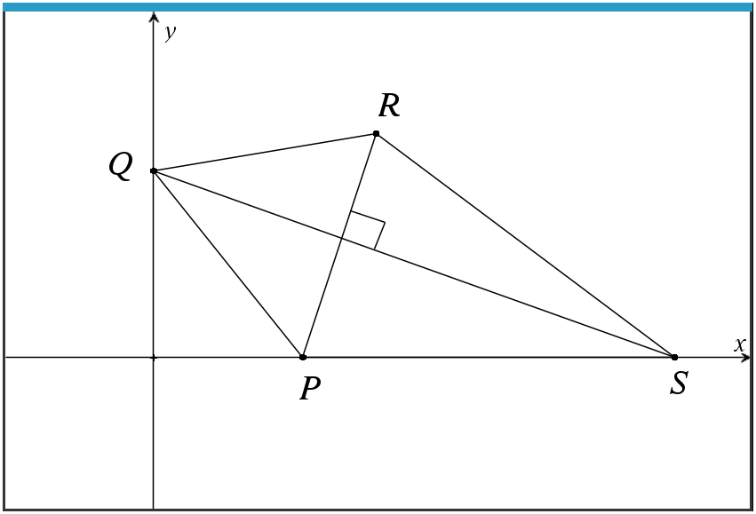 Diagram not to scale.

(a) Find the gradient of PR.

(b) Write down the gradient of QS.

(c) Find the equation of QS and write the answer in the following forms:

(i) y = mx + c

(ii) y – y₁ = m(x – x₁)

(iii) ax + by + d = 0

(d) Find the coordinates of point S.

