Problem 1 – Exploring the Centroid of a Triangle
1. Cut out the triangle below, (or use the triangle your teacher provides), and try to balance it on the eraser of your pencil. Mark the point on the triangle where the triangle was balanced. What are the coordinates of this point?
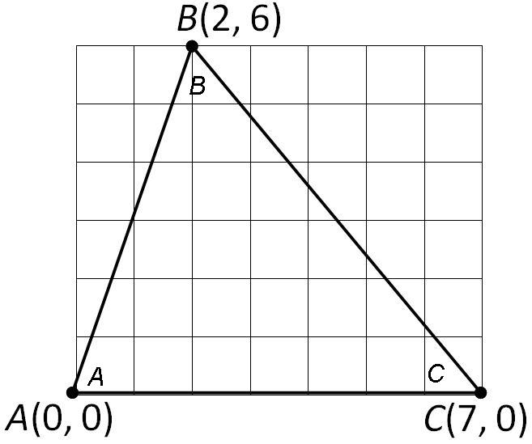
We will now explore how we can use our handhelds to find the point where the triangle will be balanced. The balancing point for an object is called the center of mass.
Problem 2 – Exploring the Medians of a Triangle
2. Define Median of a Triangle.

On page 2.3, you are given a triangle with vertices at points A, B, and C as above. Use your handheld to create the three medians of ABC.
3. What do you notice about the three medians of ABC?

4. What are the coordinates of the point of intersection of the medians?

5. How does this compare to the balancing point of the triangle that you balanced on your pencil?

6. Using the coordinates of the vertices of the triangle, find the average of the three x-coordinates and the average of the three y-coordinates. How do these averages relate to the coordinates of the intersection of the medians?

7. Define Centroid.

Problem 3 – Extending the Centroid
The medial triangle is the triangle formed by connecting the midpoints of the sides of a triangle.
On page 3.2, you are given a triangle and its centroid. Find the medial triangle and the centroid of the medial triangle.
8. What do you notice about the centroid of the original triangle and the centroid of the medial triangle?

Problem 4 – Extending the Median
The midsegment is a line segment joining the midpoints of two sides of a triangle.
On page 4.3, you will see ABC with midpoints D, E, and F of sides , , and , respectively. Midsegment DE is drawn.
- Create the median of A and construct the intersection point, G, of the median and the midsegment.
- Find the lengths of , , , and .

9. What do you notice about the relationship between the median and the midsegment?

