Open the TI-Nspire document Aquatic_Food_Webs.tns
All living things need to obtain energy. In an ecosystem, some organisms, known as producers, produce their own food to obtain energy. There are also some organisms, known as consumers, that consume other organisms to obtain energy. A final group of organisms, known as decomposers, obtain energy by breaking down dead organisms and waste matter. The energy relationship between organisms in an ecosystem is known as a food web.

All organisms have a role in a food web. The producers make food by transforming energy from the Sun, water, and nutrients into carbohydrates and other molecules. Primary consumers eat producers to obtain energy. In turn, secondary consumers will obtain energy from primary consumers, and tertiary consumers will obtain energy from secondary consumers. Decomposers break down dead organisms into basic nutrients that producers can use to make their food. In this activity, you will determine the roles of different organisms in an aquatic food web and identify the ecological relationships between different organisms.
Move to page 1.2.
Read the directions for the simulation.

 | 1. Move the organisms on the right by dragging and dropping them on the correct label. If the organism correctly matches its role in the food web, the border of the label box will turn green.  2. Once the organisms are in the correct positions, select two different organisms to show their ecological connection in the food web. (In other words, show “who eats whom” in the food web). There should be 10 connections. | 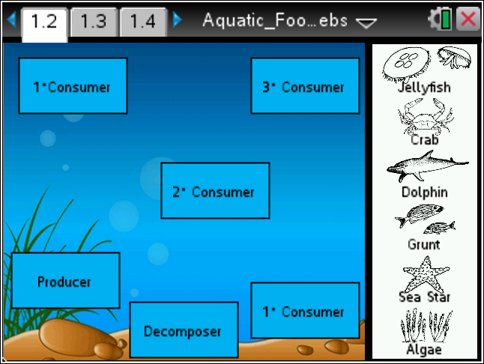
Tech Tip: To access the Directions again, select > Food Web> Directions.
Tech Tip: To access the Directions again, select b or Document Tools () > Food Web > Directions.

Move to pages 1.3 – 1.15.

After completing the simulation on page 1.2, answer questions 1 – 13 below and/or in your .tns file.

Q1. Identify the ecological role of the following organism: algae
A. producer
B. primary consumer
C. secondary consumer
D, tertiary consumer
E. decomposer

Q2. Identify the ecological role of the following organism: sea star
A. producer
B. primary consumer
C. secondary consumer
D, tertiary consumer
E. decomposer

Q3. Identify the ecological role of the following organism: grunt
A. producer
B. primary consumer
C. secondary consumer
D, tertiary consumer
E. decomposer

Q4. Identify the ecological role of the following organism: dolphin
A. producer
B. primary consumer
C. secondary consumer
D, tertiary consumer
E. decomposer

Q5. Identify the ecological role of the following organism: crab
A. producer
B. primary consumer
C. secondary consumer
D, tertiary consumer
E. decomposer

Q6. Identify the ecological role of the following organism: jellyfish
A. producer
B. primary consumer
C. secondary consumer
D, tertiary consumer
E. decomposer

Q7. From which organism(s) does the crab obtain energy? (Multiple answers possible.)
A. algae
B. jellyfish
C, sea star
D. dolphin
E. grunt

Q8. From which organism(s) does the jellyfish obtain energy? (Multiple answers possible.)
A. algae
B. crab
C, sea star
D. dolphin
E. grunt

Q9. From which organism(s) does the sea star obtain energy? (Multiple answers possible.)
A. algae
B. jellyfish
C, crab
D. dolphin
E. grunt

Q10. From which organism(s) does the dolphin obtain energy? (Multiple answers possible.)
A. algae
B. jellyfish
C, sea star
D. crab
E. grunt

Q11. From which organism(s) does the grunt obtain energy? (Multiple answers possible.)
A. algae
B. jellyfish
C, sea star
D. crab
E. dolphin

Q12. What is the main source of energy for all living things?

Q13. What does a food web tell us about an ecosystem?

