Density Curves  ID: 11069 | Time required  15 minutes

Activity Overview
In this activity, students will be introduced to density curves as a simple analysis of a data set. They will also investigate where the median and mean lie on symmetric or skewed graphs.

Topic: One-Variable Distributions
- Density curves
- Mean, median, and skewness

Teacher Preparation and Notes
- Students will need the student worksheet before the activity.
- Useful terms for this activity:
  - Uniform distribution: The height of each bar in the histogram is approximately the same.
  - Symmetric distribution: Single peak with both sides approximately the same.
  - Skewed right: Tall extends to the right side.
  - Skewed left: Tall extends to the left side.
- To download the student worksheet, go to education.ti.com/exchange and enter “11069” in the quick search box.

Associated Materials
- StatWeek03_Density_worksheet_TI-84

Drawing Density Curves
Discuss with students the shape, center, and spread of the four graphs. Remind them, if necessary, of the concepts of symmetry, skewness and uniform distributions.  The first two are symmetric whereas the third is skewed left and the fourth is skewed right. The centers of the first two are in the middle of the distributions, whereas it is on the left of the third graph. The first histogram is mound shaped with the data mostly in the middle. The data in the second histogram is more evenly spread out. The spread in the third distribution is less than that of the second. | 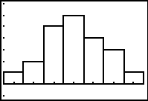  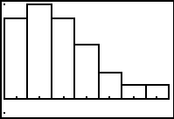
Students are to sketch the density curve for each distribution on the worksheet. You may need to show them an example.
When students are estimating the mean and median, remind them that the mean is the point that balances the data and the median is the point that divides the data in two equal groups.
Mean and Medians in Histograms
Students are to use Plot1 to graph the first histogram, using L1 and L2, and then find the mean and median.  The mean and median commands can be entered by pressing ` S, arrow right to the MATH menu and then select the command.  The Vertical command can be entered by pressing ` p and selecting Vertical. | 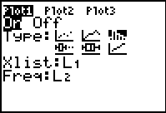
After selecting ClrDraw from the DRAW menu, students can change Plot1 to graph the second histogram, L1 and L3, and then find the mean and median.  The third histogram uses L1 and L4.  The fourth histogram uses L1 and L5. | 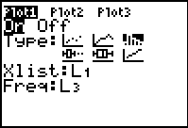
The top two histograms are symmetric and therefore their means and medians are essentially the same. The second two histograms are skewed. Their mean of a distribution that is skewed right is to the right of its median – and vice versa.

