Focus: Find patterns formed by remainders when dividing.
Recurring Remainders
Collecting and Organizing Data
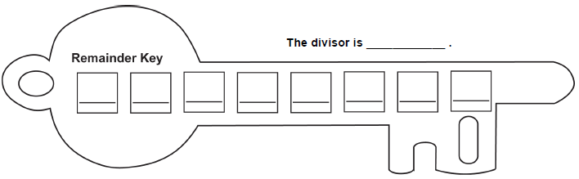
Hundred Chart
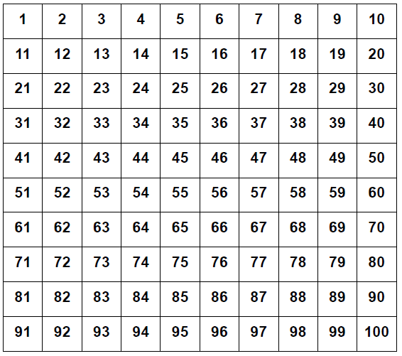

Patterns we found while we were doing this activity:

