Graphs of Rational Functions 1
TI-Nspire™ CX Family

Activity Overview
Time required
45 minutes

In this activity, students relate the graph of a rational function to the graphs of the polynomial functions of its numerator and denominator. Students graph these polynomials one at a time and identify their y-intercepts and zeros. These features of the graph are connected with the standard and factored forms of the equation. Next students graph the rational function, and connect its behavior with that of the polynomial functions. Finally, students view the numerator, denominator and rational functions on the same graph. Using the handheld’s manual manipulation functions, students can manipulate the graphs of the numerator and denominator functions and see the effect on the rational function.
Topic: Rational & Radical Functions & Equations
- Graph any rational function and identify its singularities and asymptotes.
- Factor the denominator of a rational function to locate its singularities.
- Approximate solutions to rational equations and inequalities by graphing.

Teacher Preparation and Notes
- This activity is designed to be used in an Algebra 2 or Precalculus classroom.
- Prior to beginning this activity, students should have an introduction to polynomial functions, their graphs, and the concept of degree. This activity may serve as an introduction to rational functions.
- This activity is intended to be mainly teacher-led with brief periods of independent student work. The .tns file helps guide students through the activity and poses discussion questions.
- Notes for using the TI-Nspire™ Navigator™ System are included throughout the activity. The use of the Navigator System is not necessary for completion of this activity.
Associated Materials
- RationalFunctions1_Student.doc
- RationalFunctions1.tns
- RationalFunctions1_Soln.tns

Problem 1 – Graphing the numerator
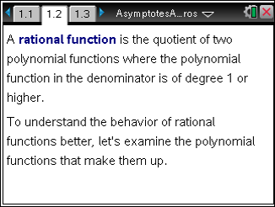
Page 1.2 gives the definition of a rational function. You may wish to give some examples of rational functions or have the class suggest some. Label the numerator and denominator functions. To help students understand why the polynomial function in the numerator must be of degree 1 or higher, ask them to consider what a function with a polynomial of degree 0 on the denominator would look like.
Page 1.3 prompts students to graph the numerator of the rational function, 2x² – 8, on page 1.4.
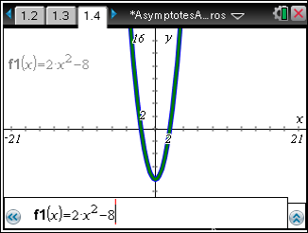
Page 1.5 prompts students to find and record the y- intercept and an explanation as to how that y-intercept was found.

TI-Nspire Navigator Opportunity: Quick Poll
See Note 1 at the end of this lesson.
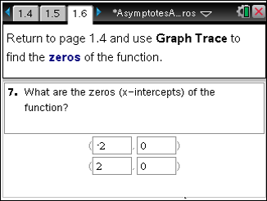
Page 1.6 prompts students to find the zeros of the function. Direct students to enter the Trace mode (MENU > Trace > Graph Trace). Once the student clicks anywhere on the graph, they should be able to manipulate the placement of a point on the graph by selecting the left or right arrows on the touchpad.
Students should connect the y-intercept with the zero degree term of the polynomial, in this case -8. To test this connection, they can “grab” and “drag” the vertex of the parabola by first turning off the formula bar (/ + G), then moving the cursor over the vertex. When the cursor changes to crosshairs they should press the center button, x, to grab the parabola, then use the up and down arrows to drag it. How does the equation change as the graph moves?
Note: Make sure to return the equation to f1 = 2x² – 8 by retyping it before proceeding.

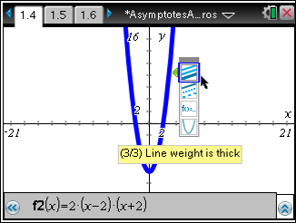
On page 1.7, students are prompted to enter the factored form of f(x) = 2x² – 8 as f2. To change the line weight to thick, students need to open the attributes menu for the line. To do this they can either arrow over to the menu icon in the formula bar for f2 and press enter, or they can press MENU > Actions > Attributes and select the line.
Students should find that the thick graph is identical to the original graph of f(x) = 2x² – 8. The zeros of the function can be found by setting each factor of the function equal to 0 and solving for x.

TI-Nspire Navigator Opportunity: Screen Capture
See Note 2 at the end of this lesson.

Problem 2 – Graphing the denominator
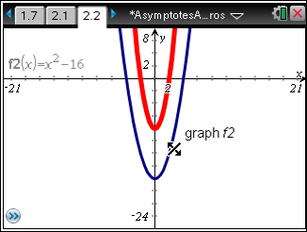
Page 2.1 directs students graph a new function,
f(x) = x² – 16 on page 2.2. Students repeat the same process of examining a polynomial function with the denominator as they did with the numerator. Page 2.3 asks students to find and record the y-intercept and provide an explanation on how it can be easily found.
Pages 2.4 and 2.5 will prompt students to find the zeros of this new function and graph the factored form as thick to once again illustrating the two functions’ similar characteristics.
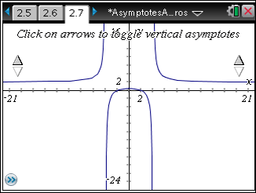
On page 2.7, student will re-graph the original quadratic from Problem 1 as f1 the original quadratic from Problem 2 as f2. Furthermore, they will create a new function in f3 depicting the quotient of those two functions.
Note: This could be a good time to remind student about the copying and pasting shortcuts, (/ + C and
/ + V).
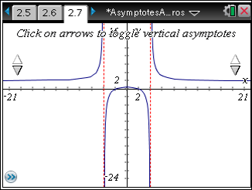
It may be helpful to suggest the students temporarily hide f1 and f2. To do this, they can either arrow over to the eye icon in the formula bar next to each function and press ·, or select MENU > Actions
> Hide/Show, then select the graph.
This could be a good time to allow students to click on the arrows to display the asymptotes.

Graph of f(x)= (2x²-8)/(x²-16) with asymptotes toggled ON.

TI-Nspire Navigator Opportunity: Screen Capture
See Note 3 at the end of this lesson.
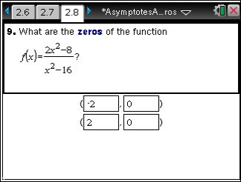
Students are asked to find and enter the zeros of this new rational function on page 2.8. Students should find that the zeros of the rational function are the same as the zeros of the numerator. Discuss why this is true. What happens when the numerator of a fraction is zero?

TI-Nspire Navigator Opportunity: Quick Poll
See Note 4 at the end of this lesson.

Page 2.10 asks students to find the y-intercept of the rational function. Challenge students to connect the value they find with the y-intercepts of the numerator and denominator functions. Recall that the y-intercept of the numerator was –8 and the y-intercept of the denominator was –16. What is the quotient of these two values?
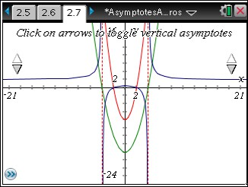
Finally on page 2.11, students are directed to unhide functions f1 and f2. If they look closely, they should see that the zeros of the numerator's parabola intersect the zeros of the rational function and that the zeros of the denominator's parabola appear to cross the asymptotes at x = 4 and x = –4. Encourage students to grab and drag the graphs of the numerator and denominator to see that these relationships hold even as the functions change.
You may wish to repeat this process on a new page with other rational functions for practice.

TI-Nspire Navigator Opportunity: Screen Capture
See Note 5 at the end of this lesson.

TI-Nspire Navigator Opportunities

Note 1
Problem 1, Quick Poll
You may choose to use Quick Poll to assess student understanding on Problem 1, page 1.5. Problem 2 on page 1.5 is subjective.

Note 2
Problem 1, Screen Capture
You may choose to use Screen Capture to ensure that students are correctly able to change a graph’s thickness.

Note 3
Problem 2, Screen Capture
Students are employing quite of few of the TI-Nspire features here. Monitoring the students’ progress via a Screen Capture will be a great way to make sure they are correctly hiding the functions f1 and f2. Additionally, this would be a great time to illustrate the copy and paste shortcuts.

Note 4
Problem 2, Quick Poll
You may choose to use Quick Poll to assess student understanding on Problem 2, page 2.8.

Note 5
Problem 2, Screen Capture
A Screen Capture of the students’ manipulation on Question 13 could provide for some interesting and valuable discussion regarding the transformation that f3 undergoes when the functions f1 and f2 are changed.

