Problem 1 - A flat triangular stack
You are stacking bricks according to the pattern shown.  Complete the table on page 1.4.  Which polynomial model should you use—linear, quadratic, cubic, or quartic? One way to decide is to calculate successive differences. The differences between the y-values are called 1st differences. The differences between the 1st differences are called the 2nd differences, and so on. | 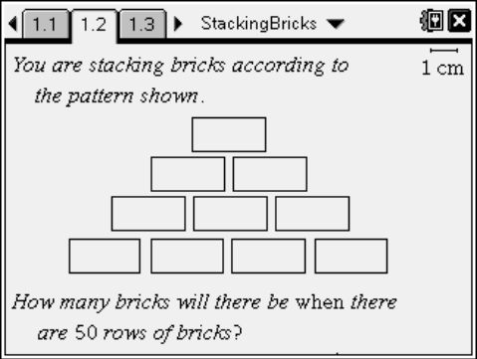
If the 1st differences are constant or close to constant, a 1st degree (linear) model is a good choice. If the second differences are close to constant, a 2nd degree model is a good choice, and so on.
Return to page 1.4. In Columns C–E, calculate the 1st, 2nd, and 3rd differences of the number of bricks.
1. Which set of differences is constant?

2. What degree polynomial model is best for this data?

3. Return to page 1.4. Go to Column F and perform the regression from the Stat Calculations menu. Store the resulting equation in f1.

4. Look at the R² value of the regression. What is it? What does this mean?

5. Check your model. Graph number of rows vs. total bricks as a scatter plot and f1 together on page 1.8. Does the function go through all the points?

6. If your model is correct, use it in the calculator pane on page 1.10 to calculate the number of bricks in a stack 50 rows high.

7. Look at the equation of the model. Are there any terms you could leave off? Why?
Type an equation without this term in f2 and hide f1

8. Discuss the shortcomings of this model for this situation. For what numbers of rows is it valid? For what numbers of rows does it not make sense? Write a domain for this model.

Problem 2 - A pyramidal stack
Use the method from problem 1 to find the number of bricks in a pyramid with 50 layers.  9. Create a small table. |  | 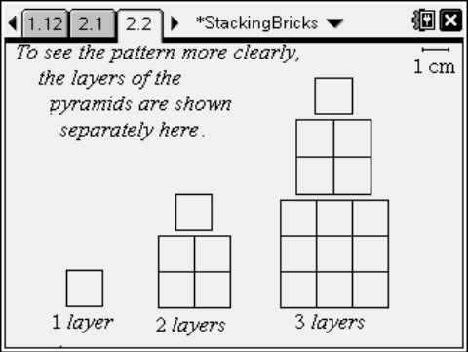
10. Calculate 1st, 2nd, and 3rd differences.

11. Choose and perform a polynomial regression.

12. Look at the R² value of the regression. What is it? What does this mean?

13. Check your model. Graph number of layers vs. total bricks as a scatter plot and f1 together on page 2.6. Does the function go through all the points?

14. If your model is correct, use it in the calculator pane below to calculate the number of bricks in a stack 50 rows high.

15. Look at the equation of the model. Are there any terms you could leave off? Why? Type an equation without this term in f2 and hide f1. How does this affect the graph?

16. Discuss the shortcomings of this model for this situation. For what numbers of layers is it valid? For what numbers of layers does it not make sense? Write a domain for this model.

