Democrat or Republican? Maybe Neither.
By Wanda McCoy
Coppin State University

INTRODUCTION
The Democratic Party, claiming a position on the left of the political theory continuum, has been labeled “liberal,” both by supporters and detractors alike. Initially, the name simply meant “worthy of a free man”. Then, beginning in the early part of the nineteenth century, the term came to imply the qualities of intellect and behavior that were considered to be characteristic of those who occupied higher social positions, whether because of wealth, education, or family relationships. Thus, an intellectually independent, broad-minded, magnanimous, frank, open, and genial person was said to be liberal.
“Liberalism” connotes a political system or tendency that is opposed to centralization and absolutism. However, the word liberal is generally used in a derogatory way today by those who subscribe to more conservative philosophies. For them, a liberal is someone who believes in big government and wasteful, giveaway social programs. Collectively, liberals pretty much agree today that government should be a force for social change, to improve the lot of the disadvantaged and to protect the individual rights of all Americans, regardless of their race, sex, ethnicity, or sexual orientation. Liberals would tend to agree that all should have affordable access to quality education and health care
Most who have political persuasions to the right on the political theory continuum label themselves, “conservative.” Generally, the Republican Party is considered “conservative”. Today the party attracts many different groups, including sportsmen and other gun owners who consider their right to bear arms to be under attack, business corporations (particularly defense, energy, and pharmaceutical industries) and wealthy individuals who benefit from limiting social programs, limiting regulations, and reduced taxes, as well as various fundamental or evangelical Christian groups who are lobbying for social change. On economic policy, conservatives and the right generally support the free market and side with business interests over rank-and-file workers and environmentalists.
Over time people from both parties have become disillusioned with their party of choice. As a result many other political parties have emerged in this country. Among these parties are the Green Party, the Libertarian Party and the Constitution Party. Still, other voters choose not to affiliate themselves with any one party, instead choosing to vote on issues and candidates regardless of the party to which the candidates belong. This group of voters is recognized as Independents.

ADAPTED FROM
- http://kgarry.wordpress.com/2006/12/31/liberal-vs-conservative-democrat-vs-republican/
- http://www.politics1.com/parties.htm

Student Activity Sheet

PROBLEM
Which Maryland Party had a higher voter turnout for the Presidential election?
Do you live in a majority Democratic or Republican county/city or neither?

DATA ANALYSIS
You will be assigned one of the three groups: Democrats, Republicans, or Unaffiliated/Other. Enter your Party’s data into the TI-73 by following the directions below.

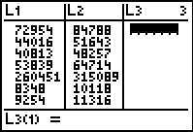
I. ENTERING DATA into the TI-73
- Press List
- Enter data from your “party’s” column entitled # Voting in L₁. Enter data from your “party’s” column entitled # Registered in L₂.
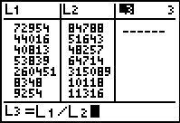

Steps 3 – 11 below will guide you as you complete student page 1 of the DATA ANALYSIS handout and answer questions 1 - 17 on page 2 for your party. You will share your results with the class.

Calculating percent for each county:
- To find the percent that L₁ is of L2 highlight the heading of column L3. Press 2nd STAT 1: L₁ ÷ 2nd STAT 2:L_{2.}
- Press ENTER to complete the calculation. The list will display the decimal calculations.
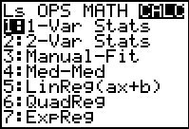
- Convert the decimals to percents, rounding to two decimal points, and fill in the appropriate column in Table 1 of the Data Analysis Sheet.

Calculating Mean and Median for the state for your group:
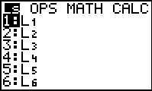
- Find the mean of the state data for L₁.
Press 2nd QUIT to go to the home screen.
Press CLEAR to make sure you have nothing else on the screen.
Press 2nd STAT then press arrow key three times to select the CALCulate menu.

- Select 1: 1-Var Stats by pressing 1. Press 2nd STAT 1:L₁. Note: If you leave off the list name, the TI-73 will use L₁ by default.
- Press ENTER. Use the down arrow to scroll.
Locate the mean ( ) of the L1 data, use it to answer question 2 on page 2 of Data Analysis Handout.
- Locate the total of Md. voters in your party ( ) of the L₁ data, use it to answer question 8.
- Locate the median (MED) of the L1 data, use it to answer question 3.
- Repeat steps 6 - 10 using L2 and L₃ and answering questions 4 – 7. Then answer 9 – 17.

II GRAPHING the data:
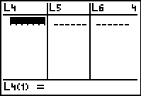
A. Pie Charts
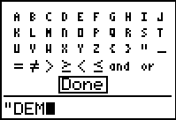
- Use Table III from your Data Analysis Handout to create Pie Charts.
- In the List Editor, go to the first cell in L4, and use the TEXT menu to get a quotation mark and letters
- After typing the quotation mark, type D, E, and M. Then highlight and press ENTER (closing quote is unnecessary)
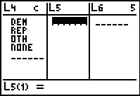
- Then press ENTER to tell TI-73 you really mean it (or to fix any typos).
- For the second cell in L4, press 2nd TEXT and put in REP (Now that the list has a word in it, the initial quote on future words is optional.)
- For the third cell in L4, put in OTH
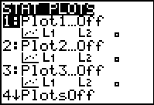
- For the fourth cell in L4, put in NONE (for those who did not vote).
- In L5 enter the numbers from Table III.
- Plot a circle graph for the data in L4 and L5. Press 2nd Plot. Select 1:PLOT1 and press ENTER.
- Turn the plot on. Select the image of the circle graph .
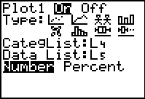
- To select L4 as CategList, press 2nd list and select L4. Press ENTER
- Select L5 as Data List. Press 2nd list and select L5. Press ENTER
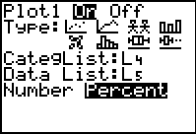
- Highlight Number. Make sure all other plots are off and there are no equations in the Y= editor. Press GRAPH and TRACE to see the values. (No window settings need be entered.)
- Go back to change the settings by pressing 2nd Plot and select Percent. Press GRAPH and TRACE.

Complete numbers 18 -20 on the Data Analysis Handout.

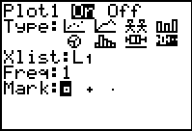
B. Box-and-whisker plots
- Plot a box-and-whisker plot for the data in L1. Press 2nd Plot. Select 1:PLOT1 and press ENTER.
- Select the image of the boxplot.
- Select L1 as Xlist. Press 2nd list and select L1. Press ENTER
- Press ZOOM. Select 7:ZoomStat by pressing 7. Press trace to see values of minX, Q1, Q2, Q3 and maxX
- Repeat steps 1-5 for L2. This time use plot 2, leaving plot 1 on.
Answer questions 21-24 on the Data Analysis Handout.

