Vocabulary  Commutative Property of Multiplication:  reciprocal: | In this activity, you will find the product of a fraction and a fraction.
1. Explain how you can argue from the unit square below that is the same as .
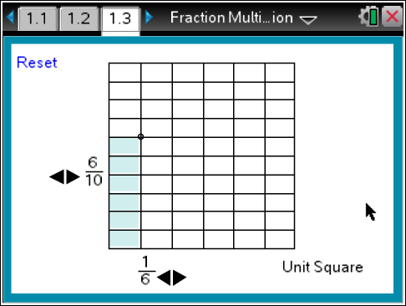

 | 2. Do you think the product of the fractions will be more or less than 1? Explain your reasoning.
3. Explain why is the same as .

4.  Evan and Keisha multiplied and . They each used a different method but got the same solution. Describe the different ways that Evan and Keisha could have used to find the solution.

