Open the TI-Nspire document Verbal_to_Visual.tns.  In this activity, you will sketch a graph to show the important features of a function as described by a problem setting. | 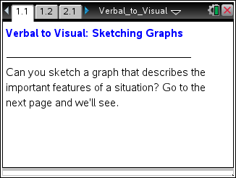

Move to page 1.2.

Below are four scenarios that provide clues about certain features of graphs. Work with a partner and make a sketch of a graph on the TI-Nspire™ that you believe the scenario describes.
- To make a sketch, grab the red point on the screen with the hand tool and move the point to where you want to start your graph.
- Change the “Draw” to “On.” When you move the red point, you will begin to draw your graph.
- If you want to start drawing again, you can select either arrow of “Erase Draw,” change the “Draw” to “On,” and then move the red point to start the new drawing.
- When you believe you have a good approximation for your sketch, use the “Show function” slider to see how your sketch matches another graph showing the important features of the function.
- Compare the important features between the two sketches. It is not likely that the sketches will be exactly identical but the important features should be very similar.
For example, if the scenario indicates the function should be decreasing at a constant rate across a certain period of time, then a negative slope is an important feature that should match. If no specific slope was provided in the problem, there could be many different negative values for a slope. Do not worry if the slopes are not exactly the same, just be sure both are negative. What is important is that you and your partner can determine the important features of the graphs that are provided in the scenarios and sketch them appropriately.

1. Problem 1: You remove the plug from a bathtub holding about 150 liters of water, and it begins draining at a constant rate. After 3 minutes, you put the plug back in to remove the small bath toys so they don’t go down the drain. That takes about 30 seconds, so the draining stopped for that length of time. You then remove the plug again and let the tub empty. That takes another 2 minutes. What might a graph of that situation look like?
a. Underline important pieces of information from the scenario that you can use to draw your sketch.
b. Draw your sketch on the TI-Nspire.
c. Draw a final copy of your sketch below.

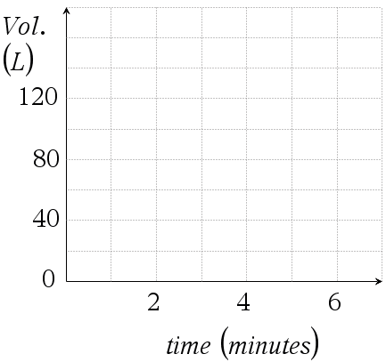
d. In your own words, describe how the important pieces of the scenario are shown in your sketch to support why you made the graph look the way it does.

2. Problem 2: You and a friend are using a motion detector. The detector keeps track of your distance away from it over a period of 15 seconds. You hold the detector facing away from you to collect motion information from your friend. She stands 1 meter from the detector and starts to walk away from you at a constant rate for 7 seconds. She stops for 3 seconds, and then walks backwards towards you faster than she walked away and arrives where she started after 5 seconds. What might a graph of this situation look like?
a. Underline important pieces of information from the scenario that you can use to draw your sketch.
b. Draw your sketch on the TI-Nspire.
c. Draw a final copy of your sketch on the next page.

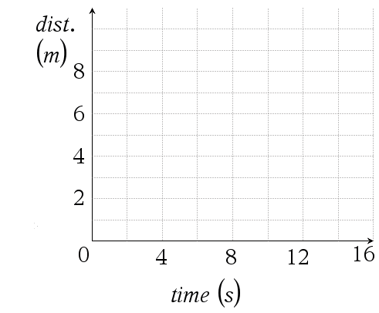
d. In your own words, describe how the important pieces of the scenario are shown in your sketch to support why you made the graph look the way it does.

3. Problem 3: Suppose you have a function that is increasing at a constant rate in the 3rd quadrant until the origin. At the origin the function is now decreasing at a slower constant rate than it was increasing. What might a graph of that function look like?
a. Underline important pieces of information from the scenario that you can use to draw your sketch.
b. Draw your sketch on the TI-Nspire.
c. Draw a final copy of your sketch below.

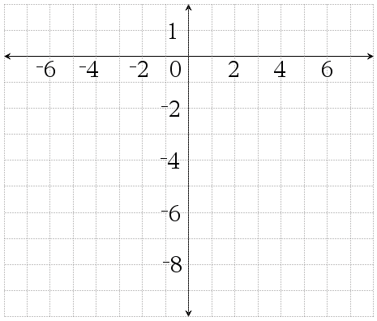
d. In your own words, describe how the important pieces of the scenario are shown in your sketch to support why you made the graph look the way it does.

4. Problem 4: Suppose you have a function that is decreasing in the 2nd quadrant until the point (0,2) and it is not decreasing at a constant rate. At the point (0,2) it begins to decrease at a constant rate. What might a graph of this function look like?
a. Underline important pieces of information from the scenario that you can use to draw your sketch.
b. Draw your sketch on the TI-Nspire.
c. Draw a final copy of your sketch below.

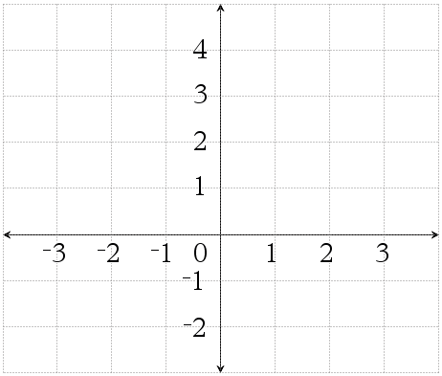
d. In your own words, describe how the important pieces of the scenario are shown in your sketch to support why you made the graph look the way it does.

Move to page 2.1.

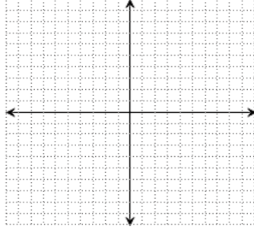
5. a. Write your own scenario that you can share with your partner to sketch a new graph. Your scenario needs to involve two variables (for example: time and temperature, or cost of a ticket and number of people) and should provide enough important features of the graph so that your partner can make a reasonable sketch. Once you have finished your scenario, trade papers with your partner and draw new sketches.

b. Draw a sketch of your own graph to the right.

