Topic 3.13: Trigonometric and Polar Coordinates | Converting between rectangular form and polar form  Finding equivalent polar coordinates
Practice Problem 1
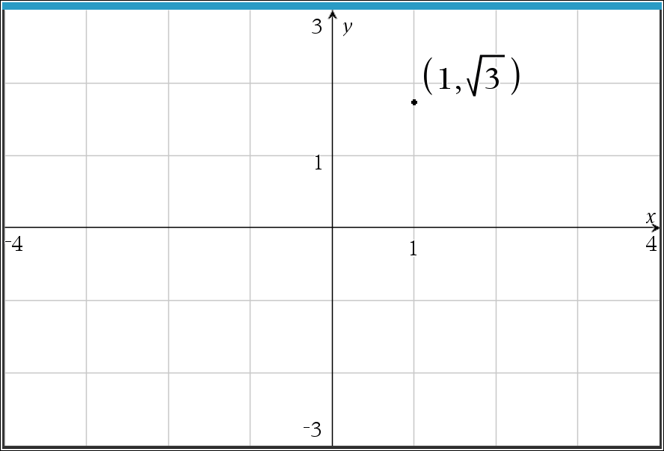
The graph of point R is shown in the rectangular plane. Which of the following are possible polar coordinates of point R?
(a) $\left(2, \frac{π}{6}\right)$
(b) $\left(1, \frac{π}{3}\right)$
(c) $\left(2, \frac{π}{3}\right)$
(d) $\left(1, \frac{π}{6}\right)$

Practice Problem 2
The point Q has polar coordinates $\left(8, \frac{2π}{3}\right)$. Which of the following is the location of Q in rectangular coordinates?
(a) $\left(4, 4\sqrt{3}\right)$
(b) $\left(4\sqrt{3}, 4\right)$
(c) $\left(-4, 4\sqrt{3}\right)$
(d) $\left(4\sqrt{3}, -4\right)$

Practice Problem 1 Solution:
(c) $\left(2, \frac{π}{3}\right)$
Students need to convert to polar coordinate form using the formulas $r^{2}= x^{2}+ y^{2}$ and $\tan{θ= \frac{y}{x}}$.
$$r^{2}= 1^{2}+ {\left(\sqrt{3}\right)}^{2} → r= \sqrt{1+3} →r= \sqrt{4} → r=2$$
$$\tan{θ}= \frac{\sqrt{3}}{1} → \arctan\left(\sqrt{3}\right) or \tan^{-1}\left(\sqrt{3}\right)= \frac{π}{3}$$

Practice Problem 2 Solution:
(c) $\left(-4, 4\sqrt{3}\right)$
Students need to convert to rectangular form using the formulas $x=r\cos{θ}$ and $y=r\sin{θ}$.
$$x=8\cos{\frac{2π}{3}}=8\left(-\frac{1}{2}\right)= -4$$
$$y=8\sin{\frac{2π}{3}=8\left(\frac{\sqrt{3}}{2}\right)}=4\sqrt{3}$$

**Note: This activity has been developed independently by Texas Instruments. AP is a registered trademark of the College Board, which was not involved in the production of, and does not endorse, this product. Policies subject to change. Visit www.collegeboard.org.

