Sum of Interior Angles in a Triangle

- Select F2: TRIANGLE and create a triangle that covers as much area as possible.

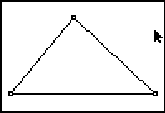

- Select F5: MEASURE ►ANGLE and measure each angle of the triangle by selecting the vertices (the middle vertex is the angle you want measured).

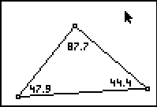

- Select F5: CALCULATE and find the sum of two of the angles.

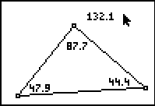

- Select F5: CALCULATE and add the sum of the first two angles to the third angle. (Select F5: Hide/Show Object to hide the sum of the first two angles)

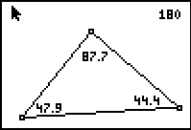

- Observe the sum of the interior angles as you move a vertex around the screen. To move a vertex, select it and press ALPHA (this makes a hand on the point and allows you to move the vertex).

